

MULTILINGUAL STORY GENERATION AND SPEECH SYSTEM
StoryVox: Prompt-to-story generation with a small instruction-tuned language model and multilingual neural narration
A project report submitted in partial fulfilment of the requirements for the award of the degree of
BACHELOR OF TECHNOLOGY
in
COMPUTER SCIENCE AND ENGINEERING
Submitted by
LINGALA SINDHU | 23K91A05D3
PADIGE AJAY | 23K91A05H8
MAHEK ANSARI | 23K91A05D8
MAHESHWARAM HARI KRISHNA | 23K91A05D9
Batch C2 (CSE-C)
Under the esteemed guidance of
A TEJASWINI
[DESIGNATION]
DEPARTMENT OF COMPUTER SCIENCE AND ENGINEERING
TKR COLLEGE OF ENGINEERING & TECHNOLOGY (AN AUTONOMOUS INSTITUTION)
Medbowli, Meerpet, Balapur, Hyderabad, Telangana - 500 097
Academic year [ACADEMIC YEAR]

CERTIFICATE
This is to certify that the project report entitled "Multilingual Story Generation and Speech System" is a bonafide record of the work carried out by LINGALA SINDHU (23K91A05D3), PADIGE AJAY (23K91A05H8), MAHEK ANSARI (23K91A05D8), MAHESHWARAM HARI KRISHNA (23K91A05D9), in partial fulfilment of the requirements for the award of the degree of Bachelor of Technology in Computer Science and Engineering, during the academic year [ACADEMIC YEAR], under my supervision.

Project Guide | Head of the Department | Principal
A Tejaswini | [HOD NAME] | [PRINCIPAL NAME]
[DESIGNATION] | Department of Computer Science and Engineering | TKR College of Engineering & Technology

External Examiner: [NAME AND SIGNATURE]
Place: [PLACE]
Date: [DATE]

DECLARATION
We hereby declare that the project report entitled "Multilingual Story Generation and Speech System", submitted to the Department of Computer Science and Engineering, TKR College of Engineering & Technology, in partial fulfilment of the requirements for the award of the degree of Bachelor of Technology in Computer Science and Engineering, is a record of original work carried out by us under the guidance of A Tejaswini, [DESIGNATION]. The results embodied in this report have not been submitted to any other university or institution for the award of any degree or diploma.

LINGALA SINDHU 23K91A05D3
PADIGE AJAY 23K91A05H8
MAHEK ANSARI 23K91A05D8
MAHESHWARAM HARI KRISHNA 23K91A05D9

Place: [PLACE]
Date: [DATE]

ACKNOWLEDGEMENT
We express our sincere gratitude to our project guide, A Tejaswini, [DESIGNATION], for valuable guidance, encouragement and constructive suggestions throughout this project.
We thank [HOD NAME], Head of the Department of Computer Science and Engineering, for providing the facilities and support needed to complete this work, and [PRINCIPAL NAME], Principal, TKR College of Engineering & Technology, for the encouragement given to us.
We thank the project coordinators and all faculty and staff members of the department for their help, and our families and friends for their constant support.
We also acknowledge the authors of the base paper, C. Tran and S. Sakti, whose work on cross-lingual text-to-speech translation framed this project; the Qwen team, the Meta MMS project and OpenAI, whose open Qwen3-0.6B, MMS-TTS and Whisper models StoryVox builds on; Google, for the FLEURS speech benchmark (released under CC BY 4.0) on which the speech round trip was measured; and the maintainers of the open-source software used here: PyTorch, Hugging Face Transformers, FastAPI, SQLAlchemy, React, Vite and Playwright.

LINGALA SINDHU
PADIGE AJAY
MAHEK ANSARI
MAHESHWARAM HARI KRISHNA
Storytelling supports education, language learning and entertainment, but producing stories in several languages and reading them aloud normally takes writers and narrators for every language. This project builds StoryVox, a Multilingual Story Generation and Speech System that runs on a single computer: the user types a story idea and chooses a language, a style and a length; a small instruction-tuned language model (Qwen3-0.6B) writes the story; a per-language neural speech model (MMS-TTS, VITS) reads it aloud; and the story, the audio and the evaluation results are kept in a local database. The system has a React web application with five pages, a FastAPI service with 11 routes, 15 supported languages, 8 story styles and 3 lengths, and 29 passing automated tests. No model was trained or fine-tuned: StoryVox is a cascade of pretrained models, so it uses the base paper, SAM Translator, as the reference for multilingual speech output and does not reimplement its self-paced learning, mixture-of-experts or self-training.
We measured the pipeline on a CPU-only machine. Speech was checked by a round trip: 10 FLEURS sentences per language were synthesised and transcribed by Whisper-small. Across the 12 languages narrated by MMS the mean real-time factor is 0.247 (faster than real time) and the mean normalised character error rate is 8.8%; English scores a word error rate of 20.6%. Italian, Chinese and Japanese have no MMS checkpoint on the model hub and fall back to an operating-system voice that has only English voices on the test machine: it read all 10 Italian sentences (word error rate 49.4%) but narrated only 2 of 10 Chinese and 1 of 10 Japanese sentences. The story model is the weak link: with the prompt the application sends, the story text matched the requested language in 18% of 17 test cases, and all four non-English stories generated through the API came out in English, which the foreign-language voice then read badly. A chat-template variant tried as an experiment raised the match to 47%. The application's own evaluation page also reports no word or character error rate for story-length audio, because the recogniser call rejects audio longer than 30 seconds; the experiments use a separate chunked script.
The batch objectives are met in part: prompt entry, story generation with style and length control, speech output in 12 languages, playback and download, and automated evaluation are implemented; translation, reading-level control, voice and speed selection and user rating are not. We report these results and gaps as measured.
Keywords: multilingual story generation, text-to-speech, speech synthesis, natural language processing, storytelling system, MMS-TTS, Whisper, Qwen3, educational technology.

TABLE OF CONTENTS
CERTIFICATE i
DECLARATION ii
ACKNOWLEDGEMENT iii
TABLE OF CONTENTS v
LIST OF FIGURES viii
LIST OF TABLES x
LIST OF ABBREVIATIONS xi
CHAPTER 1: INTRODUCTION 1
1.1 Introduction to the Project Domain 1
1.2 Background and Motivation 1
1.3 Problem Statement 2
1.4 Need for the Proposed System 2
1.5 Project Objectives 3
1.6 Scope of the Project 3
1.7 Project Contributions 4
1.8 Limitations and Assumptions 4
1.9 Organization of the Report 5
CHAPTER 2: LITERATURE SURVEY 6
2.1 Overview 6
2.2 Base Paper Analysis 6
2.3 Neural story generation 8
2.4 Multilingual and low-resource text-to-speech 8
2.5 Cross-lingual and direct speech translation (the base-paper theme) 9
2.6 Evaluating generated speech: WER, CER and real-time factor 9
2.7 Low-resource languages 9
2.8 Datasets and Algorithms Used in Related Work 10
2.9 Strengths and Limitations of Existing Research 10
2.10 Research Gap 12
CHAPTER 3: FEASIBILITY STUDY 13
3.1 Technical Feasibility 13
3.2 Economic Feasibility 14
3.3 Operational Feasibility 15
3.4 Schedule Feasibility 15
3.5 Advantages and Constraints 16
CHAPTER 4: SYSTEM REQUIREMENTS AND ANALYSIS 17
4.1 Existing System 17
4.2 Limitations of the Existing System 17
4.3 Proposed System 17
4.4 Advantages of the Proposed System 18
4.5 Functional Requirements 19
4.6 Non-Functional Requirements 20
4.7 Hardware Requirements 20
4.8 Software Requirements 21
4.9 User Roles and System Constraints 21
CHAPTER 5: SYSTEM DESIGN 22
5.1 Design goals and architecture 22
5.2 High-level workflow 23
5.3 Data flow diagrams 24
5.4 UML design 26
5.5 Database design 28
5.6 Core algorithm design 29
5.7 Module design 31
5.8 API design 32
5.9 User interface design 33
5.10 Design decisions and trade-offs 33
CHAPTER 6: METHODOLOGY AND SOFTWARE IMPLEMENTATION 34
6.1 Overall methodology 34
6.2 Dataset 35
6.3 Preprocessing 35
6.4 Prompt construction and sampling 37
6.5 Algorithm choice and justification 37
6.6 Mathematical formulation 38
6.7 Model architecture and inference configuration 40
6.8 Evaluation protocol 40
6.9 Application architecture 42
6.10 API design 42
6.11 Security and error handling 43
6.12 Installation and execution 44
CHAPTER 7: SYSTEM TESTING 46
7.1 Testing strategy 46
7.2 Unit testing 47
7.3 Integration and API testing 47
7.4 Functional testing 48
7.5 Security testing 48
7.6 Validation and edge cases 49
7.7 Performance testing 50
7.8 User acceptance and the browser walk-through 51
7.9 Limits of the testing done 52
CHAPTER 8: RESULTS AND OUTPUT SCREENS 54
8.1 Experimental set-up 54
8.2 Output screens 55
8.3 Narration speed and intelligibility 56
8.4 Story generation: three conditions 58
8.5 Language mismatch and its effect on narration 60
8.6 Speed and resource use 61
8.7 The application's own evaluation 62
8.8 Success cases 63
8.9 Failure cases 63
8.10 Comparison with the base paper 64
8.11 Analysis 65
8.12 Limitations of these results 66
8.13 Objectives versus outcomes 66
8.14 Summary of findings 67
CHAPTER 9: CONCLUSION 68
9.1 Summary 68
9.2 Objectives achieved 68
9.3 Key findings 68
9.4 Practical applications 69
9.5 Known limitations 69
CHAPTER 10: FUTURE SCOPE 70
10.1 Improvements to the existing system 70
10.2 Additional features 70
10.3 Scalability and deployment 70
10.4 Further research 71
REFERENCES 72
APPENDIX A: IMPORTANT CODE 74
A.1 Prompt construction and output parsing (`story_generator.py`) 74
A.2 Splitting text for the speech model (`app/utils/__init__.py`) 74
A.3 MMS narration (`tts_service.py`) 75
A.4 Speech recognition (`asr_service.py`) 75
A.5 The generate route (`routes.py`) 75
APPENDIX B: INSTALLATION AND USER GUIDE 77
B.1 Requirements 77
B.2 Installation and start with run.bat 77
B.3 Manual start 77
B.4 Configuration (`.env`) 77
B.5 Using the application 78
B.7 Tests and experiments 78
B.8 Troubleshooting 78
APPENDIX C: ADDITIONAL SCREENS 79

LIST OF FIGURES
Figure 1: Layered architecture of StoryVox: React console, FastAPI application with 11 API routes, the service layer, pretrained models, SQLite and WAV storage. 22
Figure 2: End-to-end workflow: enter an idea, validate, build the prompt, generate, parse, save, narrate, store the audio, play, manage history and evaluate. 23
Figure 3: Context diagram (DFD level 0): StoryVox as one process with the user, the Hugging Face Hub and the operating-system speech engine. 24
Figure 4: DFD level 1: five processes (validate, generate story, synthesise narration, manage history, run evaluation) and the data stores D1 to D4. 25
Figure 5: DFD level 2: process 3.0 expanded into seven sub-processes, from chunking to the written WAV file, including the silence check and the fallback voice. 25
Figure 6: UML class diagram: API routes and schemas, the story and speech services with the TTSProvider hierarchy, evaluation and helper modules, and the three ORM classes. 26
Figure 7: Sequence diagram of POST /api/stories/generate with narration, followed by the audio request. 27
Figure 8: Use-case diagram: the story creator and the library and evaluation user, twelve use cases, and the model cache and speech engine as supporting systems. 28
Figure 9: Entity-relationship diagram of the SQLite database: stories (1) to audio_outputs (0..*), and the stand-alone evaluations table. 28
Figure 10: Flowchart of generate_story_text: validate, build the prompt, load the model once, sample, parse, check the length and otherwise use the offline composer. 29
Figure 11: Left: the narration provider chain with its silence check and fallback. Right: the evaluation loop that produces WER, CER, similarity, ROUGE-L and RTF. 30
Figure 12: The four pretrained models used by StoryVox, each shown as its processing chain: Qwen3-0.6B, MMS-TTS (VITS), Whisper-small and multilingual MiniLM. 31
Figure 13: End-to-end time by story length: story generation and narration, stacked. 51
Figure 14: Studio before any story: the idea box (limit 2,000 characters), the language list (15 languages), style and length lists, the Narrate the story automatically switch and the Generate story button. The right-hand panel says No story yet. 55
Figure 15: Studio after generating story 7 (English, Adventure, Medium): 335 words, about 2 minutes of listening, written in 41 s. The narration card has the audio player (1:57), Download WAV, Regenerate narration and the voice used, facebook/mms-tts-eng, 16,000 Hz. The text shows a model failure: after two sentences the story turns into a list of instructions (The story should contain 22 characters, 1000 words ...). 55
Figure 16: History library: seven stories with title, language, style, word count, creation time, audio status and the View, Play, Download and Delete buttons; the search box filters by title, language or style and the headings sort. Six of the seven titles are Untitled Story because the model produced no bare Title: line. 55
Figure 17: Story detail page for story 7 with tabs Story and Details, the language, style and length tags, the player and the story text. 55
Figure 18: A Hindi story, number 3: 185 words, written in 20 s, narrated by facebook/mms-tts-hin. The text on screen is English, and the player shows 0:04: the Hindi voice produced four seconds of sound for a 185-word story (Section 8.5). 56
Figure 19: Evaluation page, run of 5 samples: the form to start a run (samples, language, skip narration, skip story model), the run selector and the summary cards. WER and CER show a dash (Needs narration + transcription); topic similarity is 0.524. 56
Figure 20: Evaluation, Chart tab: story latency 20.39 s, narration 15.10 s, RTF 0.221, ROUGE-L 0.029, and the per-sample real-time factor of the five samples (English, English, French, German, Spanish). 56
Figure 21: Evaluation, Samples tab: each of the five built-in prompts with its language, story time, narration time, audio length, RTF, WER, CER (both empty) and prompt-story similarity (0.503, 0.707, 0.622, 0.502, 0.287). 56
Figure 22: Mean real-time factor of narration per language. Orange bars are the operating-system fallback voice; bars above 1.3 are cut off. 57
Figure 23: Normalised WER and CER per language. Hatched bars are the fallback voice; Chinese and Japanese bars use only the 2 and 1 sentences that produced any audio. 57
Figure 24: Latency, length, language match and variety of the three story conditions (A shipped, B chat template, C offline composer). 59
Figure 25: Language match of the 17 stories under the three conditions (green: story in the requested language). 60
Figure 26: Time per stage for the seven live generate requests (story writing and narration). 62
Figure 27: Additional screen: landing page in the light theme, with the counters for languages, styles, lengths and the story model. 79
Figure 28: Additional screen: the same landing page in the dark theme. 79
Figure 29: Additional screen: Studio before a story exists, with the idea box, language, style and length selectors. 79
Figure 30: Additional screen: Evaluation page, Chart tab, with the per-sample real-time factor for the five evaluation prompts. 80
Figure 31: Additional screen: Evaluation page, Samples tab, with latency, audio duration, real-time factor and similarity per prompt. 80
Figure 32: Additional screen: story page for a request in Hindi; the story text is English and contains echoed instruction text, and the Hindi voice produced only 4.4 seconds of audio. 80

LIST OF TABLES
Table 1: Abbreviations used in this report xi
Table 2: Objectives of the project and their outcome 3
Table 3: Base paper at a glance 7
Table 4: Base paper and StoryVox compared 8
Table 5: Data sets and algorithms in the surveyed work 10
Table 6: Comparison of the surveyed work 10
Table 7: Pretrained models used and their size on disk 13
Table 8: Technical risks and the measurements that retired them 14
Table 9: Manual practice and the first interface compared with StoryVox 18
Table 10: Functional requirements 19
Table 11: Non-functional requirements and measured values 20
Table 12: Hardware 20
Table 13: Software 21
Table 14: Principal modules and the data they pass on. 26
Table 15: Tables of the SQLite database. 29
Table 16: Modules, sizes and responsibilities. 31
Table 17: The 11 routes of the StoryVox API (plus the single-page-app fallback). 32
Table 18: Application pages and the endpoints they use. 33
Table 19: Data used in the measurements. 35
Table 20: The controls that the prompt and the configuration expose. 37
Table 21: Story-generation conditions on the 17 items (Short length, same idea). 38
Table 22: Models and their inference settings. 40
Table 23: Test levels, tools and results. 46
Table 24: Unit tests by module (tests/test_services.py). 47
Table 25: Security-relevant behaviour of the product. 49
Table 26: Edge cases, expected behaviour and observed result. 49
Table 27: Latency of repeated calls to the endpoints that do not run a model (milliseconds). 50
Table 28: Seven complete generations with narration through the live API (seconds). 50
Table 29: Story length against time: chat-template story plus English MMS narration (seconds, one run each). 51
Table 30: Experiments and what each used. 54
Table 31: Speech round trip per language (10 FLEURS sentences each; normalised WER and CER; RTF is the mean over the narrated sentences). 56
Table 32: Story conditions on 17 requests (idea: A young inventor discovers a hidden library; Short length; seed 0). 58
Table 33: Story-length narration read back by Whisper-small (normalised WER and CER; live API stories). 60
Table 34: The five-sample run of the application's own evaluation (live server, real models). 62
Table 35: Observed failures with the real text or measurement. 63
Table 36: SAM Translator and StoryVox side by side. 64
Table 37: The six project objectives against what was measured. 66
Table 38: Objectives against outcomes 68
Table 39: Settings read from .env (defaults in .env.example) 77
Table 40: Pages and what to do on them 78
Table 41: Common problems 78

LIST OF ABBREVIATIONS
Table 1: Abbreviations used in this report
Abbreviation | Expansion | Abbreviation | Expansion
AI | Artificial Intelligence | MoE | Mixture of Experts
API | Application Programming Interface | MOS | Mean Opinion Score
ASR | Automatic Speech Recognition | NFR | Non-Functional Requirement
BLEU | Bilingual Evaluation Understudy | NLP | Natural Language Processing
CER | Character Error Rate | ORM | Object-Relational Mapping
CPU | Central Processing Unit | REST | Representational State Transfer
CSV | Comma-Separated Values | RTF | Real-Time Factor
DAST | Data-Augmented Self-Training | ROUGE-L | Recall-Oriented Understudy for Gisting Evaluation, longest common subsequence
DFD | Data Flow Diagram | SAM | Self-paced learning and mixture-of-experts (SAM Translator)
ER | Entity-Relationship | SPA | Single-Page Application
FLEURS | Few-shot Learning Evaluation of Universal Representations of Speech | SPL | Self-Paced Learning
FR | Functional Requirement | TTS | Text-to-Speech
GPU | Graphics Processing Unit | UI | User Interface
HTTP | Hypertext Transfer Protocol | UML | Unified Modeling Language
JSON | JavaScript Object Notation | VITS | Variational Inference with adversarial learning for end-to-end Text-to-Speech
LLM | Large Language Model | WAV | Waveform Audio File Format
MMS | Massively Multilingual Speech | WER | Word Error Rate

CHAPTER 1: INTRODUCTION

1.1 Introduction to the Project Domain
Storytelling is one of the oldest ways of teaching and one of the most effective: children learn vocabulary, values and sequence from stories, adults use them to learn languages, and every culture keeps its own. Producing a good story, however, takes a writer, and producing it in several languages takes a writer, a translator and, if it is to be heard rather than read, a narrator for each language. That cost is the reason why most multilingual story material is limited to a few widely spoken languages and a few fixed titles.
Two areas of artificial intelligence now make it possible to attack the cost. Natural language processing (NLP) with large language models [18] can write coherent narrative text from a short instruction, and neural text-to-speech (TTS) [9] can turn text into natural-sounding audio. Joining the two gives an end-to-end experience from a single prompt: a story idea goes in and a spoken story comes out. The difficulty is to do it for many languages, because a model that writes fluent English may write poorly or not at all in another language, and because speech models exist for a language only when someone has trained one [10].
Terms used throughout: a prompt or story idea is the user's short instruction; a story model is the language model that writes the story; a speech model turns text into a waveform; a recogniser is an automatic speech recognition (ASR) model that turns audio back into text; a round trip synthesises text and transcribes it again to check that the speech is intelligible; WER and CER (word and character error rate) measure how far the transcript is from the original text; and the real-time factor (RTF) is synthesis time divided by audio duration, so values below 1 mean faster than real time.

1.2 Background and Motivation
The batch's base paper is "SAM Translator: Self-paced learning and mixture-of-experts for cross-lingual text-to-speech translation" by Tran and Sakti [1]. It translates text in one language into speech in English with a direct text-to-unit model: an mBART encoder-decoder [30] with sparse mixture-of-experts layers [32], trained with a self-paced curriculum [31] and extra synthetic data (data-augmented self-training), whose speech units are turned into audio by a vocoder, and it measures the result by transcribing the speech and computing BLEU on the CVSS-C and CoVoST-2 corpora. It is a research model trained on a data-centre GPU for one and a half to two days, aimed at better translation quality for low-resource languages.
The batch abstract takes its motivation from that paper but sets a different goal: not translation research, but an application that a student, a teacher or a parent can run to get a story in a chosen language and hear it read aloud. We therefore treat the base paper as the reference for multilingual speech output and for evaluating speech by transcription, and we build the application from pretrained components that run on an ordinary computer: Qwen3-0.6B [12] for the story, MMS-TTS [10] for the voice, and Whisper [11] to check the voice. None of the base paper's training techniques is implemented here, and Chapters 2 and 8 state plainly why its BLEU scores cannot be compared with the error rates reported in this report.

1.3 Problem Statement
The batch problem statement lists four difficulties: producing multilingual stories by hand requires writers and narrators for every language; generic text-to-speech sounds mechanical and unsuited to narrative delivery; low-resource Indian languages have limited synthesis support and poor voice quality; and existing tools handle either text generation or speech synthesis, not both together. The need is a single system that generates a story from a prompt and narrates it naturally in the user's chosen language.
We restate the problem as one that can be tested. Given a short story idea, a target language, a style and a length, build a system that writes a story, reads it aloud in the chosen language on a CPU-only computer, keeps the result, and measures with real numbers how well each stage does: whether the story is in the requested language, whether the speech is intelligible when transcribed again, how fast each stage runs, and how the overall response time grows with story length.

1.4 Need for the Proposed System
• One pipeline, not two tools. Story generators produce text and speech tools read text; a user must carry the text from one to the other and cannot compare the result across languages. StoryVox runs both in one request and stores the story with its audio.
• Many languages from one interface. The system offers 15 languages with a single dropdown and a per-language speech model, so adding a language means adding a checkpoint name, not building a new application.
• Local and private. Models run on the user's CPU; prompts, stories and audio stay in a local SQLite database and a local folder, with no account and no cloud call after the one-time model download.
• Honest measurement built in. An evaluation page measures round-trip WER and CER, topic similarity, ROUGE-L, latency and RTF on real outputs instead of showing pre-filled numbers.
• Graceful degradation. If the story model fails or returns too little text, an offline composer still returns a story; if the multilingual speech model is unavailable, an operating-system voice is used. The user always gets a result, and the model name is shown so the fallback is never hidden.

1.5 Project Objectives
The six objectives set for the batch, and where this report addresses each, are listed in the table below. The outcome column is the short version; Chapter 8 gives the measurements and Chapter 9 the full verdict.
Table 2: Objectives of the project and their outcome
No. | Objective | Outcome (summary)
1 | Accept a user prompt specifying theme, characters and target language | Achieved: Studio page with an idea box (2,000-character limit), 15 languages, 8 styles; input is validated by the API.
2 | Generate coherent narrative text with controls for length and reading level | Partly: 3 lengths (220, 420 and 700 new tokens) and 8 styles; no reading-level control. Short, Medium and Long stories took 22, 39 and 50 s to write on the CPU.
3 | Translate the story into the selected target languages | Not implemented as translation: the language is requested in the prompt and the model answers in it directly. With the shipped prompt the text was in the requested language in 18% of 17 cases.
4 | Convert the story into natural speech with multilingual TTS | Achieved for 12 languages with MMS (mean RTF 0.25, mean CER 8.8%); Italian, Chinese and Japanese use an English-only OS voice.
5 | Provide playback with adjustable voice, speed and language selection | Partly: browser player with play, seek and WAV download; language chosen when generating; no voice or speed selection.
6 | Evaluate coherence, translation quality and naturalness through user rating | Partly: automated evaluation (WER, CER, similarity, ROUGE-L, RTF); no user-rating collection, so naturalness was not rated by people.

1.6 Scope of the Project
In scope. Entering a story idea; choosing one of 15 languages, one of 8 styles and one of 3 lengths; generating the story with Qwen3-0.6B or, as a fallback, the offline composer; narrating it with the MMS speech model for the language or an operating-system voice; saving stories, audio files and evaluation runs in SQLite and on disk; a history page to view, replay, download and delete; an evaluation page that runs the measurement pipeline; an API with 11 routes; and the tests and scripts that reproduce every number in this report.
Out of scope. Training or fine-tuning any model; translating an existing story; reading-level control; voice cloning and reference-audio upload; selecting voice or speed; collecting user ratings; user accounts; multi-user deployment; GPU-specific optimisation; and human evaluation of story quality or of voice naturalness.

1.7 Project Contributions
1. A working end-to-end local pipeline. A React web application with five pages over a FastAPI service with 11 routes and a SQLite store, covered by 29 passing tests (8 on the API and 21 on helpers, the offline composer and edge cases).
2. A provider abstraction with visible fallbacks. Speech goes through a TTSProvider interface with an MMS provider and an operating-system provider, and every story and audio record names the model that really produced it.
3. A round-trip speech measurement in 15 languages. Ten FLEURS test sentences per language were synthesised with the application's own services and transcribed with Whisper-small, giving real-time factor, WER and CER per language (Chapter 8).
4. A controlled look at the story model. Three conditions (the shipped prompt, a chat-template variant and the offline composer) on 17 test cases show that the shipped path mostly answers in English, with a language match of 18% against 47% for the chat template.
5. Documented defects and dependencies. The application's own evaluation cannot score story-length audio because the recogniser rejects clips over 30 seconds; three MMS checkpoints named in the configuration do not exist; ffmpeg and the uroman package are undeclared dependencies. Each is reproduced and reported.

1.8 Limitations and Assumptions
• Small story model. Qwen3-0.6B was chosen so that the whole system runs on a CPU. It often ignores the target language and the requested style, and sometimes repeats the instruction text; story quality was measured only with automatic proxies, and no person rated a story.
• Language coverage. MMS checkpoints exist for 12 of the 15 languages in the interface; Italian, Chinese and Japanese fall back to an operating-system voice that, on the test machine, has English voices only.
• Evaluation limits. The round trip mixes the speech model's error with Whisper-small's own error; Whisper's error floor on natural recordings was not measured. Test sets are small (10 sentences per language, 17 story prompts), so differences of a few points are not significant. WER is not reported for Chinese and Japanese.
• Single machine. All timings are from one CPU-only computer (12 threads, 15.7 GB). A GPU would change every latency but was not available.
• Assumptions. The user has a one-time internet connection to download model weights (several gigabytes), ffmpeg is installed for the recogniser, and prompts are in a language the story model understands.
• Documentation environment. The project's virtual environment pointed at a Python version that is no longer installed and the disk had little free space, so the measurements were run with the system Python 3.11.9; run.bat itself was not exercised.

1.9 Organization of the Report
Chapter 2 surveys the literature and analyses the base paper. Chapter 3 studies feasibility and Chapter 4 sets out the existing and proposed systems and the requirements. Chapter 5 gives the design: architecture, workflow, data flow and UML diagrams, the database and the user interface. Chapter 6 describes the methodology and implementation: the models, the prompt and chunking logic, the evaluation formulas, the API, error handling and how to install and run it. Chapter 7 reports testing. Chapter 8 presents every output screen, the measured results, the comparison with the base paper (stating where the two cannot be compared), failure analysis and the objectives against outcomes. Chapter 9 concludes and Chapter 10 sets out the future scope. The references and three appendices (important code, installation and user guide, additional screens) follow.

CHAPTER 2: LITERATURE SURVEY

2.1 Overview
The survey has four threads, because the project joins four bodies of work. The first is neural story generation with small language models. The second is multilingual and low-resource text-to-speech. The third is cross-lingual speech translation, which is the subject of the base paper [1]. The fourth is how generated speech is evaluated: transcription-based error rates, real-time factor and embedding similarity. The base paper is analysed in depth in Section 2.2; every claim about it in this report was checked against the paper itself, which is in the batch folder. Claims about the other works come from their own papers, abstracts or proceedings pages and are limited to what those sources state.
The batch literature survey (5.LITERATURE SURVEY.docx) lists five works: the base paper and four papers from 2025 and 2026 on multilingual story generation, emotional speech synthesis, speech for programming languages and speech-guided motion synthesis. We searched for all four by title. EmoSSLSphere [3] was located (arXiv 2508.11273) and is described below; the other three were not found online, so they are listed in the reference list as the batch gave them and are not described or used for any claim here. We added companion work that the application actually uses or that bears directly on its design: OmniVoice [6], MultiGen [7], Kahaani [8], VITS [9], MMS [10], Whisper [11] and Qwen3 [12]. (The repository note archived_base_papers/BASEPAPER_REFERENCES.md names OmniVoice as base paper; the batch documents name SAM Translator, so SAM Translator is the base paper used here and OmniVoice is cited as supporting work.)

2.2 Base Paper Analysis
Reference. C. Tran and S. Sakti, "SAM Translator: Self-paced learning and mixture-of-experts for cross-lingual text-to-speech translation," IEEE Access, vol. 14, pp. 2742-2752, 2026, doi 10.1109/ACCESS.2025.3644647 [1].
Problem. Text-to-speech translation turns text in one language into speech in another. A cascade of translation and synthesis accumulates errors and needs a model for each step; direct text-to-unit models predict discrete speech units straight from source text, but their quality drops for low-resource languages where parallel data are scarce. The authors ask how to improve a direct model without collecting more real data.
Method. SAM Translator replaces the shared feed-forward layers of an mBART text-to-unit model with a sparse mixture of eight experts (top-2 routing, load-balancing loss alpha = 0.001), trains with a self-paced curriculum (threshold tau starts at 2 and grows by 0.25 every 2,000 steps until all samples are used), and adds filtered synthetic pairs for six low-BLEU languages (5K, 10K and 15K pairs). Speech units come from HuBERT-Base with K-means (K = 200, 50 units per second), and Grad-TTS turns units into audio. Evaluation transcribes the output with a wav2vec 2.0 recogniser and reports BLEU.
Data. CVSS-C (speech-translation data covering 21 source languages into English speech) and CoVoST-2 (about 209K, 14K and 14K train, dev and test utterances). The target is always English speech, and the model's output is judged by transcribing it and scoring BLEU against the reference translation.
Table 3: Base paper at a glance
Aspect | What the base paper reports
Architecture | mBART text-to-unit model; feed-forward layers replaced by a sparse mixture of 8 experts (top-2 routing); HuBERT-Base units, K-means K = 200, 50 units per second; Grad-TTS decoder
Training tricks | Self-paced learning (threshold tau starts at 2, +0.25 every 2,000 steps); data-augmented self-training with 5K, 10K and 15K filtered synthetic pairs for six low-BLEU languages
Scale and cost | 611M-parameter baseline, 1.7B-parameter MoE model; one A100 80 GB GPU; about 1.5 to 2 days of training
Evaluation | wav2vec 2.0 recogniser transcribes the output; BLEU on CVSS-C and CoVoST-2; subjective study with 10 listeners and 15 samples per system
Headline results | Relative BLEU gains of about 2-3% (high-resource) and 7-10% (low-resource) over mBART on CVSS-C; DAST about +21.6% for Welsh and +25.83% for Mongolian; +4-6% on CoVoST-2
Subjective study | Naturalness 4.12 +/- 0.14 for speech units against 4.15 +/- 0.14 for text-based synthesis

Strengths. Benchmarks on two public corpora, CVSS-C and CoVoST-2, so the numbers can be reproduced by others. Each of the three ideas is ablated: SPL improved 18 of 21 languages, MoE gave consistent gains over the baseline, and 10K synthetic pairs gave the largest low-resource gains. A subjective study (10 listeners, 15 samples per system) rates naturalness 4.12 +/- 0.14 for speech units against 4.15 +/- 0.14 for text-based synthesis. Honest limitations: low BLEU for Welsh and Tamil, repetition and semantic errors, and a worse result than the cascade for some languages such as Russian.
Limitations. Target language is English in both datasets, so it does not show many-target narration. It translates; it does not write stories, and no content control (style, length, theme) exists. Cost: 611M-parameter baseline and 1.7B-parameter MoE model, one A100 80 GB GPU, about 1.5-2 days of training. More synthetic data (15K) lowered scores for Japanese, Mongolian and Welsh.
What this project takes and what it does not. StoryVox takes multilingual speech output as the final product, evaluated by transcribing the audio with an ASR model; the use of an ASR round trip as an objective, text-based quality check; the motivation for education and for under-served languages. It does not take: Self-paced learning, mixture-of-experts layers, data-augmented self-training and discrete speech units are not implemented: StoryVox trains nothing. No translation step: the story is generated directly in the chosen language by the language model. StoryVox cascades two off-the-shelf pretrained models (an instruction-tuned LLM, then a per-language VITS checkpoint), run on a CPU.
Table 4: Base paper and StoryVox compared
Aspect | Base paper | StoryVox
Task | Translate text into English speech | Generate a story in a chosen language and narrate it
Model | One trained mBART + MoE text-to-unit model, Grad-TTS vocoder | Pretrained Qwen3-0.6B (story) + pretrained MMS-TTS VITS (voice); nothing trained
Training | Self-paced learning, mixture-of-experts, data-augmented self-training | None
Hardware | One A100 80 GB GPU | CPU only (12 threads)
Languages | 21 source languages to English | 15 requested; speech models for 12 (MMS), OS voice for the rest
Evaluation | BLEU of the ASR transcript on CVSS-C and CoVoST-2 | Round-trip WER and CER on 10 FLEURS sentences per language, RTF, story-level proxies
Comparability | - | The base paper reports BLEU on CVSS-C / CoVoST-2 for translation into English; StoryVox reports TTS-to-ASR round-trip WER/CER, real-time factor and story-level checks on its own small test sets. The numbers measure different things on different data and must not be compared.

2.3 Neural story generation
Story generation moved from convolutional sequence models conditioned on a short premise [20] to Transformer language models [18]. Fluent text is not enough: likelihood-maximising decoding repeats itself, and nucleus sampling [21] became the standard remedy. TinyStories [19] showed that even very small models write coherent short stories when the training data are simple and narrow, which is why a 0.6-billion-parameter instruction model such as Qwen3-0.6B [12] is a plausible choice for a laptop. Kahaani [8] pairs LLM story co-creation with speech, music and video for children, but with an English-skills goal. These works either leave out speech or stay in English; none measures what happens when a small model is asked for a story in several languages.
The measurement in Chapter 8 supports the cautious reading of this literature. With the application's own prompt, the 0.6-billion-parameter model produced text in the requested language in only 18% of 17 test cases; small models can tell a fluent short story in the language they know best, but the language-following ability of a model this small is limited.

2.4 Multilingual and low-resource text-to-speech
End-to-end synthesis replaced concatenative and statistical parametric systems with Tacotron 2 [22], FastSpeech 2 [23] and VITS [9], using neural vocoders such as HiFi-GAN [24]. The Massively Multilingual Speech project [10] released one VITS-style checkpoint for each of 1,107 languages, which is the cheapest route to many languages and the one StoryVox uses. Newer systems scale or clone voices: XTTS [26], Fish-Speech [27] and OmniVoice [6], which covers 646 languages with a diffusion language model and reports an average CER of 4.00% on FLEURS-Multilingual-102. MultiGen [7] shows that a fine-tuned LLM-based generator beats a VITS baseline in Malay, Tamil and Singapore Mandarin, with Tamil CER falling from 9.6% to 2.1%, and EmoSSLSphere [3] adds emotion control for English and Japanese. A survey of controllable synthesis [28] places these systems in context. Most of these models need a GPU and a reference voice, and none produces the story text.

2.5 Cross-lingual and direct speech translation (the base-paper theme)
Text-to-speech translation converts text in one language into speech in another. The usual cascade translates and then synthesises; the base paper [1] follows direct text-to-unit models: HuBERT units [29] are predicted from source text by an mBART model [30] and turned into speech by a Grad-TTS decoder [25]. SAM Translator adds self-paced learning [31], sparse mixture-of-experts layers [32], [33] and self-training on synthetic pairs. It is evaluated by transcribing the output and scoring BLEU on CVSS-C and CoVoST-2. This addresses a different problem from StoryVox, which generates the story itself in the target language and does not translate; the base paper is used as the reference point for multilingual speech output, for evaluating speech by transcription, and for the low-resource-language motivation.

2.6 Evaluating generated speech: WER, CER and real-time factor
Objective speech evaluation commonly synthesises text, transcribes it with an ASR model and compares the transcript with the input; the base paper does this with a wav2vec 2.0 recogniser, MultiGen with Whisper for Mandarin, and OmniVoice with ASR-based CER on the FLEURS benchmark [16]. Whisper [11] is trained on 680,000 hours and is the usual multilingual judge. Character error rate is preferred where words are not space-separated, and real-time factor (synthesis time divided by audio duration) reports speed; OmniVoice reports RTF 0.0319 on an H20 GPU. Topic fit of a story can be scored with multilingual sentence embeddings [13], [14] and ROUGE-L [15]. The weakness of the method is that the judge has its own errors, so a round trip measures the pair of models, not the speech model alone.

2.7 Low-resource languages
Low-resource languages are the central concern of the base paper [1], which uses data-augmented self-training for Welsh and Mongolian and still reports low scores for Welsh and Tamil, of MultiGen [7], which fine-tunes with collected speech, and of OmniVoice [6], which trains on 581k hours. Checkpoint coverage is the practical problem for an application: the number of languages a toolkit lists is not the number it can speak, because a language needs both a text model that writes it and a speech model that reads it [10], [17].

2.8 Datasets and Algorithms Used in Related Work
Table 5: Data sets and algorithms in the surveyed work
Work | Data set | Algorithms
Base paper | CVSS-C, CoVoST-2 | mBART, sparse mixture-of-experts, self-paced learning, data-augmented self-training, HuBERT units, Grad-TTS, wav2vec 2.0 ASR
OmniVoice | 581k hours, 646 languages; test on FLEURS-Multilingual-102 | Masked-diffusion language model over acoustic tokens, Qwen3-0.6B initialisation
MultiGen | Malay, Tamil and Mandarin corpora, including child speech | LLM speech-token model with flow matching and HiFi-GAN vocoder
EmoSSLSphere | English and Japanese emotional speech | Spherical emotion vectors with discrete self-supervised speech tokens
Kahaani | Not specified | LLM story co-creation with TTS, music and video generation
VITS / MMS | LJ Speech, VCTK / religious-text recordings in 1,107 languages | Conditional VAE with flow and adversarial training; one checkpoint per language
Whisper | 680,000 hours of web audio | Encoder-decoder Transformer ASR
Qwen3 / TinyStories | Large web corpus / synthetic children's stories | Decoder-only Transformer; small models trained on narrow data
This project | FLEURS test split (10 sentences per language, CC BY 4.0); 17 story prompts; nothing trained | Qwen3-0.6B, MMS-TTS (VITS), Whisper-small, MiniLM embeddings, WER, CER, ROUGE-L, RTF

FLEURS [16] is a read-speech benchmark in which the same sentences are read in many languages; StoryVox uses its text side as the reference for a round trip, which is a standard way to check intelligibility without recordings of people. Similarity between a prompt and a story is scored with a multilingual sentence-embedding model [14] and ROUGE-L [15], and the speech is judged by Whisper [11].

2.9 Strengths and Limitations of Existing Research
The table below lists each surveyed work with its approach, data, reported result and limitation, using only what its paper or abstract states.
Table 6: Comparison of the surveyed work
Work | Approach | Reported result | Limitation
Tran and Sakti, SAM Translator (base paper) | Text-to-speech translation: mBART text-to-unit model with self-paced learning (SPL), sparse mixture-of-experts feed-forward layers (8 experts, top-2) and data-augmented self-training (DAST); HuBERT units (K=200) decoded by Grad-TTS | BLEU of the ASR transcript: relative +2-3% (high-resource) and +7-10% (low-resource) over mBART on CVSS-C; DAST about +21.6% (Welsh) and +25.83% (Mongolian); +4-6% on CoVoST-2 | Target side is English only; cascaded model still better for some languages; low BLEU for Welsh and Tamil; repetition errors; 611M vs 1.7B parameters, A100 80 GB, 1.5-2 days of training
Zhu et al., OmniVoice | Zero-shot TTS: non-autoregressive masked-diffusion language model over 8-codebook acoustic tokens, bidirectional Transformer initialised from Qwen3-0.6B | Average CER 4.00% against 5.11% for the ground-truth recordings; 82 of 102 languages at CER <= 5%; RTF 0.0319 (16 steps, batch 1, H20 GPU) | Trained on 8 H800 GPUs for 9.66 days; speech generation only, no story text; the authors flag misuse risk of voice cloning
Gao, Zhang and Chen, MultiGen | Child-friendly multilingual speech generator: LLM speech-token model fine-tuned from CosyVoice-300M with child speaker x-vectors, flow matching and HiFi-GAN | CER Tamil 9.6 -> 2.1, Malay 3.4 -> 2.3, Mandarin 10.7 -> 4.0 (%); Tamil MOS quality 4.05 vs 2.51 (VITS); 30 native listeners | Three languages; relies on collected child-speech data that is not public; no story generation
Park and Nakamura, EmoSSLSphere | Multilingual emotional TTS combining spherical emotion vectors with discrete tokens from self-supervised speech models | Reports gains in intelligibility, spectral quality and prosody and better naturalness and expressiveness in listening tests | Two languages; emotion control rather than story content
Arif et al., Kahaani | Co-creative storytelling for children: LLM story co-creation with text-to-speech, text-to-music and text-to-video | Interactive multimodal system; described as an educational storytelling aid | English-language learning focus; the arXiv page does not report multilingual narration
Kim, Kong and Son, VITS | End-to-end TTS: conditional VAE with normalising flow, adversarial training and a stochastic duration predictor, so text maps straight to a waveform | Reported MOS close to ground-truth recordings on LJ Speech; one-stage training and parallel synthesis | Single language per checkpoint; quality depends on the training corpus
Pratap et al., MMS | Massively multilingual speech: wav2vec 2.0 pre-training, ASR and VITS-based TTS checkpoints | One TTS model per language; the ASR model more than halves Whisper's word error rate on 54 FLEURS languages | Per-language checkpoints are single-speaker and narrow in domain; some scripts need romanisation
Radford et al., Whisper | Encoder-decoder Transformer ASR trained with weak supervision on web audio | Robust zero-shot transcription across many benchmarks and languages | Error rates differ widely between languages; can hallucinate on poor audio
Yang et al., Qwen3 | Open decoder-only language-model family with dense and mixture-of-experts variants and a thinking / non-thinking switch | Reported competitive results against open and proprietary models (as stated by the authors) | The smallest model (0.6B) is far weaker than the flagship; needs the chat template to follow instructions
Eldan and Li, TinyStories | Shows that very small language models trained on synthetic children's stories produce fluent, consistent short stories | Small models reach coherent English storytelling when the data are narrow and simple | English only; the stories come from a restricted vocabulary and domain

Strengths. End-to-end synthesis such as VITS and its per-language MMS checkpoints give good speech cheaply; ASR round trips give an objective, recording-free check; small language models trained or tuned on narrow story data write fluent short stories; and the base paper shows how a curriculum, sparse experts and synthetic data lift low-resource quality when training is possible.
Limitations. The strongest speech systems need GPUs, reference voices or private data; speech-translation papers report BLEU on benchmark sentences, not on narrative text; none of the surveyed systems measures a story generator and a speech model together; and a model's language list says little about whether it can write in each of those languages.

2.10 Research Gap
The four remaining titles of the batch survey (references [2], [3], [4], [5]) are cited as the batch lists them; only EmoSSLSphere could be located and read, and the other three are listed in the reference list without any claim about their content.
The surveyed work advances cross-lingual text-to-speech, massively multilingual synthesis and speech evaluation, and a few systems combine an LLM with speech for children, but none of them joins controllable story generation (language, style and length chosen by the user) to multilingual narration in one locally runnable application and then measures the whole chain honestly, with the story model, the speech model and a speech recogniser used as the judge. Papers on speech translation report BLEU on benchmark corpora, papers on TTS report MOS or CER on read sentences, and neither tells a user whether a story told in Hindi or Korean actually comes out in that language, is intelligible when spoken, and finishes in a practical time on a laptop CPU.
Put as questions this project can answer with the data it has: for a story idea in each of 15 languages, does the pipeline produce a story in that language, is the narration intelligible when transcribed, and how long does each stage take on a laptop CPU? And which of the failures lie in the story model, which in the speech model and which in the application around them? Chapters 6 and 8 give the method and the answers.

CHAPTER 3: FEASIBILITY STUDY

3.1 Technical Feasibility
Hardware. Every measurement in this report was taken on an Intel Core i5-12500 (12 logical threads) with 15.7 GB of memory, with no graphics card used for computation, running Windows 11 Pro. The story model, the speech models and the speech recogniser all ran on the processor (the server reports cuda: false). The project therefore shows that the complete pipeline, from story idea to a narrated WAV file, runs on an ordinary office PC; smaller machines and machines with a graphics card were not tested.
Software. The components are open-source packages: Python 3.11.9, PyTorch 2.14.1 and Hugging Face Transformers 5.20.2 [17] for the models, FastAPI 0.143.3 with Uvicorn 0.54.0 and SQLAlchemy 2.0.30 for the service, SQLite for storage, and React 19 with Vite and Recharts for the web application. requirements.txt lists the Python packages without version pins. Three needs are not in that list and were found only by running the system: ffmpeg (Whisper reads the WAV file through it), the uroman romaniser (the Korean speech checkpoint needs it) and the operating-system speech voices; the Dockerfile installs ffmpeg and espeak-ng, which suggests the authors met the first one before.
Models. StoryVox uses four pretrained models and trains none of them. The table gives their role and the disk space each occupies in the local Hugging Face cache on the test machine (measured with a directory-size count).
Table 7: Pretrained models used and their size on disk
Model | Role | Size on disk
Qwen/Qwen3-0.6B [12] | Story generation (decoder-only language model) | 1,519 MB
facebook/mms-tts-* [10], [9] | Narration, one VITS checkpoint per language; 12 languages were fetched in the experiments | 145 MB each
openai/whisper-small [11] | Speech recognition for the evaluation only | 971 MB
paraphrase-multilingual-MiniLM-L12-v2 [14] | Prompt-story similarity in the evaluation only | 480 MB

The four models together need roughly 4.7 GB of disk once the twelve narration checkpoints are cached. The process that held the story model, the recogniser and the similarity model during the experiments was observed at 3.7 to 4.9 GB of resident memory; this was watched during the runs and not logged as a formal measurement.
Data. The pipeline needs no dataset to run: the user types the story idea. Evaluation uses the FLEURS speech corpus [16] (test split, CC BY 4.0), of which only 10 short sentences per language were taken. It is downloaded from the Hugging Face dataset repository on demand and not stored in the project.
Evidence from measurement. The main technical risks were tested directly instead of argued. The table lists them with what was measured.
Table 8: Technical risks and the measurements that retired them
Risk | Measurement | Verdict
A 0.6 B-parameter story model is too slow on a CPU | 9.1 tokens per second; a Short story (220 new tokens) takes 22.1 s, Medium 39.0 s, Long 49.7 s | Feasible, slow
Neural narration is too slow without a GPU | Mean real-time factor 0.25 over 12 languages (range 0.22 to 0.46): 10 s of speech in about 2.5 s | Feasible
The whole chain is too slow to be interactive | Short story with narration 36.8 s, Medium 60.4 s, Long 79.9 s; the first API call after start-up (cold, models loading) took 42.13 s against 30.15 s for a comparable warm call | Usable, not instant
Speech is not intelligible | Round trip through Whisper-small on FLEURS sentences: mean normalised CER 8.8%, English WER 20.6% / CER 9.1% | Feasible for the 12 MMS languages
All 15 languages can be narrated | facebook/mms-tts-ita, -cmn and -jpn do not exist on the model hub; the operating-system voice narrated 10 of 10 Italian (read by an English voice), 2 of 10 Chinese and 1 of 10 Japanese sentences | Not feasible for it, zh, ja
The small model writes in the requested language | Language match 18% with the shipped prompt, 47% with the chat template; all 4 non-English API stories came out in English | Not established
The evaluation measures story-length narration | The recogniser call fails for audio longer than 30 s, so the shipped evaluation returns no WER or CER (5 of 5 samples); a chunked call works | Needs a one-line fix

Environment problems that did occur. The project's .venv was created on another machine and points at a Python 3.14 that is not installed, and the project drive had about 1.5 GB free, so it could not be rebuilt; every run used the system Python 3.11.9, and run.bat was not used (the server was started with uvicorn directly). The speech checkpoints are fetched on first use, which took 19 to 25 s for each of the ten languages loaded for the first time and 1.8 s for English and Korean, which were already cached. A Python client calling the service through the name localhost added about two seconds per request on this machine, so all API timings use 127.0.0.1. None of these blocks the project, and each is recorded where it matters.

3.2 Economic Feasibility
The project was built with no software licence cost: Python, PyTorch, Transformers, FastAPI, SQLite, React and Vite are open source, and the four models are downloaded free of charge. After the one-time download the system needs no internet connection and calls no paid service, so there is no per-story or per-minute fee; the cost of a story is the processor time shown in Section 3.1.
Licences of the models matter as much as their price. As we read the model cards, Qwen3-0.6B, Whisper-small and the MiniLM model carry permissive licences, whereas the MMS-TTS checkpoints are released under a non-commercial licence (CC BY-NC 4.0). We did not verify this against the legal texts; anyone who wants to use StoryVox commercially must check the licence of every checkpoint first. The FLEURS data are CC BY 4.0 and are used here for evaluation only.
The hardware is a standard computer that the team already had. Electricity and the team's own time were the only costs, and we put no money figures on them because none were recorded. For a school or a family the economic question is whether a local tool replaces a subscription service for narrated stories; this project does not measure that comparison, and it also does not show that the story quality is good enough to replace one (Chapter 8).

3.3 Operational Feasibility
A user needs no programming skill. The web application has five pages: Home, Studio, History, Story and Evaluation. In the Studio the user types an idea, chooses a language, a style and a length, and presses one button; the page shows an elapsed-time counter while the models work, then the story with an audio player and a download button. History lists the saved stories and offers view, play, download and delete; Evaluation runs and shows the measurement loop. Errors come back as plain sentences ('Please enter a story idea.', 'This language is not currently supported for narration.'), not as stack traces.
Operation is deliberately simple. The application is single-user and local: it listens on 127.0.0.1, keeps stories in a SQLite file and narration in WAV files under data/, has no login, and loads each model lazily at first use. That suits one person on one machine; it does not suit several simultaneous users, because a generation request holds a worker for about 22.1 to 49.7 s and no concurrency test was done. Maintenance is light: the Python code is 16 small files, and 29 automated tests (8 written with the application and 21 added during the documentation run) catch regressions in the service layer, although they replace the models with stubs (Chapter 7).

3.4 Schedule Feasibility
The work divides into phases that follow the dependencies of the pipeline. Calendar dates are left as placeholders because the batch file does not record them; the order and the output of each phase are what the report can state truthfully.
The work followed the dependencies of the pipeline, with calendar dates left as placeholders [DATES]: problem study and base-paper reading; the service layer (story generator, speech providers, recogniser, database); the React web application; the evaluation pipeline and the first automated tests; and finally the documentation run with its experiments, added tests, diagrams and screenshots. Each phase depends on the previous one, and the schedule risk was model download and CPU time rather than programming effort.
The schedule is feasible because every phase depends only on the previous one and each is small; the heaviest compute step, the whole experiment suite, ran in a few hours on the CPU, mostly waiting for story generation at about 22 s per story. The risk to the schedule was not programming but the environment: model downloads, a broken virtual environment, a full disk and a library upgrade that changed how Whisper handles long audio.

3.5 Advantages and Constraints
• Advantages. No licence cost for the software; runs on a desktop; local and private (no story leaves the machine after the downloads); one interface for writing, listening, keeping and measuring; a replaceable speech provider behind an abstract class; every number in this report is reproducible by a script.
• Constraints. The 0.6 B story model usually answers in English whatever language is requested (18% language match); three of the 15 languages have no neural speech checkpoint; there is no translation module, no voice or speed control and no rating form; the evaluation fails for story-length audio without a fix; models need about 4.7 GB of disk and several GB of memory; the first request after start-up is slow; one user at a time.

CHAPTER 4: SYSTEM REQUIREMENTS AND ANALYSIS

4.1 Existing System
Two things count as the existing system. In practice, someone who wants a narrated story in another language combines separate tools by hand: a text generator or a book for the story, a translation service if the language differs, and a text-to-speech service or app for the voice. Each step has its own interface, its own account or licence, and no shared record of what was produced. Related research systems address parts of this chain: story co-creation tools such as Kahaani [8], a child-friendly multilingual speech generator built around large language models [7], and broad multilingual speech synthesisers [6], [26].
In the project's own history, the existing system was the first interface in legacy_frontend/ (three files, 358 lines of plain HTML, CSS and JavaScript). It called the same API (/api/stories/generate, /api/audio/{id}, /api/evaluations) and asked for confirmation before deleting, but it offered no routed pages, no searchable or sortable library, no per-story detail page and no evaluation charts. It was replaced by the React application, and the folder is kept for reference.

4.2 Limitations of the Existing System
• Separate tools make the user copy text between programs, give no record of which language, style or voice produced a file, and rarely run offline.
• Cloud services send the user's ideas to a third party, charge per use or per month and change without notice.
• Narration of a story needs the text to be in the language of the voice; a tool that does not check this reads text in the wrong language.
• None of them tells the user how intelligible the speech is or how long it takes; the speed and the error rate are rarely measured in the same place as the product.
• The first plain interface was a single page with no search, sorting, detail view or charts.

4.3 Proposed System
StoryVox joins the steps into one local pipeline. The user types a story idea and chooses a language, a style and a length. The service builds a prompt, asks the Qwen3-0.6B language model for a title and a story, stores them, splits the text into sentence-sized chunks and narrates each chunk with the VITS checkpoint of the chosen language, joins the audio and stores it as a WAV file. When the language model is unavailable or returns too little text, an offline composer writes a prompt-conditioned story instead, and when the neural checkpoint is unavailable or silent, the operating-system voice narrates. A History page keeps every story and its audio, and an Evaluation page runs a measurement loop that transcribes the narration with Whisper and reports error rates, similarity and speed.
Two design rules shape the proposed system. First, the model id is always recorded: each story row and each audio row says which model produced it (Qwen/Qwen3-0.6B or storyvox-local-fallback-v1; facebook/mms-tts-* or system-tts-offline-fallback), so a fallback can never pass as the neural model. Second, nothing is pre-filled: every number on the Evaluation page is computed at the moment the evaluation runs, and a value that cannot be computed is shown as a dash, not as zero.
The proposed system does not translate: the objectives in the batch document speak of translating the story into the target language, but StoryVox asks the model to write directly in that language, and Chapter 8 measures how often it does so. It also has no voice, speed or reading-level control and no user rating form; these objectives are stated as not met in Chapters 8 and 9.

4.4 Advantages of the Proposed System
• One interface for writing, listening, keeping and measuring a story, with a library that stores the text, the audio file, the model ids and the timing of every item.
• Local and private: stories and audio stay on the machine; no account, no subscription, no per-use cost.
• Fifteen languages offered; twelve narrated by a neural model whose measured speed is faster than real time on a CPU.
• An abstract speech provider with an ordered fallback chain and a silence check, so a failure of the neural model produces a clear result and never an empty audio file.
• Honest measurement built into the product: round-trip error rates, similarity, ROUGE-L, latency and real-time factor, with the method named next to the score; 29 automated tests and scripts that regenerate every number in this report.
Table 9: Manual practice and the first interface compared with StoryVox
Aspect | Separate tools (typical practice) | First plain interface | StoryVox
Interface | Several programs | One HTML page | React application, 5 routed pages
Story and voice in one step | No | Yes | Yes
Languages | Depends on the tools | 15 offered | 15 offered, 12 with neural narration
Library of past stories | Manual files | Basic list | Searchable, sortable table; play, download, delete with confirmation
Records which model produced an item | No | Yes (database) | Yes, shown on screen
Measured quality and speed | No | Evaluation call without charts | Evaluation page with cards, chart, per-sample table and method notes
Works offline after set-up | Rarely | Yes | Yes

4.5 Functional Requirements
The requirements below are those the delivered system meets; each is tied to the page that offers it and the route(s) behind it.
Table 10: Functional requirements
ID | Requirement | Page | Route(s)
FR-1 | Accept a story idea of 1 to 2,000 characters and reject an empty or over-long one with a plain message | Studio | POST /api/stories/generate
FR-2 | Let the user choose one of 15 languages, one of 8 styles and one of 3 lengths | Studio | GET /api/languages, /api/meta
FR-3 | Generate a title and a story with the language model, or with the offline composer when the model fails or returns fewer than 20 words | Studio | POST /api/stories/generate
FR-4 | Save the story with its language, style, length, word count and generation time | Studio | POST /api/stories/generate
FR-5 | Narrate the story chunk by chunk with the neural checkpoint of the language, falling back to the operating-system voice, and store a non-silent WAV file | Studio, Story | POST /api/stories/generate, POST /api/stories/{id}/synthesize
FR-6 | Play the narration in the browser and download it as a WAV file; show duration, sample rate, model and real-time factor | Studio, Story, History | GET /api/audio/{id}
FR-7 | List stories (up to 200) with title, language, style, words, date and audio status; open one story; regenerate its narration | History, Story | GET /api/stories, GET /api/stories/{id}
FR-8 | Delete a story together with its audio rows and files | History | DELETE /api/stories/{id}
FR-9 | Run an evaluation of 1 to 30 samples (the built-in set has 5 prompts), optionally for one language, with narration and story generation each skippable | Evaluation | POST /api/evaluations/run
FR-10 | Report WER, CER, prompt-story similarity, ROUGE-L, story and narration latency and RTF; save the run as JSON and CSV and as a database row | Evaluation | POST /api/evaluations/run, GET /api/evaluations
FR-11 | Report health, the story and recogniser model names, the styles and the lengths | All pages | GET /api/health, /api/meta

Input rules enforced by the service: the idea may not be empty or longer than 2,000 characters (MAX_PROMPT_CHARS); the language, style and length must be among the offered values, otherwise the answer is HTTP 422; an evaluation sample count must lie between 1 and 30; the story list limit lies between 1 and 200.
Requirements in the batch objectives that the delivered system does not meet: translation of the story into a target language; adjustable voice and speed; a reading-level control; collection of user ratings for coherence, translation quality and naturalness; and upload of reference audio. They appear in the table of objectives in Chapter 8 with their status.

4.6 Non-Functional Requirements
Table 11: Non-functional requirements and measured values
ID | Requirement | Measured value or evidence
NFR-1 | Performance: narration faster than real time on the target machine | Mean RTF 0.25 for the 12 MMS languages; Short story with narration 36.8 s, Long 79.9 s
NFR-2 | Latency: ordinary routes answer within interactive time | Median 15.0 ms (health), 14.3 ms (languages), 1.25 ms (meta), 1.95 ms (story list, empty) and 11.6 ms (WAV download) over 10 to 30 calls each, 127.0.0.1
NFR-3 | Correctness: silence is never served as speech | Audio with RMS below 1e-4 is rejected and the next provider is tried; tested with a synthetic silent signal
NFR-4 | Reliability: invalid input returns a clear error, not a crash | 422 for bad language, style, length or empty idea; 404 for unknown story or audio; 500 with a plain message for model failure; tested
NFR-5 | Reproducibility: every reported number can be regenerated | scripts/run_experiments.py, run_story_asr.py, measure_api.py and run_tests.py write experiments/*/metrics.json; docs/REPORT_FACTS.md is generated from them
NFR-6 | Usability: guided and accessible | Elapsed-time counter, character counter, confirmation before delete, light and dark theme, labelled controls; no accessibility audit and no user study were done
NFR-7 | Privacy: stories stay on the machine | Server bound to 127.0.0.1; SQLite and WAV files under data/; the only network use is the model download
NFR-8 | Portability: runs on a standard computer | Windows 11, Python 3.11, Node; no GPU; Docker files exist but were not tested
NFR-9 | Maintainability: tested and modular | 29 pytest tests (8 API, 21 unit) all passing in 5.8 s; models replaced by stubs in the API tests

Security is modest by design for a single-user tool. The service is bound to 127.0.0.1, the browser reaches it through the same origin (the Vite proxy in development, the FastAPI static route in production), so the application sets no cross-origin rules; there is no sign-in; the audio route serves only files whose records the server itself wrote; and the story text is rendered as text in the page. A deployment shared between users would need authentication, per-user storage and a request queue, which are listed as future scope.

4.7 Hardware Requirements
Table 12: Hardware
Item | Minimum we would suggest | Used for the measurements
Processor | Any recent 4-core CPU | Intel Core i5-12500, 12 logical threads
Memory | 8 GB (the project guide's recommendation) | 15.7 GB; 3.7 to 4.9 GB resident was seen for the process holding the models
Storage | 8 GB free (the project guide's figure) for models, packages and audio | About 4.7 GB of models in the cache, on the system drive
Graphics | None | No GPU used (cuda: false)
Display and audio | 1280 x 800 and a speaker or headphones | Screenshots at 1440 x 900

The suggested minimums are our estimates and were not tested; only the right-hand column was measured or observed.

4.8 Software Requirements
Table 13: Software
Component | Version used | Role
Python | 3.11.9 | Language of the service and the experiments
PyTorch / Transformers | 2.14.1 / 5.20.2 | Model execution; text-generation, speech and recogniser pipelines
FastAPI / Uvicorn / Pydantic | 0.143.3 / 0.54.0 / 2.14.1 | REST service and validation
SQLAlchemy / SQLite | 2.0.30 / bundled | Story, audio and evaluation storage
jiwer / rouge-score / sentence-transformers | 4.0.0 / 0.1.2 / 6.2.0 | WER and CER, ROUGE-L, similarity
soundfile / NumPy / pyttsx3 | 0.14.0 / 1.26.4 / 2.99 | WAV input and output, arrays, operating-system voice
ffmpeg, uroman, langdetect | portable build / 1.3.1.1 / 1.0.9 | Whisper file reading (not declared), Korean romanisation (not declared), language check in the experiments
React 19, Vite 8, Recharts 3 | as in package.json | Web application
pytest / httpx | 8.2.0 / 0.28.1 | Automated tests
Operating system / browser | Windows 11 Pro / Chrome | Platform used; Playwright drove Chrome for the screenshots

4.9 User Roles and System Constraints
There is one role, the user (a storyteller, parent, teacher or evaluator) who writes, listens, manages the library and runs the evaluation; there is no sign-in, because the product is a local single-user tool. A second role, the developer or evaluator, runs the scripts and tests that import the same app/ package. The Hugging Face hub and the operating-system speech engine are supporting systems, not users.
• Single user and no queue. Requests are served one worker at a time; a generation request holds its worker for about 20 s to a minute.
• First use needs the internet. Each model is downloaded once; the Italian, Chinese and Japanese checkpoints that the configuration names do not exist, so those languages use the operating-system voice, which on the test machine had only English voices.
• Language fidelity. The story language is requested in the prompt only; a 0.6 B model often answers in English, and an English text read by a foreign-language voice is unintelligible (Chapter 8).
• Story length. Short, Medium and Long mean 220, 420 and 700 new tokens; the stories measured in the length experiment had 175, 316 and 418 words.
• Evaluation. The built-in set has five prompts in four languages; for story-length audio the recogniser needs chunked decoding, which the shipped code does not use.

CHAPTER 5: SYSTEM DESIGN
This chapter describes how StoryVox is put together: the architecture and workflow, the data flow, the UML and data design, the modules, the API and the user interface. The diagrams were drawn from the code in app/; the complete set, each with a longer explanation, is also in the Block Diagrams document. A note on scope: the product is a single-user local application. It has no accounts, no queue and no scheduler, and these absences are design choices that the sections below explain rather than hide.

5.1 Design goals and architecture
Five goals shaped the design. First, local first: after the one-time model download nothing leaves the machine, and every story and narration is stored in a SQLite file and a folder of WAV files. Second, truthful provenance: every story row and every audio row records the identifier of the model that produced it, so a fallback can never pass as the neural model. Third, never serve silence: the narration service rejects empty or silent audio and moves to the next provider; if all fail the request returns an error and the story is kept without audio. Fourth, honest evaluation: every number on the Evaluation page is computed at run time from real outputs, and a number that cannot be computed is shown as a dash. Fifth, thin routes: the routes validate input and map errors, and the work lives in four service modules, so the same functions serve the web application, the test suite and the experiment scripts.
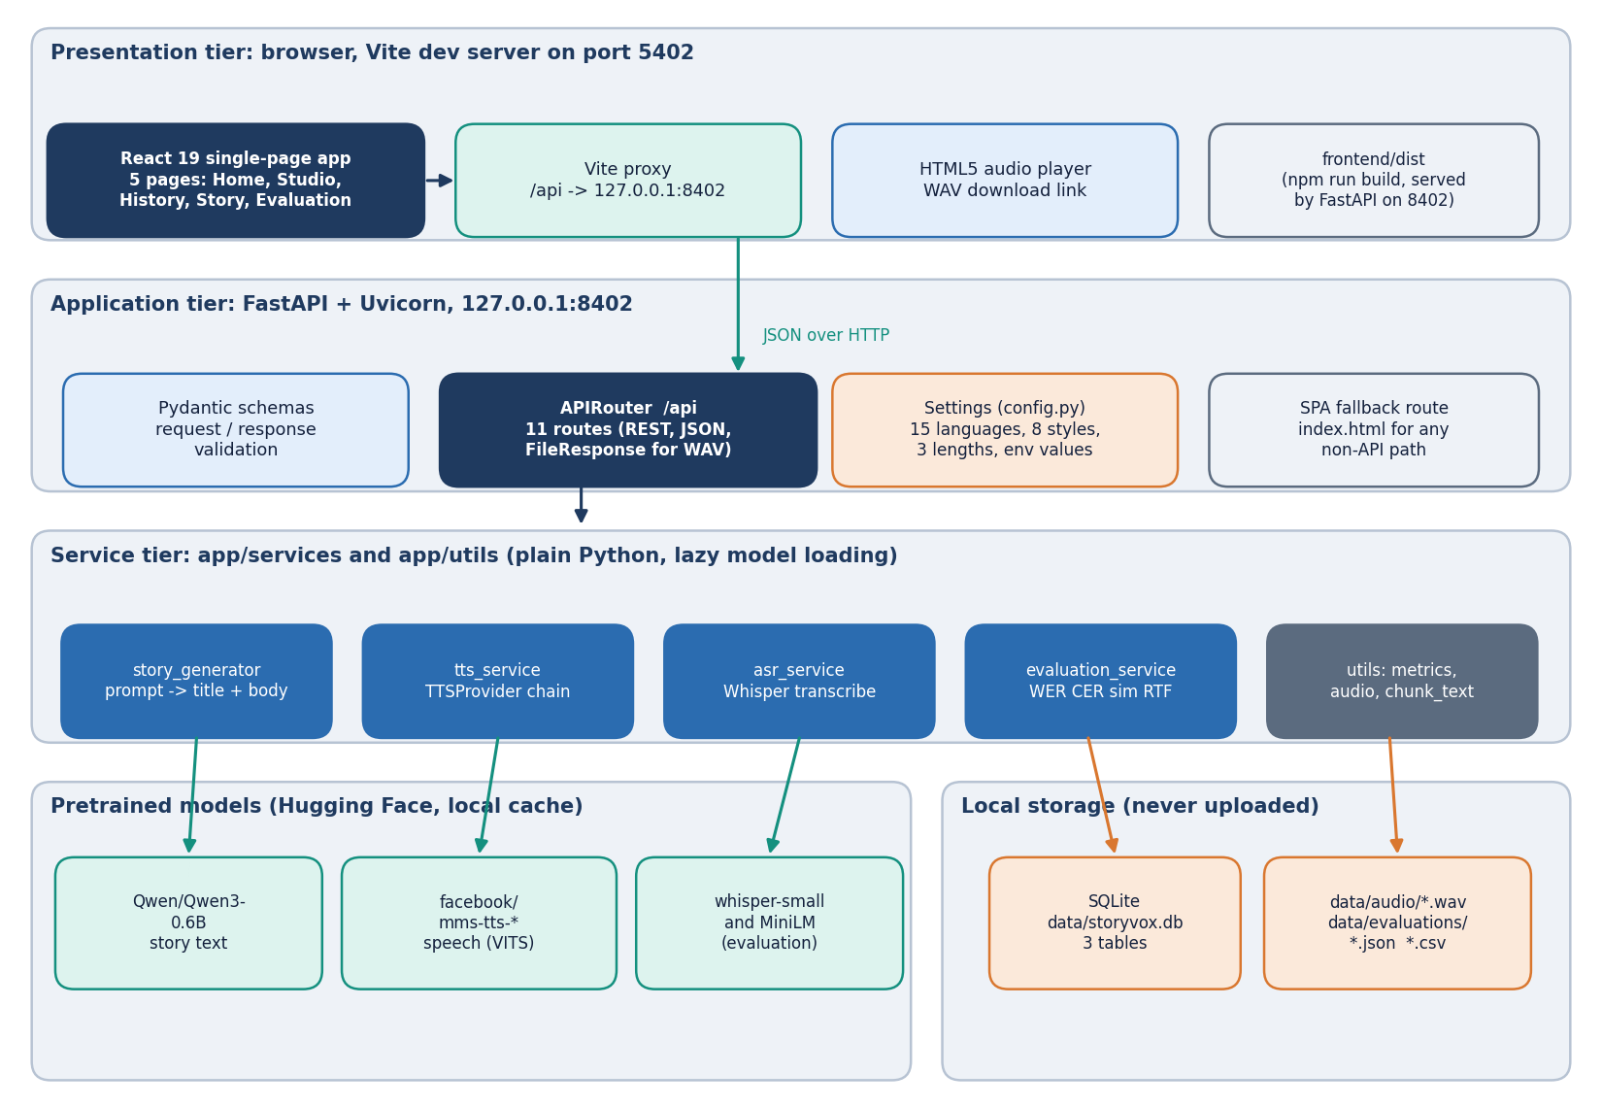
Figure 1: Layered architecture of StoryVox: React console, FastAPI application with 11 API routes, the service layer, pretrained models, SQLite and WAV storage.
In development the React application is served by Vite on port 5402 and the Vite proxy forwards every /api request to the FastAPI application on 127.0.0.1:8402; in production npm run build writes frontend/dist, and the same FastAPI process serves the built files, with a fallback route that returns index.html for any path that is not an API route or an asset, so the browser always sees one origin. For that reason the application defines no cross-origin rules. The application has one router with 11 routes. Settings come from environment variables (read on every instantiation so that tests can isolate them), the models are loaded lazily on first use under a lock and cached in module variables, and a request that arrives while a model is loading simply waits for the lock.

5.2 High-level workflow
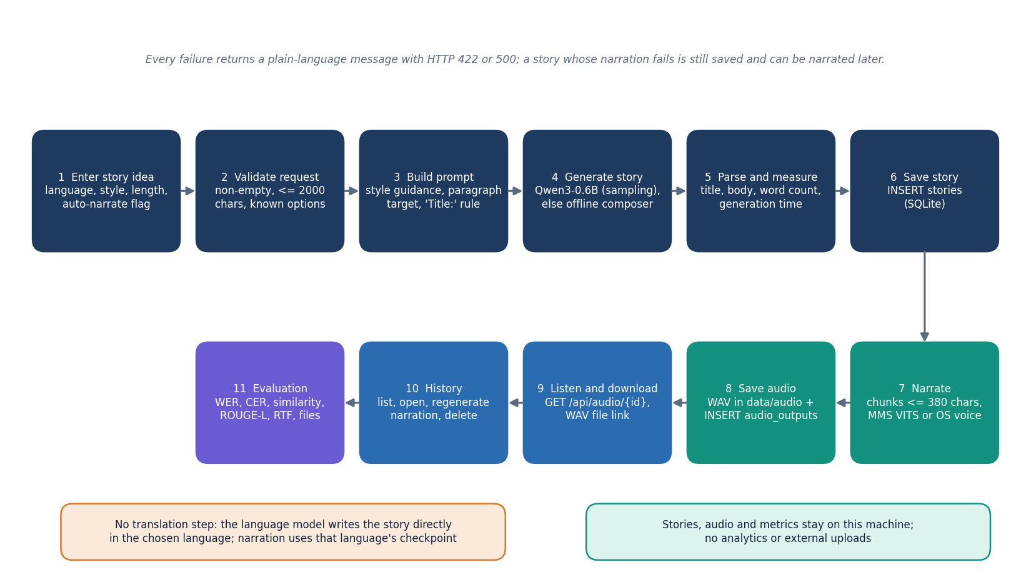
Figure 2: End-to-end workflow: enter an idea, validate, build the prompt, generate, parse, save, narrate, store the audio, play, manage history and evaluate.
The workflow has seven stages. Validate: the route rejects an empty or over-long idea and an unknown language, style or length. Prompt: the service builds one instruction that names the style, the language, the paragraph target (3, 5 or 8) and the rule that the first line must start with Title:. Generate: the language model samples at temperature 0.8 and top-p 0.9 up to 220, 420 or 700 new tokens; if it cannot be loaded or returns fewer than 20 words, the offline composer writes the story. Save: the title, body, word count and generation time become a stories row. Narrate: the text is cut into chunks of at most 380 characters at sentence ends, every chunk is synthesised, normalised to a peak of 0.9 and joined with 0.25 s pauses, and the WAV file and an audio_outputs row are written. Play and manage: the browser plays and downloads the audio; History lists, opens, re-narrates and deletes. Evaluate: the Evaluation page runs the loop of Section 5.6.
Two properties of this workflow matter for the results in Chapter 8. There is no translation step: the language is a word in the prompt and nothing checks that the output is in that language. And narration depends only on the language code, not on the language of the text, so a story that came out in English is read by the checkpoint of whatever language was requested.

5.3 Data flow diagrams

5.3.1 Level 0: context
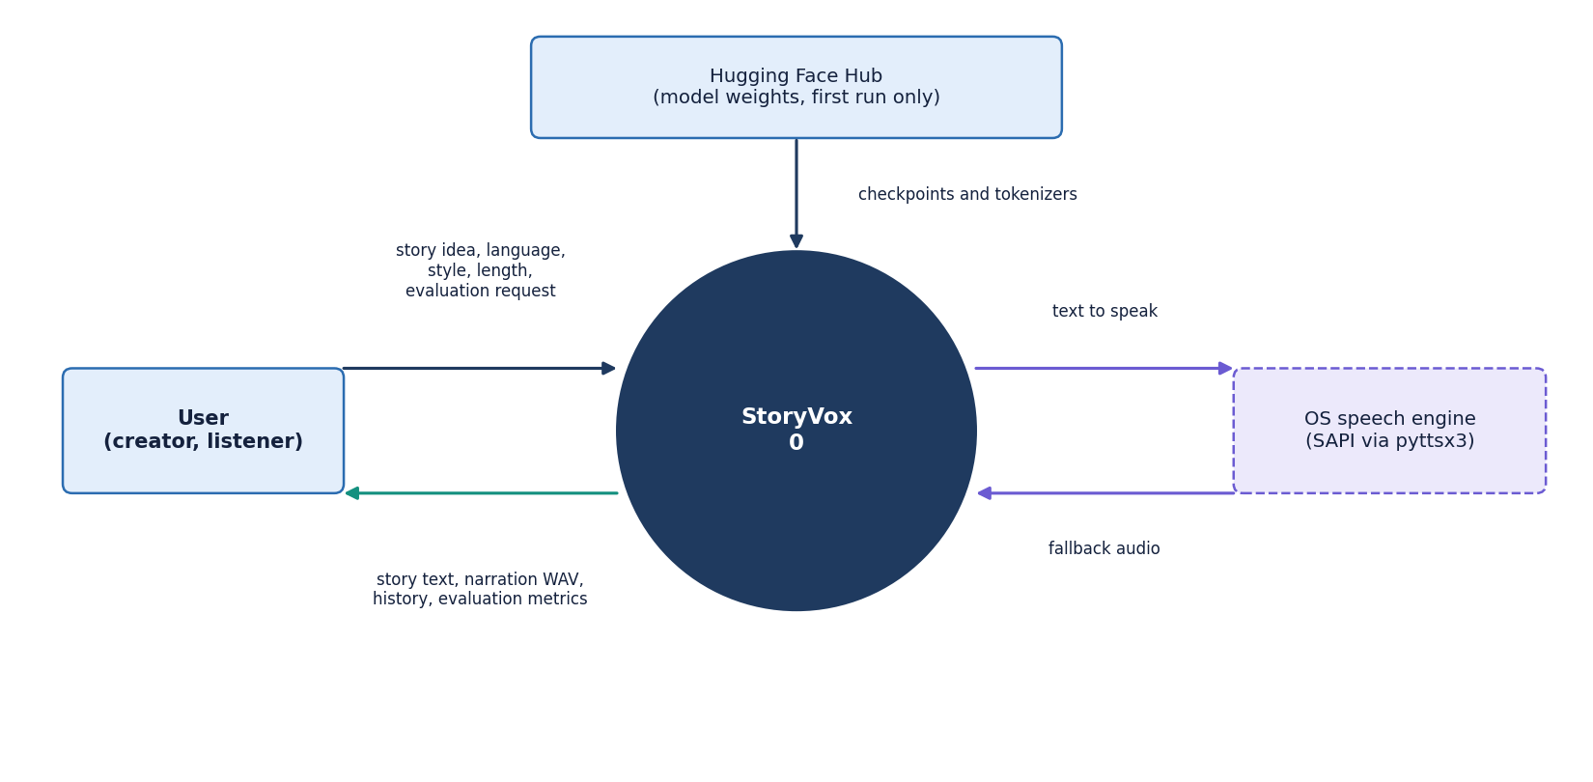
Figure 3: Context diagram (DFD level 0): StoryVox as one process with the user, the Hugging Face Hub and the operating-system speech engine.
At level 0 StoryVox is one process with three external entities. The user supplies story ideas, choices and evaluation requests and receives stories, audio, the story list and metrics. The Hugging Face hub is the source of model weights and tokenizers; it is contacted only when a model is not yet in the local cache. The operating-system speech engine receives text and returns audio only when the neural checkpoint cannot be used. No analytics service and no cloud storage appear because the product does not use them.

5.3.2 Level 1: five processes
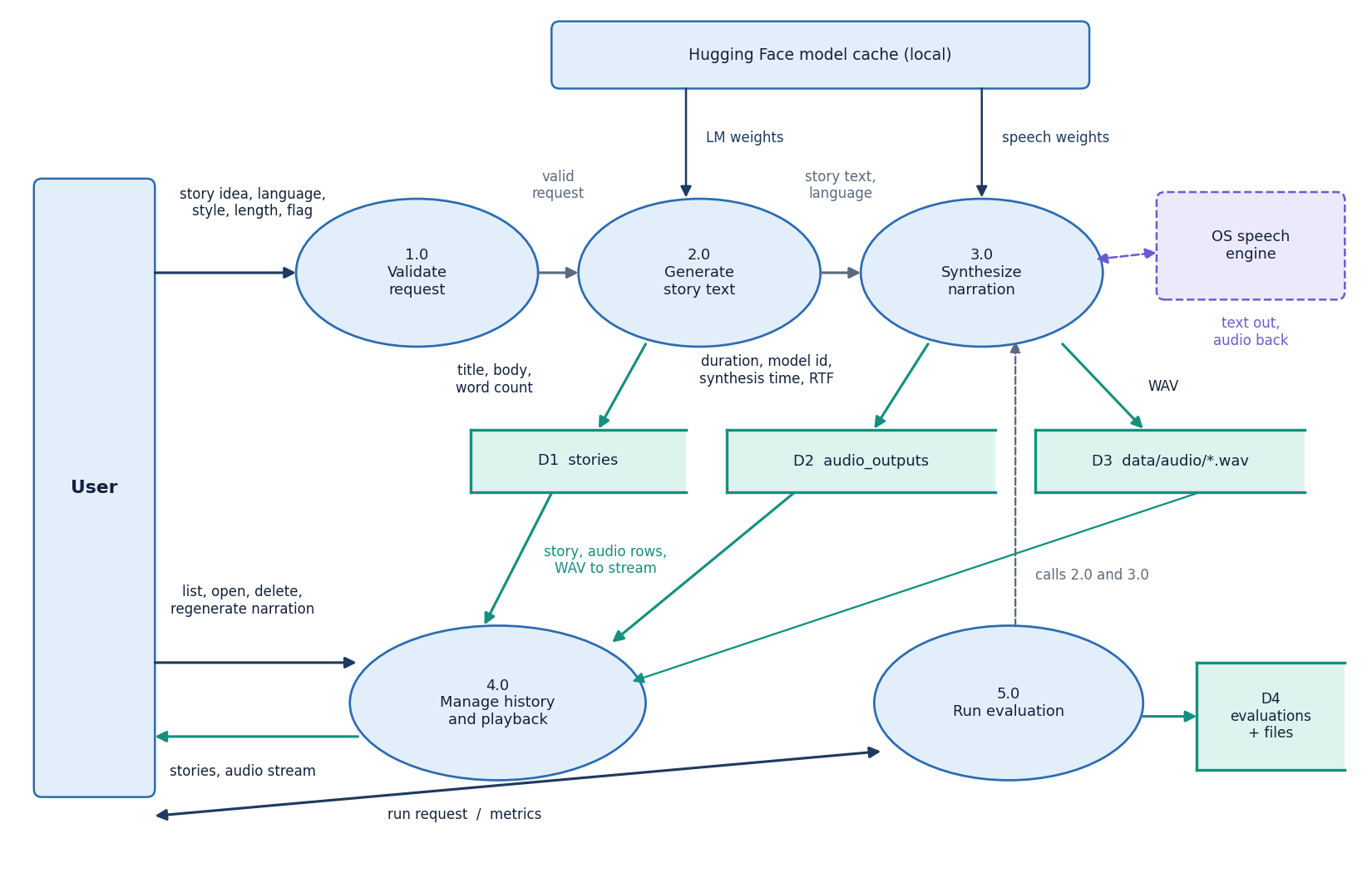
Figure 4: DFD level 1: five processes (validate, generate story, synthesise narration, manage history, run evaluation) and the data stores D1 to D4.
Level 1 shows the five processes and four data stores. 1.0 Validate checks the request. 2.0 Generate story writes the title, body and word count to D1 (stories). 3.0 Synthesise narration writes the WAV file to D3 (audio folder) and the duration, model id, synthesis time and real-time factor to D2 (audio_outputs). 4.0 Manage history reads D1, D2 and D3 to list, open, stream and delete stories and to regenerate narration. 5.0 Run evaluation calls processes 2.0 and 3.0 on built-in prompts, transcribes the audio and writes the metrics to D4 (one evaluations row plus a JSON and a CSV file).

5.3.3 Level 2: narration
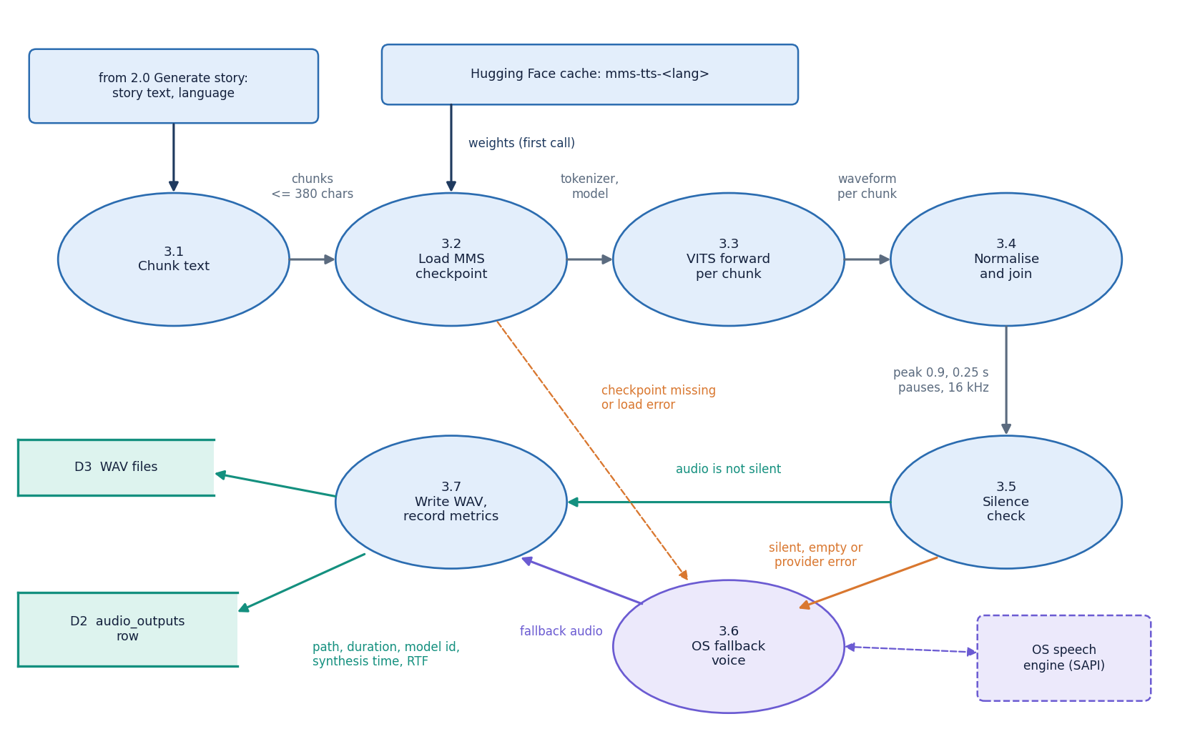
Figure 5: DFD level 2: process 3.0 expanded into seven sub-processes, from chunking to the written WAV file, including the silence check and the fallback voice.
Narration is expanded to level 2 because it is where the product can fail and where most of the measured time goes. Seven sub-processes take the story text to a stored WAV file: chunking, loading the checkpoint once and caching it, running the VITS model on each chunk, normalising and joining, rejecting empty or silent audio, the operating-system fallback, and computing the duration and real-time factor. A silent result, an empty result or any load or inference error sends the text to the fallback; the fallback's result is resampled to 16 kHz so that the rest of the system sees one format.

5.4 UML design

5.4.1 Class diagram
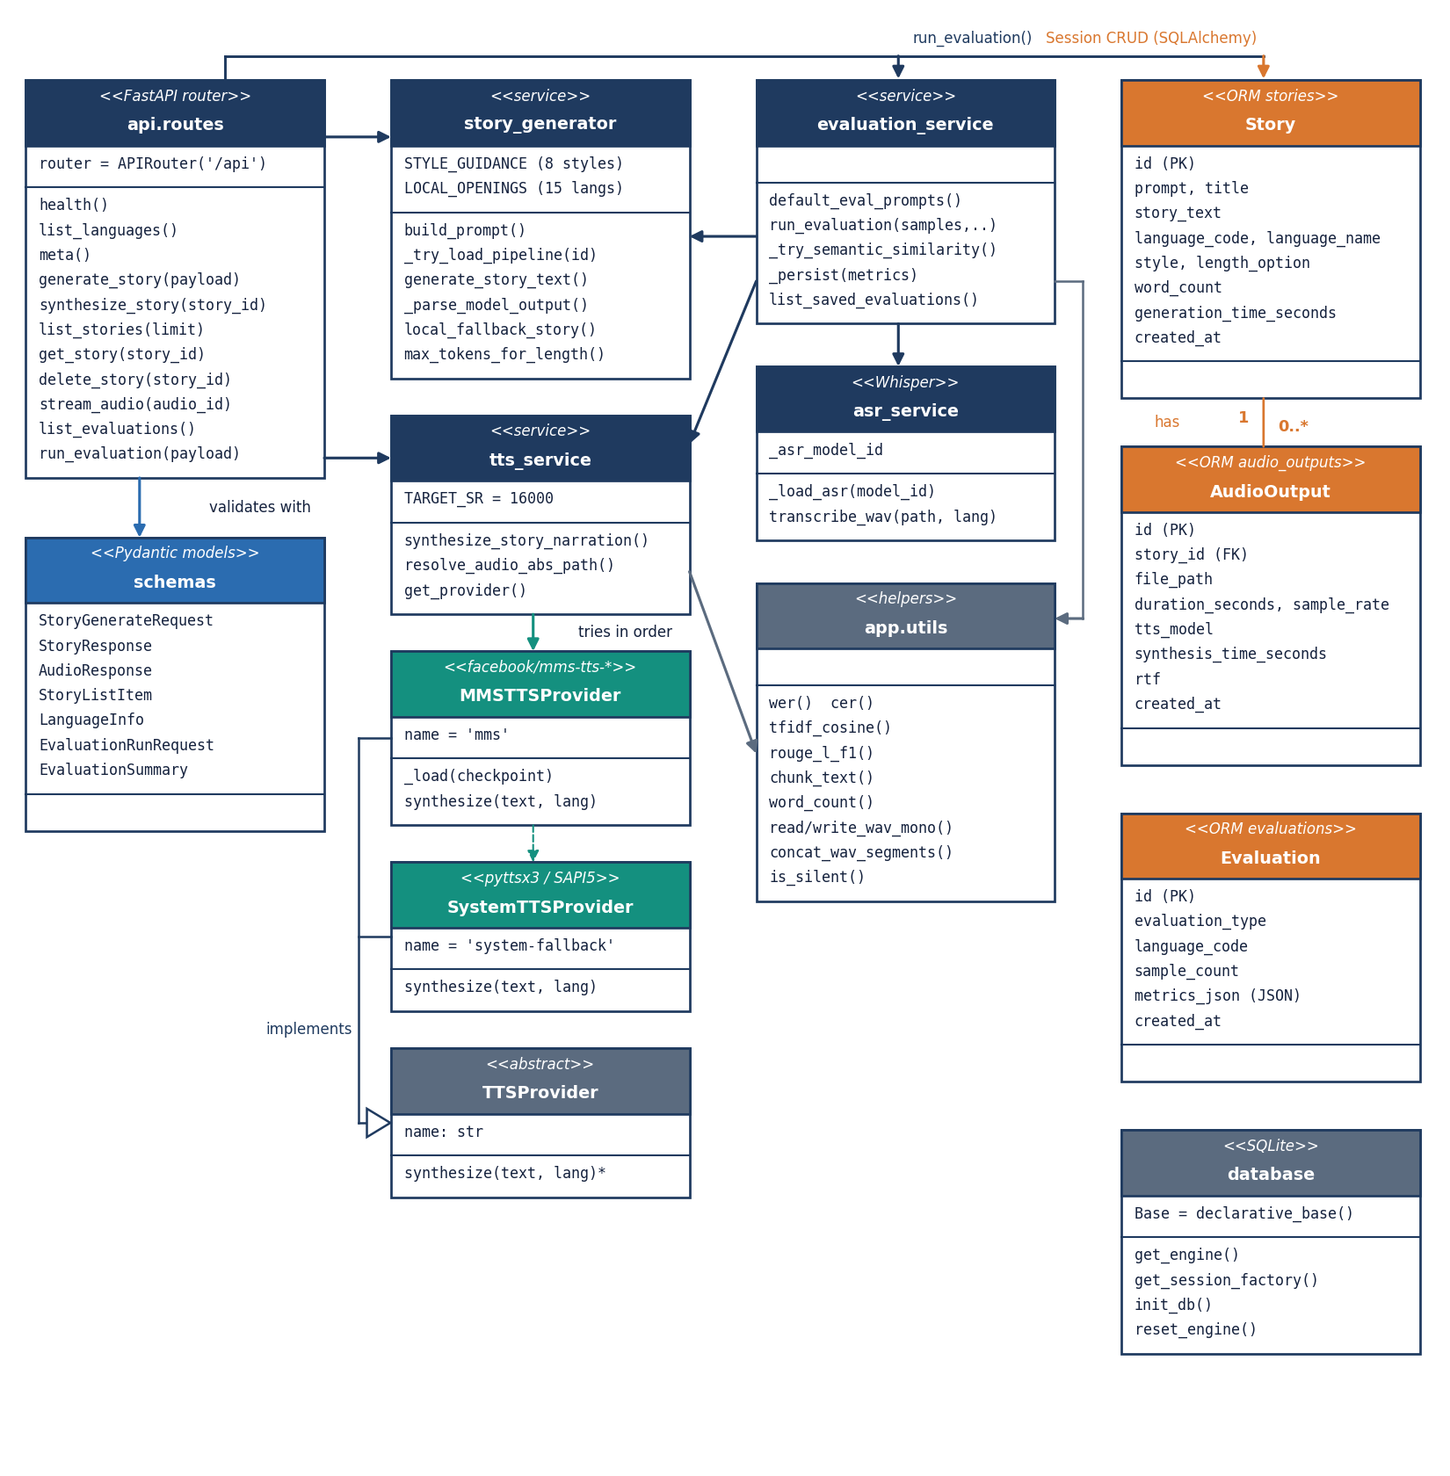
Figure 6: UML class diagram: API routes and schemas, the story and speech services with the TTSProvider hierarchy, evaluation and helper modules, and the three ORM classes.
Most of the code base is modules of functions, which suits a pipeline in which each step takes text or audio and returns text or audio; the diagram draws each module as a class-like box. The real classes are the abstract TTSProvider with its two implementations MMSTTSProvider and SystemTTSProvider, the Pydantic schemas of the API, and the three ORM classes. Story owns zero or more AudioOutput objects through a cascading relationship; Evaluation stands alone and keeps its metrics in one JSON column.
Table 14: Principal modules and the data they pass on.
Module | Takes | Returns
story_generator | Idea, language code, style, length | Title, body, model id, elapsed seconds
tts_service | Story text, language code | Relative WAV path, duration, sample rate, model id, synthesis time, RTF
asr_service | WAV path, language code | Transcript text
evaluation_service | Sample count, optional language, skip flags | Metrics dictionary with averages and per-sample rows; JSON and CSV files
utils.metrics | Reference and hypothesis text | WER, CER, TF-IDF cosine, ROUGE-L
utils.audio | Waveform arrays, WAV paths | Joined audio, resampled audio, silence decision

5.4.2 Sequence diagram
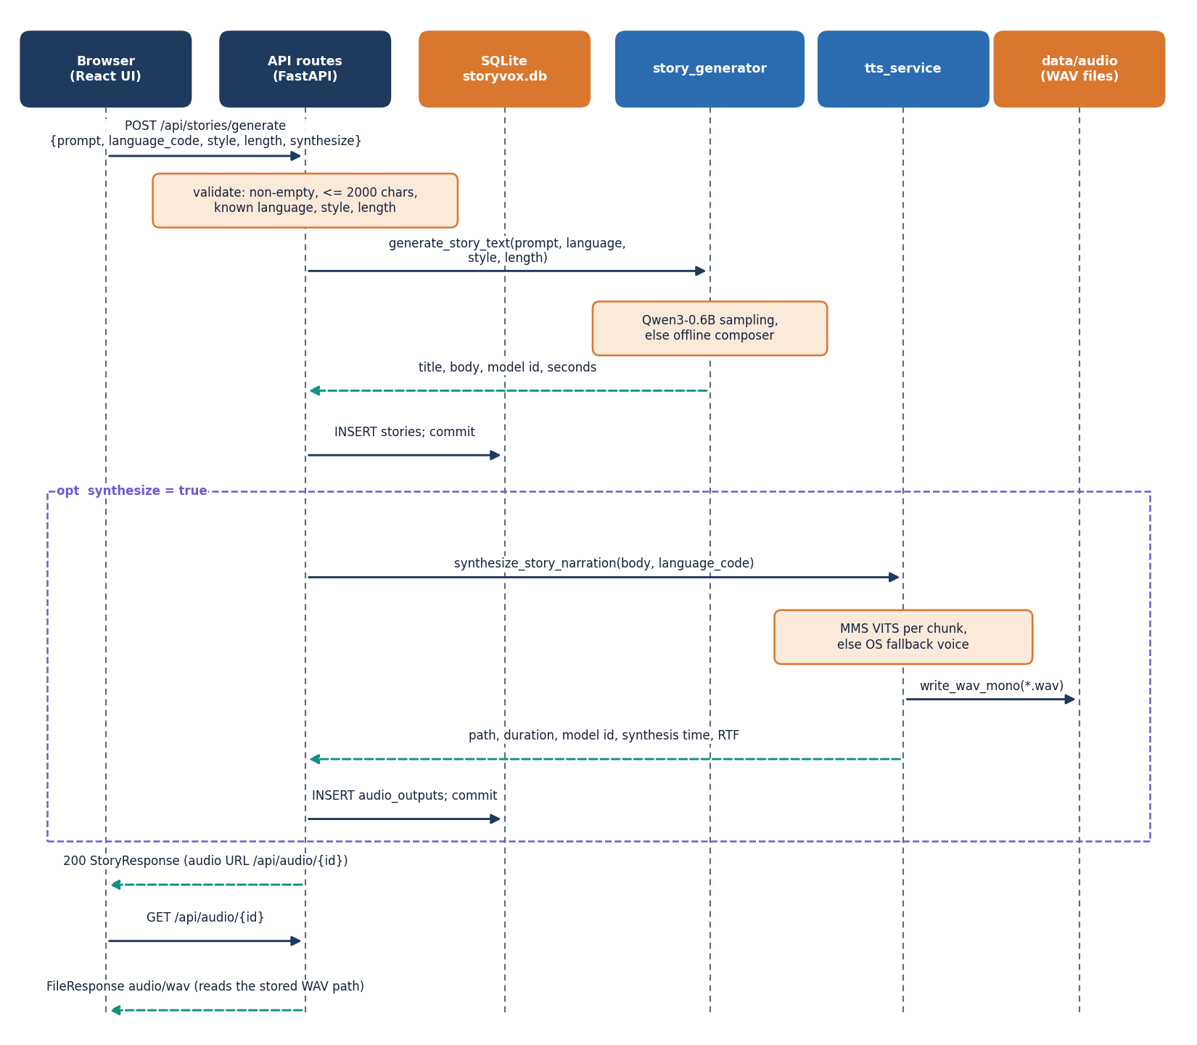
Figure 7: Sequence diagram of POST /api/stories/generate with narration, followed by the audio request.
The sequence follows POST /api/stories/generate with narration. The route validates the request, calls generate_story_text, inserts the stories row and then, if synthesize is true, calls synthesize_story_narration and inserts the audio_outputs row. If narration raises an error the story is still saved and returned without audio so that it can be narrated later through POST /api/stories/{id}/synthesize. The measured end-to-end time of this call for a Short story was 36.8 s in the length experiment, of which 22.1 s was generation, and the browser then fetches the audio with GET /api/audio/{id}.

5.4.3 Use-case diagram
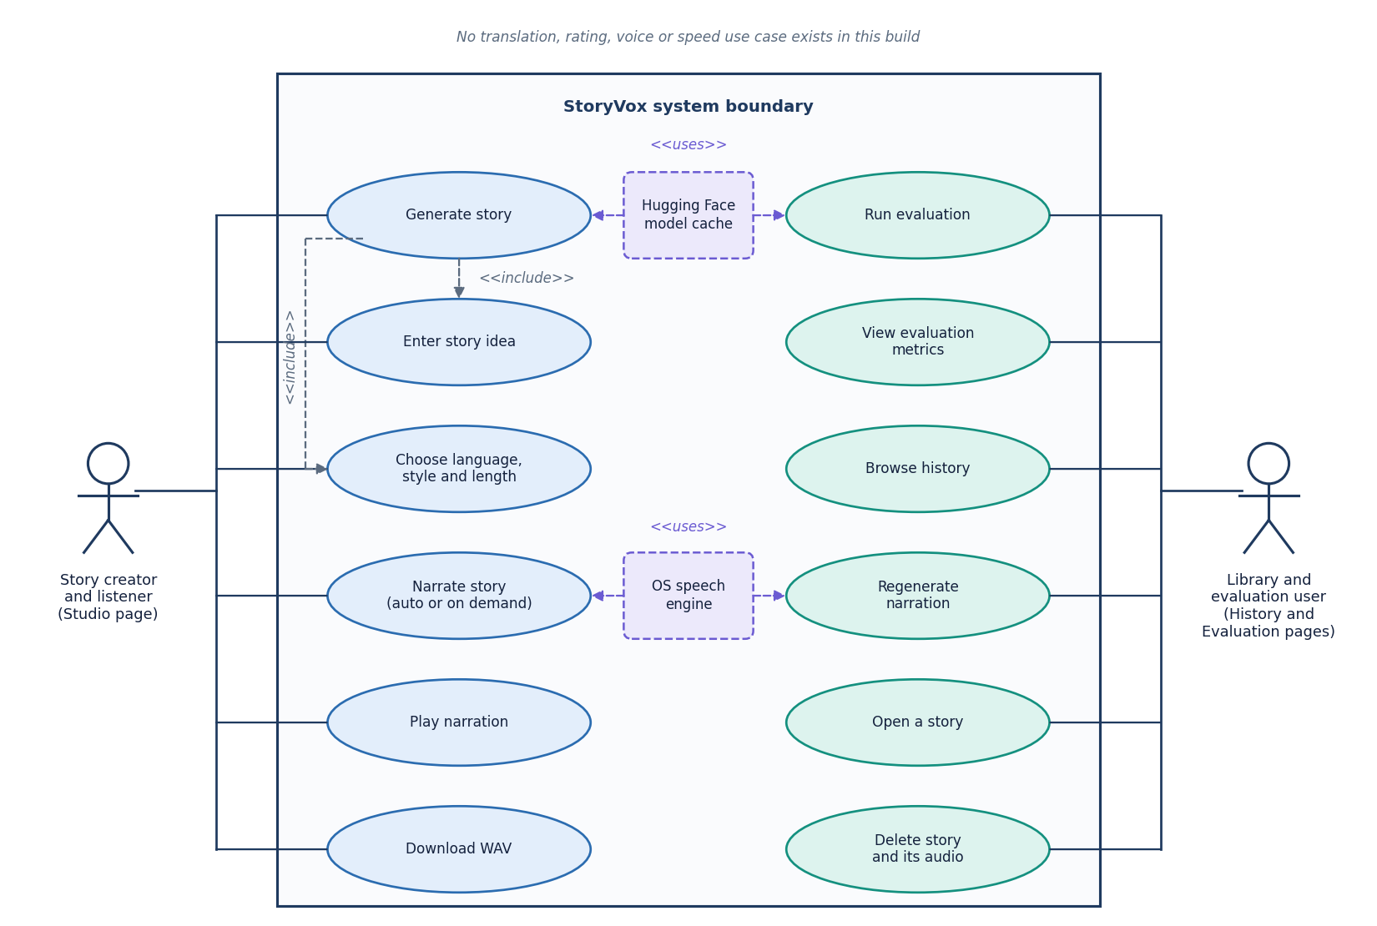
Figure 8: Use-case diagram: the story creator and the library and evaluation user, twelve use cases, and the model cache and speech engine as supporting systems.
The product has no accounts, so the two actors are roles of the same local user. The story creator works in the Studio: enters an idea, chooses language, style and length, generates, narrates, plays and downloads. The library and evaluation user works on History, Story and Evaluation: browses, opens, regenerates narration, deletes, runs an evaluation and reads the metrics. The model cache and the operating-system speech engine are supporting systems. Translation, rating, voice choice, speed control and reference-audio upload are not use cases of this build.

5.5 Database design
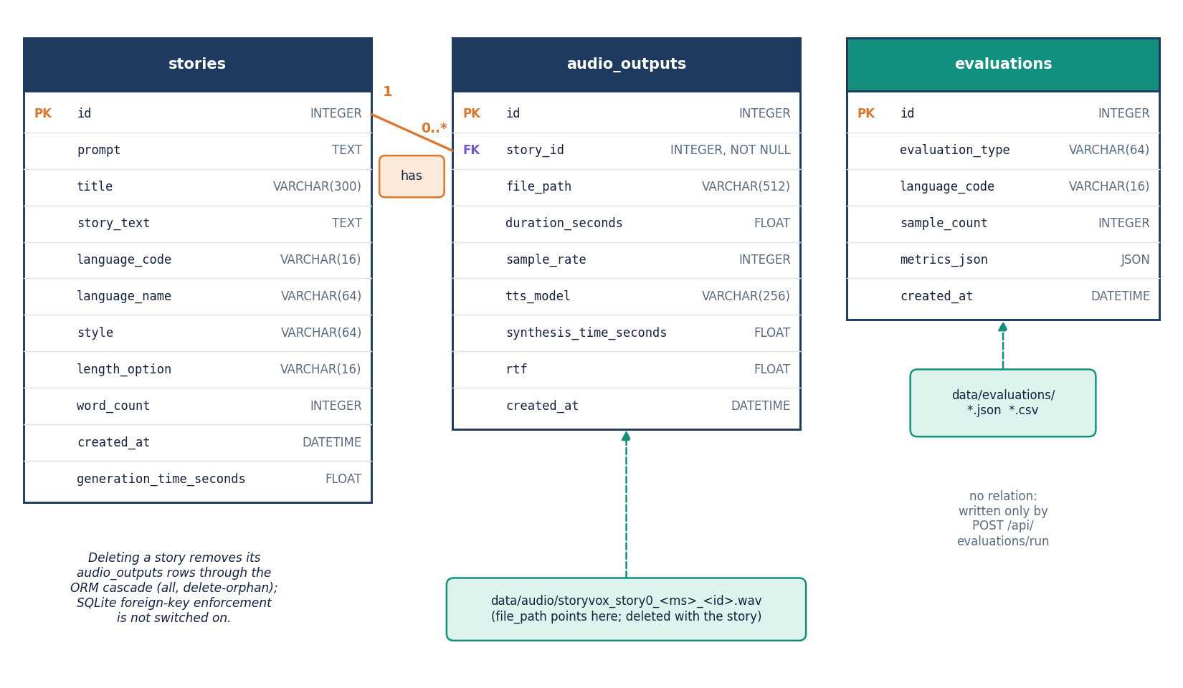
Figure 9: Entity-relationship diagram of the SQLite database: stories (1) to audio_outputs (0..*), and the stand-alone evaluations table.
The database data/storyvox.db has three tables created by SQLAlchemy at start-up. The tables and their columns are listed below. A story can have several narrations because regenerating narration adds a row instead of replacing one.
Table 15: Tables of the SQLite database.
Table | Columns | Notes
stories | id, prompt, title (300), story_text, language_code, language_name, style, length_option, word_count, created_at, generation_time_seconds | One row per generated story; title and body are stored as the parser produced them
audio_outputs | id, story_id (foreign key), file_path, duration_seconds, sample_rate, tts_model, synthesis_time_seconds, rtf, created_at | One row per narration; tts_model is the speech checkpoint or system-tts-offline-fallback
evaluations | id, evaluation_type, language_code, sample_count, metrics_json (JSON), created_at | Stand-alone; the same payload is written to data/evaluations as JSON and CSV

The foreign key is declared with ON DELETE CASCADE and the ORM relationship cascades deletes, but SQLite does not enforce foreign keys unless the pragma is switched on, and the application does not switch it on; deleting a story therefore removes its audio rows through the ORM, not through the database, and the delete route also removes the WAV files. Three folders persist across restarts: data/audio (WAV files), data/evaluations (JSON and CSV) and data/datasets (created at start-up and not used by any route). The .gitignore excludes the database, the audio and the evaluation files.

5.6 Core algorithm design
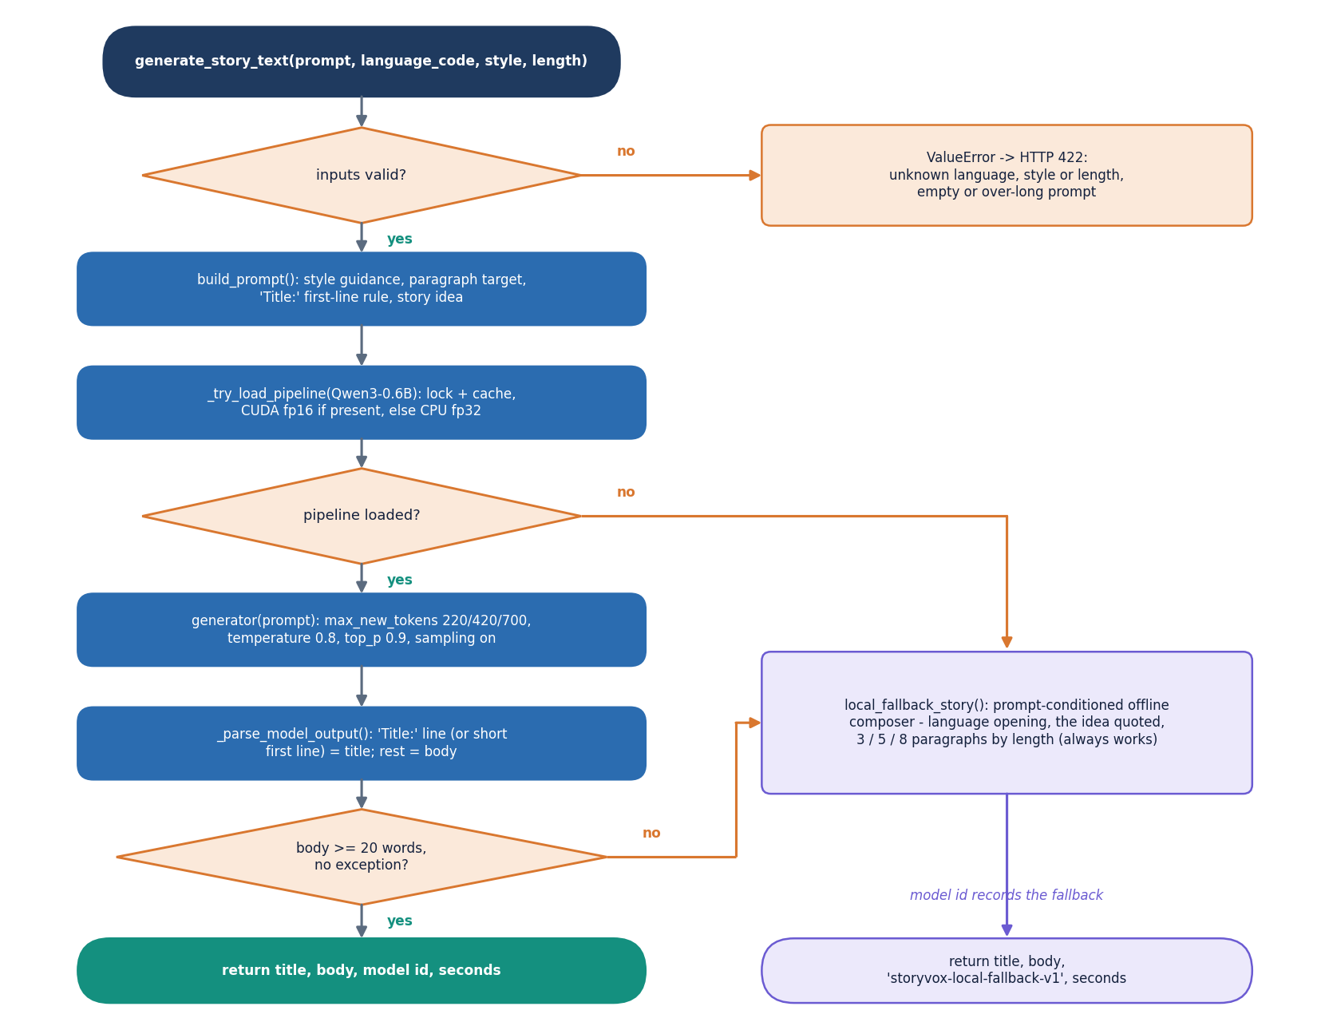
Figure 10: Flowchart of generate_story_text: validate, build the prompt, load the model once, sample, parse, check the length and otherwise use the offline composer.
The story algorithm is a short chain with two guards. Input guards reject an unknown language, style or length, an empty idea and an idea over 2,000 characters before any model runs. The output guard is the 20-word rule: a body shorter than 20 words, or any exception in the pipeline, switches to the offline composer, which always returns a story that quotes the idea, and the model id returned to the caller says which path produced the text. The parser takes a Title: line (or a short first line) as the title and the rest as the body; when neither exists the title is Untitled Story. A consequence, measured in Chapter 8, is that the guard checks length only, not language, not instruction echo and not narrative quality.
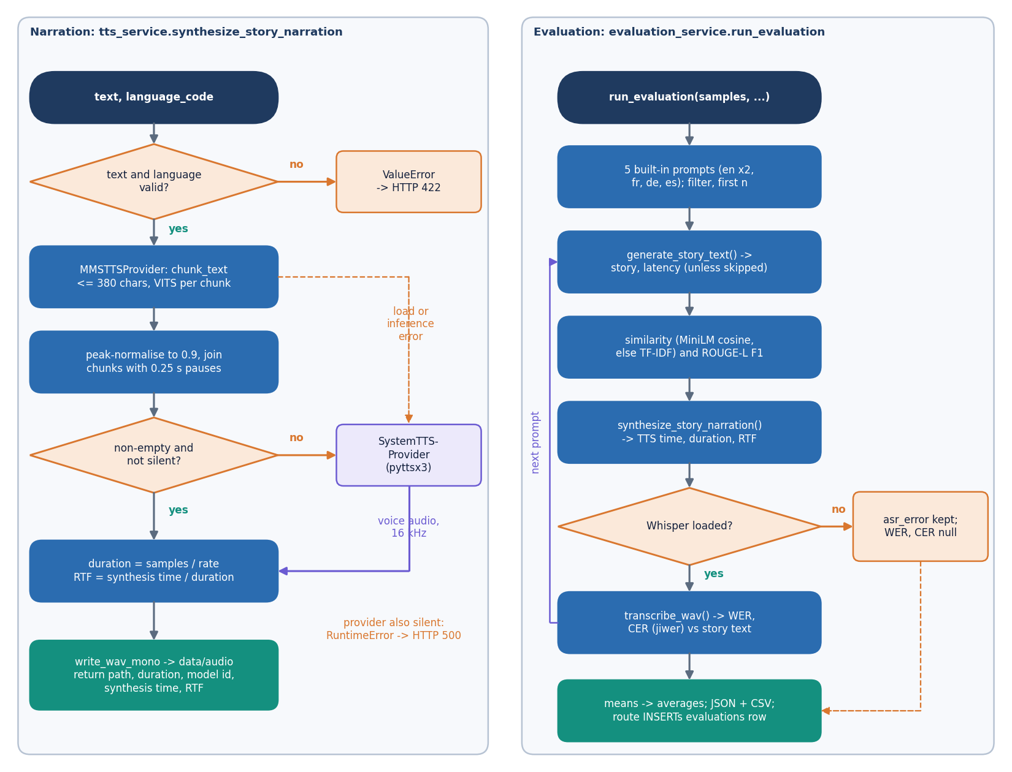
Figure 11: Left: the narration provider chain with its silence check and fallback. Right: the evaluation loop that produces WER, CER, similarity, ROUGE-L and RTF.
On the left of the second flowchart, narration tries the neural provider first and the operating-system provider second, and applies the silence test to whatever comes back; the real-time factor is synthesis time divided by audio duration. On the right, the evaluation takes the first n of five built-in prompts (English adventure, English bedtime, French fantasy, German inspirational, Spanish mystery), generates and narrates a story for each, computes the prompt-story similarity and ROUGE-L, transcribes the audio with Whisper and computes WER and CER against the story text. If the recogniser raises an error the message is stored in the row and WER and CER stay empty, which is exactly what happened for story-length audio in this project (Chapter 8).
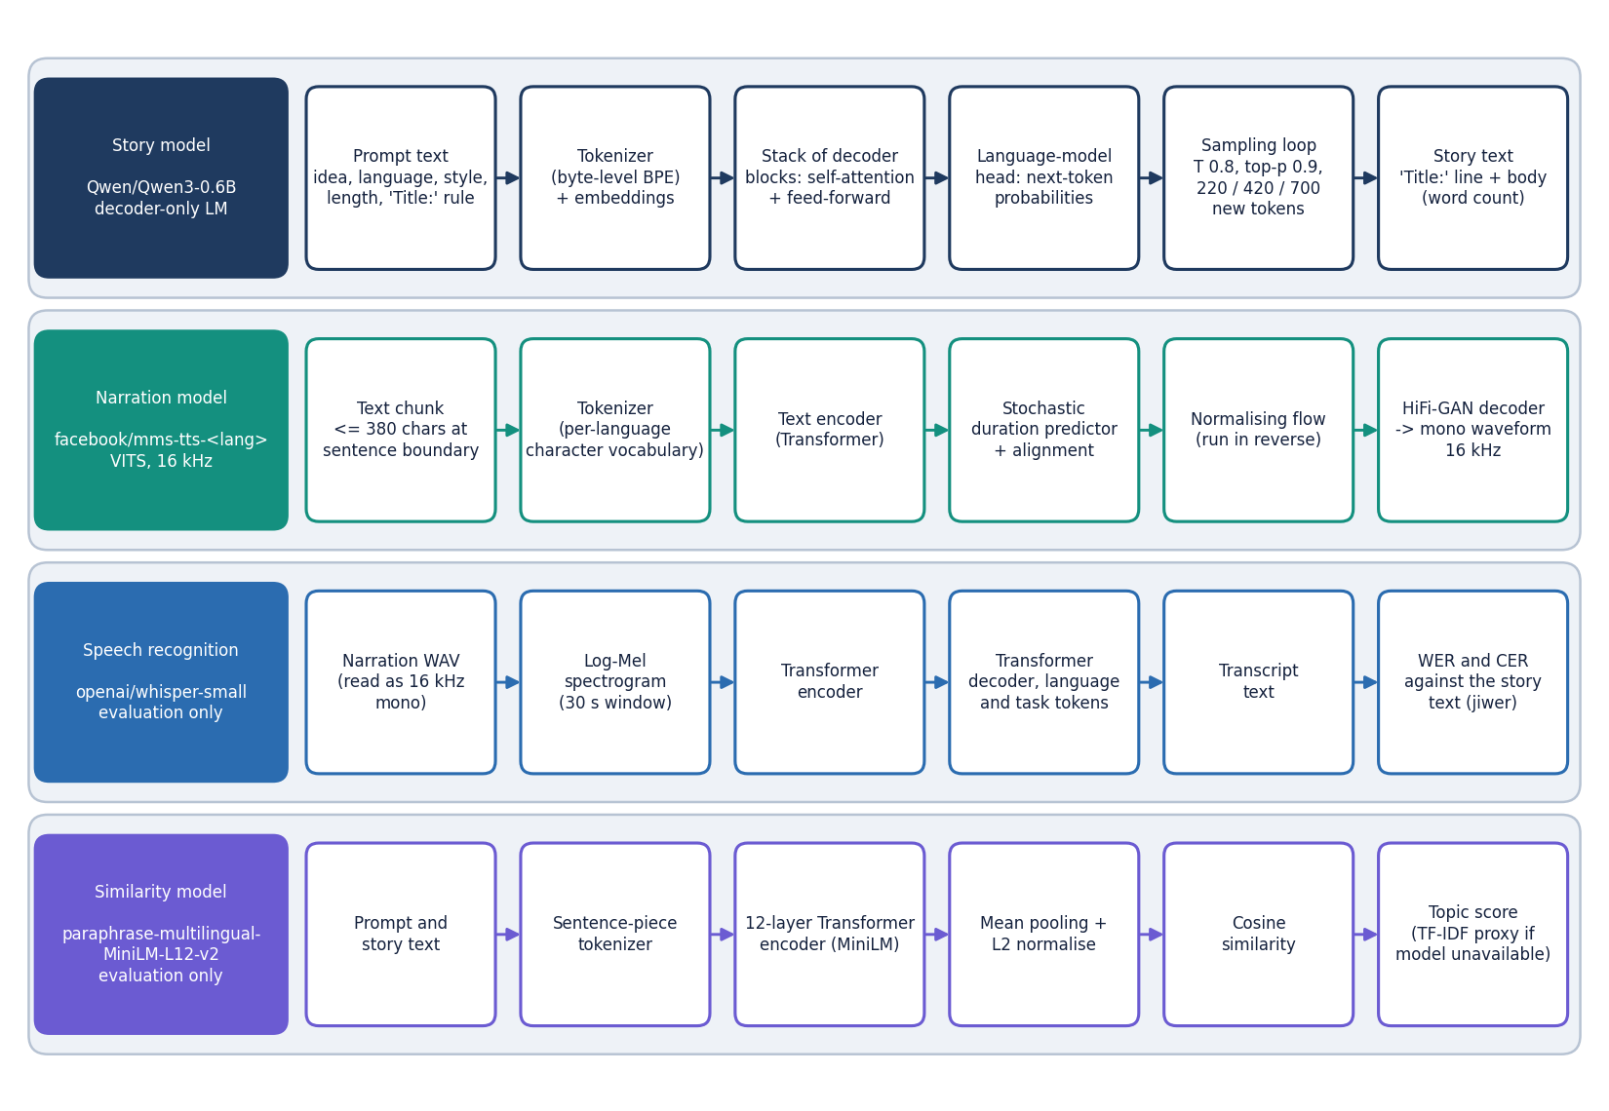
Figure 12: The four pretrained models used by StoryVox, each shown as its processing chain: Qwen3-0.6B, MMS-TTS (VITS), Whisper-small and multilingual MiniLM.
StoryVox trains no model. The Qwen3-0.6B decoder continues the prompt token by token; each MMS checkpoint is a VITS model whose text encoder, duration predictor and flow produce a latent representation that a HiFi-GAN decoder turns into a 16 kHz waveform [9], [10]; Whisper-small and the multilingual MiniLM encoder are used only by the evaluation [11], [14]. Supporting a language means mapping its code to a checkpoint in app/config.py, which is also where the three non-existent checkpoints (Italian, Chinese, Japanese) are named.

5.7 Module design
The code is split so that each file has one reason to change. Line counts below were measured from the repository.
Table 16: Modules, sizes and responsibilities.
Module | Lines | Responsibility
app/main.py | 48 | Creates the FastAPI application, mounts the built web application and the single-page-app fallback route
app/config.py | 110 | Settings read from the environment; the 15 languages with their checkpoints, 8 styles and 3 lengths
app/database.py | 47 | SQLite engine, session factory, table creation and creation of the data folders
app/models/__init__.py | 60 | ORM classes Story, AudioOutput and Evaluation
app/schemas.py | 81 | Pydantic request and response models (generate request, story, audio, evaluation run)
app/api/routes.py | 254 | The 11 REST routes, validation and error mapping
app/services/story_generator.py | 185 | Prompt builder, lazily loaded Qwen3 pipeline, output parser, offline composer
app/services/tts_service.py | 180 | TTSProvider interface, MMS and operating-system providers, WAV writing
app/services/asr_service.py | 42 | Lazily loaded Whisper pipeline for the evaluation
app/services/evaluation_service.py | 174 | Built-in prompts, the measurement loop, JSON and CSV output
app/utils/__init__.py | 76 | Word count, reading time, sentence chunking, file-name helpers, directory guard
app/utils/audio.py | 71 | WAV read, write, resample, join with pauses, RMS and silence test
app/utils/metrics.py | 73 | WER, CER, TF-IDF cosine and ROUGE-L
frontend/src/ | 3,253 | React 19 application: 5 pages, in-house UI kit, charts, API client, theme and motion helpers
tests/ | 340 | 29 pytest tests (8 API tests, 21 unit and edge-case tests)
scripts/ | - | Experiment, measurement and screenshot scripts; the smoke test, the data download and the evaluation command line

5.8 API design
All routes live under /api. Reads are GET and actions are POST or DELETE. Failures return the FastAPI detail string, which the web application shows verbatim, so messages are written for the user: 'Please enter a story idea.' is what a 422 says. The status codes follow one rule: 422 means the request was understood but a value is not acceptable, 404 means a story, an audio record or a file is missing, and 500 means a model or the speech engine failed; the detail never contains a stack trace, which goes to the server log.
Table 17: The 11 routes of the StoryVox API (plus the single-page-app fallback).
Method | Path | Purpose | Errors
GET | /api/health | Liveness check: status, application name, whether CUDA is available, server time | -
GET | /api/languages | The 15 supported languages with their speech checkpoints | -
GET | /api/meta | Styles, lengths, story model name and recogniser model name | -
POST | /api/stories/generate | Validate, generate a story, save it and (if asked) narrate it; returns the story with its audio record | 422 empty, over-long, unknown language, style or length; 500 model failure
POST | /api/stories/{id}/synthesize | Narrate a saved story again and add an audio record | 404 unknown story; 422; 500 narration failure
GET | /api/stories | Stories, newest first, with an audio flag; limit 1 to 200 (default 50) | 422 limit out of range
GET | /api/stories/{id} | One story with reading time, listening time and the latest audio | 404
DELETE | /api/stories/{id} | Delete the story, its audio rows and the WAV files inside the audio folder | 404
GET | /api/audio/{id} | Stream the stored WAV file as audio/wav with a download file name | 404 record or file missing; 400 invalid stored path
GET | /api/evaluations | Saved evaluation runs (50 newest rows; if the table is empty, up to 20 JSON files on disk) | -
POST | /api/evaluations/run | Run the measurement loop (samples 1 to 30, optional language, skip narration, skip story) and save the result | 422 unknown language; 500 failure

POST /api/stories/generate is the main route. Its body has the idea, the language code, the style, the length option and a synthesize flag (default true). The response is a StoryResponse with the story, its word count, reading and listening time, the generation time and, when narration ran, an audio object whose file_path is the URL /api/audio/{id}. Interactive documentation is generated by FastAPI at /docs.

5.9 User interface design
The web application has five pages: a public Home page, the Studio, History, a Story page and Evaluation, plus a not-found page. Pages are loaded lazily so that the Home page does not pay for the charts. The visual language is a flat, high-contrast grid with thick borders, one accent colour and monospace labels; a light and a dark theme are available from every page, and the choice is kept in browser storage guarded by try and catch.
Table 18: Application pages and the endpoints they use.
Page | Route | Endpoints used
Home | / | None (public page)
Studio | /studio | GET /api/languages, /api/meta; POST /api/stories/generate; GET /api/stories/{id} (to restore ?story=)
History | /stories | GET /api/stories?limit=100, /api/audio/{id}; DELETE /api/stories/{id}; the shell reads /api/languages, /api/meta, /api/health once
Story | /stories/:id | GET /api/stories/{id}, /api/audio/{id}; POST /api/stories/{id}/synthesize
Evaluation | /evaluation | GET /api/evaluations; POST /api/evaluations/run

5.10 Design decisions and trade-offs

CHAPTER 6: METHODOLOGY AND SOFTWARE IMPLEMENTATION

6.1 Overall methodology
StoryVox treats story narration as a cascade of pretrained models joined by ordinary software: a language model writes the text, a speech model reads it aloud, and, for the evaluation only, a recogniser and a sentence encoder measure the result. The base paper [1] takes the opposite route for its task: it trains one end-to-end model (an mBART encoder-decoder with self-paced learning, a sparse mixture of experts and data-augmented self-training) to turn text in one language into speech in another, and reports translation quality by BLEU. StoryVox shares the goal of multilingual speech output and nothing of the method; it trains no model, so its methodology is a pipeline design and an evaluation protocol. The method has eight steps.
1. Validate. Reject an empty idea, an idea over 2,000 characters and an unknown language, style or length before any model runs.
2. Prompt. Build one instruction from the style guidance, the language name, the paragraph target and the title rule, followed by the user's idea.
3. Generate. Sample the story from Qwen3-0.6B [12] with the length-dependent token budget; use the offline composer if the model is unavailable, fails, or returns fewer than 20 words.
4. Parse and save. Take the Title: line (or a short first line) as the title and the rest as the body; count the words; store the row with the model id and the generation time.
5. Chunk and narrate. Cut the body into chunks of at most 380 characters at sentence ends, synthesise each chunk with the MMS-TTS checkpoint of the language [10], [9], normalise, join with pauses, reject silence, and fall back to the operating-system voice if needed.
6. Store and play. Write the WAV file and the audio row (duration, model id, synthesis time, real-time factor); the browser streams it.
7. Evaluate. Transcribe the narration with Whisper-small [11] and compare with the source text (WER, CER); compare the story with the idea (sentence-encoder cosine, ROUGE-L [15]); record latency and real-time factor.
8. Report. Save every run as a database row and as JSON and CSV files; show the cards, the chart, the per-sample table and the method notes.

6.2 Dataset
StoryVox needs no dataset to run: the input is the user's idea. Datasets appear only in the evaluation. Narration is evaluated on FLEURS [16], Google's multilingual read-speech benchmark, using the text of its test split for the 15 languages of the application (English en_us, Hindi hi_in, Spanish es_419, French fr_fr, German de_de, Italian it_it, Portuguese pt_br, Russian ru_ru, Arabic ar_eg, Turkish tr_tr, Dutch nl_nl, Polish pl_pl, Mandarin cmn_hans_cn, Japanese ja_jp and Korean ko_kr). The dataset is released under CC BY 4.0; only the raw-transcription column of the test.tsv file is downloaded from the Hugging Face dataset repository, no audio is used and nothing is stored in the project. For each language the first 10 sentences that fit a length window (6 to 30 words; 12 to 70 characters for Chinese and Japanese, which have no spaces) and are not repeated were taken, giving 150 sentences in all.
Table 19: Data used in the measurements.
Item | Value
Evaluation text | FLEURS test split, 10 sentences per language, 15 languages (150 sentences), CC BY 4.0
Story-generation experiment | One idea ('A young inventor discovers a hidden library.'), Short length, 17 items: English with Adventure, Bedtime and Mystery plus the other 14 languages with Adventure; seed 0
Length experiment | The same idea in English, Adventure, at Short, Medium and Long
Built-in evaluation prompts | Five prompts (English x 2, French, German, Spanish) in evaluation_service.default_eval_prompts
API stories | 7 stories generated through the running API (en, en, hi, fr, de, es, en) and narrated; transcribed again with chunked Whisper
Training data | None: no model was trained or fine-tuned

Three properties of this data shape every result. FLEURS sentences are short (about 8 to 14 s of speech), so the narration results describe sentences and not whole stories; story-length audio was measured separately on only seven stories. The evaluation text consists of sentences taken from Wikimedia texts, which differ from the simple narrative English that the story model writes. And the story experiment uses a single idea, so it measures how the pipeline handles one prompt in many languages, not how it handles many prompts.

6.3 Preprocessing
There is no data cleaning in the usual sense; preprocessing is the handling of text and audio on the way through the pipeline. It is implemented in app/services/* and app/utils/* and is the same in the web application, the tests and the experiments.

6.3.1 Text handling
The route strips the idea, rejects it if empty or longer than 2,000 characters, and stores the stripped text. The model's raw output is parsed by _parse_model_output: a line of the form Title: ... is taken as the title (cut at 150 characters) and the text after it as the body; if there is no such line and the first line is shorter than 120 characters and followed by more lines, that line becomes the title with its leading #, * and spaces removed; otherwise the title is Untitled Story. Runs of three or more line breaks collapse to one blank line. The word count is the number of tokens matched by a Unicode word pattern, the reading time is the word count divided by 200 words per minute, and the listening time is the audio duration (or, without audio, the word count divided by 150).
The parser is the reason for a visible defect: with the raw prompt, the model rarely writes a Title: line, so the title is often Untitled Story, and when the model repeats the instruction the parser can take the repeated text as the title (one German evaluation sample was titled with the sentence "The title should include 'Brot' and 'Berg'..."). Chapter 8 counts how often the story text itself repeats the instruction.

6.3.2 Chunking
chunk_text collapses whitespace and splits at the end of a sentence (a full stop, question mark, exclamation mark, the Devanagari danda or the ideographic full stop followed by a space) and then packs whole sentences into chunks of at most 380 characters. A single sentence longer than the limit is cut into pieces of 380 characters (a 1,000-character word run becomes pieces of 380, 380 and 240 characters, which a unit test checks). Languages written without spaces after a full stop, such as Chinese or Japanese, therefore usually end up as one long sentence that is cut at 380 characters, possibly in the middle of a word.

6.3.3 Audio handling
Each chunk is synthesised separately. Its waveform is scaled so that its largest absolute value is 0.9, which levels the chunks against each other; the chunks are joined with 0.25 s of silence between them at 16,000 Hz; the result is rejected if its root-mean-square value is below 1e-4 (silence). Audio from the operating-system voice is read back from its temporary file, mixed to mono and resampled to 16 kHz by linear interpolation. The final signal is written as 16-bit PCM WAV.

6.3.4 Normalisation for scoring
The application's own WER and CER compare the story text and the transcript as they are, so capitalisation and punctuation count as errors. The experiments report these as the raw values and add normalised values: Unicode NFKC, lower case, punctuation and symbols removed, spaces collapsed, and for Chinese and Japanese the spaces removed altogether. For English the corpus-level normalised WER is 20.6% against a mean raw sentence WER of 26.2%; the normalised figures are the ones quoted in this report unless stated.

6.4 Prompt construction and sampling
The only control StoryVox has over the story is the prompt. build_prompt produces one string; for the idea used in the experiments it is exactly the text below (the line break is added for printing):
Write an original adventure story in English, full of discovery, movement, and courage. Target length: short (about 3 short paragraphs).
Start the first line with 'Title: ' followed by a short evocative title, then a blank line, then the story body only. Story idea: A young inventor discovers a hidden library.

Table 20: The controls that the prompt and the configuration expose.
Control | Values | Effect
Style (8) | Adventure, Fantasy, Educational, Bedtime, Mystery, Inspirational, Funny, Custom | A fixed phrase is inserted: for example 'full of discovery, movement, and courage' (Adventure) or 'calm, soothing, and comforting with a peaceful ending' (Bedtime)
Length (3) | Short, Medium, Long | Paragraph target 3, 5, 8 in the prompt; token budget 220, 420, 700 new tokens
Language (15) | en, hi, es, fr, de, it, pt, ru, ar, tr, nl, pl, zh, ja, ko | The language name is inserted in the prompt; the same code selects the speech checkpoint
Sampling | temperature 0.8, top-p 0.9, sampling on | Set in the environment; the same for all lengths

The prompt is passed to the text-generation pipeline as raw text, without the chat template that Qwen3 was tuned to expect, and return_full_text is false so that only the continuation is returned. This matters. A small instruction-tuned model given an instruction as plain text tends to continue it as a document, which in our runs produced instruction-like sentences ("The story should end with...") and text about the story rather than the story. To measure the effect the experiments add a second condition (B) that wraps the same prompt in the chat template with thinking disabled; it is not part of the product. In the 17 items, the share of sentences that repeat the instruction fell from 9.7% (condition A, as shipped) to 0.7% (B).
Sampling uses torch.manual_seed(0) in the experiments so that runs can be repeated; the product sets no seed. With the same seed, condition A produced almost the same English text for most languages, because the language word changes only a few tokens of a long prompt; the 17 items therefore show how often the model follows the language instruction, but they are not 17 independent stories.

6.5 Algorithm choice and justification
The choices were made for a machine without a graphics card. Qwen3-0.6B [12] is the smallest Qwen3 language model; it fits in 1.5 GB on disk and generates 9.1 tokens per second on the test CPU, which makes a three-paragraph story a matter of seconds and not minutes. MMS-TTS [10] offers one small VITS model [9] per language (145 MB each), so adding a language adds a file and not a retraining; VITS is a single-pass generator, which is why the mean real-time factor is 0.25. Whisper-small [11] is multilingual and, being used only to judge the narration, does not need to be the best recogniser. The multilingual MiniLM encoder [14] compares a prompt with a story in any of the 15 languages.
Larger systems were not used. OmniVoice [6] and XTTS [26] cover more languages or clone voices, but they are much larger models and running them on this CPU-only machine was outside the project, and the base paper's end-to-end model [1] was trained for 1.5 to 2 days on an A100 graphics card; we did not look for released weights. Whether the small choices are good enough is a measured question, and the measurements below show that the speech half is, while the text half is not.
Table 21: Story-generation conditions on the 17 items (Short length, same idea).
Measure | A: shipped (raw prompt) | B: chat template | C: offline composer
Mean latency (s) | 22.7 | 21.5 | < 0.001
Mean words | 178.6 | 152.6 | 96.3
Tokens per second | 9.14 | 9.28 | n/a
Story in the requested language | 17.6% | 47.1% | 17.6%
Sentences that repeat the instruction | 9.7% | 0.7% | 2.9%
Distinct-2 (variety) | 0.788 | 0.957 | 0.907
Idea-story similarity (MiniLM) | 0.549 | 0.580 | 0.680
ROUGE-L, idea vs. story | 0.054 | 0.045 | 0.135

Three readings follow. The language instruction is mostly ignored: with the shipped prompt only 18% of the stories were detected as being in the requested language (the English ones); the chat template raises this to 47%, still below half. The composer scores highest on similarity (0.68) only because it quotes the idea word for word, which is why similarity to the prompt cannot be read as quality. Speed is the same for A and B because the same model and token budget are used. The language detector is itself unreliable on very short or mixed text, so the match rates are indicative, not exact.
For speech the corresponding evidence is in Chapter 8: 12 languages are narrated by MMS-TTS with a mean normalised CER of 8.8% after a round trip through Whisper-small, and the best and worst are Spanish (2.1%) and Hindi (17.9%). This mixes the error of the speech model with that of the recogniser, whose own error on natural speech was not measured separately, so the speech figures are upper bounds on the narration error.

6.6 Mathematical formulation

6.6.1 Sampling
The language model gives, at each step, a score z_i to every token i of its vocabulary. With temperature T the probabilities are p_i = softmax(z / T). Nucleus sampling [21] keeps the smallest set V of tokens whose probabilities add up to at least top-p, renormalises inside V and draws the next token from it:
p_i = exp(z_i / T) / sum_j exp(z_j / T), V = smallest set with sum_{i in V} p_i >= top-p, token ~ p_i / sum_{j in V} p_j (1)
StoryVox uses T = 0.8 and top-p = 0.9. A higher temperature flattens the distribution and makes the text more varied and more error-prone; a lower one makes it repetitive.

6.6.2 Narration
Let the text be cut into chunks x_1 ... x_m and let s_k be the waveform of chunk k at 16,000 Hz. Each waveform is scaled to a peak of 0.9 and the chunks are joined with a pause of 0.25 s of zeros, so the duration of the narration is
s'_k = 0.9 * s_k / max|s_k|, audio = s'_1 || 0 || s'_2 || 0 || ... || s'_m, duration D = ( sum_k len(s_k) + (m - 1) * 0.25 * 16000 ) / 16000 (2)
The real-time factor is the synthesis time divided by the duration; values below 1 mean faster than real time:
RTF = T_synth / D (3)

6.6.3 Intelligibility metrics
For a reference text r and a recogniser transcript h, the word error rate is the word-level edit distance divided by the number of reference words; the character error rate is the same at character level:
WER = (S + D + I) / N_words(r), CER = (S + D + I) / N_chars(r) (4)
S, D and I are the substitutions, deletions and insertions of the minimum edit alignment. The application computes WER and CER with jiwer for each sample and averages them; the experiments also report a corpus value in which the edit counts and the reference lengths are first summed over all sentences of a language, which weights long sentences more and is the figure used for the language tables. WER can exceed 1 when the transcript is much longer than the reference.

6.6.4 Similarity and variety metrics
The idea-story similarity is the cosine of the sentence embeddings u (idea) and v (story) of the multilingual MiniLM encoder [14]; if the encoder cannot be loaded, the application falls back to a cosine of word-count vectors and says so in the row. ROUGE-L [15] is the F-measure of the longest common subsequence of the two texts. Distinct-2 is the share of different word pairs among all word pairs of a story (characters for text without spaces), a simple measure of repetition. The instruction-echo ratio is the share of the sentences of a story that contain a phrase from a fixed list of instruction fragments (for example 'the story should', 'blank line', 'title:').
cos(u, v) = u . v / (|u| |v|), Distinct-2 = |unique bigrams| / |bigrams|, echo = (sentences matching a fragment) / (all sentences) (5)
The language-match rate is the share of stories for which the langdetect library names the requested language. It was applied to texts of 100 to 200 words; it is reported as an indicator because the library can mislabel short or mixed-script text.

6.7 Model architecture and inference configuration
No model was trained or fine-tuned in this project, so there are no training curves, no loss, no learning rate and no hyper-parameter search to report. What the project fixes is the way pretrained models are run; the table lists every setting.
Table 22: Models and their inference settings.
Model | Role | Settings
Qwen/Qwen3-0.6B | Story text | transformers text-generation pipeline; float32 on CPU (float16 if CUDA is found); sampling on; temperature 0.8; top-p 0.9; max new tokens 220 / 420 / 700; raw prompt; loaded once under a lock (4.4 s from the cache)
facebook/mms-tts-* | Narration | VITS checkpoint chosen by language; tokenizer from the same repository; 16 kHz output; chunks of at most 380 characters; peak 0.9; pause 0.25 s; first load 1.8 s from the cache, 19 to 25 s when downloaded; one model per language kept in memory
System voice (pyttsx3) | Fallback narration | Operating-system voice at rate 170, text cut at 4,000 characters, WAV read back and resampled to 16 kHz; only English voices (David, Zira) existed on the test machine
openai/whisper-small | Recogniser (evaluation) | Transformers speech-recognition pipeline; language forced to the story language; task transcribe; no chunking in the product (chunk_length_s = 30 in the story-audio experiment); load 6.6 s
paraphrase-multilingual-MiniLM-L12-v2 | Similarity (evaluation) | Sentence-transformers encoder with normalised embeddings; re-created at every evaluation sample in the product; in the experiments loaded once

Two implementation details have consequences. The text pipeline is created with trust_remote_code=True, which allows code from the model repository to run at load time; this is a security trade-off, and we did not test whether the model loads without it. And the speech tokenizer for some languages (Korean) needs the uroman romaniser, which is not in requirements.txt; without it Korean text reaches the tokenizer unconverted.

6.8 Evaluation protocol
The protocol has five parts, each implemented by a script that calls the application's own services so that the numbers describe the shipped behaviour.
1. Narration round trip (scripts/run_experiments.py tts_asr). For each language, 10 FLEURS sentences are narrated through synthesize_story_narration, transcribed by Whisper-small with the language forced, and scored against the source sentence. The first sentence of a language is not discarded; model-load time is measured separately.
2. Chinese and Japanese fallback (run_experiments.py cjk). Because no MMS checkpoint exists for these two languages, each sentence is narrated in its own child process with a 90 s limit (the operating-system engine can hang on text it has no voice for) and scored the same way; 2 of 10 Chinese and 1 of 10 Japanese sentences were narrated.
3. Story generation (run_experiments.py story). The 17 items are generated under conditions A, B and C and scored with the measures of Section 6.6; a second part generates the Short, Medium and Long English story with condition B and narrates each with MMS (36.8, 60.4 and 79.9 s in total).
4. API measurement (scripts/measure_api.py). A running server is called 10 to 30 times on each cheap endpoint and seven times on POST /api/stories/generate with narration; the first call is cold. The seven stories remain in the database and feed the screenshots.
5. Story-length intelligibility (scripts/run_story_asr.py). The seven API stories and their WAV files are transcribed with chunked Whisper (30 s windows) and scored with normalised WER and CER, because the application's own evaluation cannot score audio longer than 30 s.
The application's built-in evaluation (POST /api/evaluations/run) was also run twice through the API (5 samples and 2 English samples) to populate the Evaluation page; both runs report WER and CER as empty, for the reason in Chapter 8. Tests are run with scripts/run_tests.py, which stores the pytest outcome (29 of 29 passed). The environment was CPU-only (Intel Core i5-12500, 15.7 GB), Python 3.11.9, PyTorch 2.14.1, Transformers 5.20.2, with other jobs running on the same machine, so timings are indicative.
Limits of the protocol. The narration scores include the error of the recogniser, which was not separated. Only ten sentences per language were used, so differences of a few points between languages are within the noise (for example, the 12 MMS languages range from 2.1% to 17.9% CER). No human listened to the audio and no human rated a story, so naturalness, coherence and narrative quality were not measured; the automatic story measures are proxies. One idea and one seed were used for the story experiment.

6.9 Application architecture
The product is one FastAPI service (app/main.py, port 8402) and one React 19 application built with Vite (port 5402 in development, served by the same service after a build). The service is organised around one idea: a route does only HTTP work. It validates the request with Pydantic and explicit checks, calls a service function, stores the result through a SQLAlchemy session and maps exceptions to status codes. The services hold the logic and the models, each loaded on first use and cached in a module variable behind a lock.
The narration service shows the pattern best. It tries the providers in order, stops at the first that returns audio, and refuses to write a file if all fail or the result is silent. The loop below is the core of synthesize_story_narration.
for provider in (MMSTTSProvider(), SystemTTSProvider()):
try:
audio, sample_rate, model_id = provider.synthesize(story_text, language_code)
break
except ValueError:
raise # unsupported language: a user error, do not fall back
except Exception as exc:
last_error = exc
logger.warning("StoryVox: TTS provider %s failed: %s", provider.name, exc)
continue
if audio is None or audio.size == 0 or is_silent(audio):
raise RuntimeError("Narration could not be generated. Check the server log for details.")

The front end loads the languages, the styles and lengths and the server health once through a context provider and shows the result in the top bar (API online - CPU, or API offline). Pages call the API through one fetch wrapper that returns the server's detail message as the error text and a fixed message ('Could not reach the StoryVox server.') when the server cannot be reached. Studio keeps the id of the last story in the address (?story=12) so that a reload restores the result; History and Evaluation are tables and charts over the stored rows.

6.10 API design
Chapter 5 lists the 11 routes. This section shows the shape of the main exchange. The request is a five-field JSON document and the response carries everything the page draws, so the page makes one call and no further computation happens in the browser. The values below are those of the first real call of the measurement run (English, Adventure, Short, with narration; long fields abbreviated).
POST /api/stories/generate
{ "prompt": "A young inventor discovers a hidden library.", "language_code": "en",
"style": "Adventure", "length_option": "Short", "synthesize": true }

200 OK
{ "id": 1, "title": "Untitled Story", "story_text": "The library is built by a time traveler ...",
"language_code": "en", "language_name": "English", "style": "Adventure", "length_option": "Short",
"word_count": 181, "generation_time_seconds": 28.771,
"audio": { "id": 1, "file_path": "/api/audio/1", "duration_seconds": 54.948, "sample_rate": 16000,
"tts_model": "facebook/mms-tts-eng", "synthesis_time_seconds": 13.299, "rtf": 0.242 } }

The response shows two honest details: the title is Untitled Story, because the model did not write a Title: line, and the story starts with 'The library is built by a time traveler', which shows how the raw prompt turns the idea into a description. The audio route returns the file with the media type audio/wav and a download name storyvox_narration_{id}.wav, which is what the browser player and the download button use.
Measured behaviour (127.0.0.1, other jobs on the machine). The lightweight routes answer in a median of 15.0 ms (health), 14.3 ms (languages), 1.25 ms (meta) and 1.95 ms (empty story list, 30 calls each); an invalid generate request is rejected in 10.8 ms; the WAV download takes 11.6 ms (median of 10 downloads of a 55 s file). A real generate call with narration took 42.13 s for the first (cold) request and 30.15 s for a comparable warm one; the Medium story took 66.64 s. The time is spent in the two models, not in the API.

6.11 Security and error handling
StoryVox is a local single-user application and its security model is correspondingly simple. We list what exists and what does not, so that nobody assumes more.
• No authentication or accounts. Anyone who can reach the port can use the tool and read every story. The server is started on 127.0.0.1, which is the protection; the Docker command in the guide publishes the port only to 127.0.0.1 as well.
• Same origin. The browser reaches the API through the Vite proxy in development and through the same process in production, so the application defines no CORS rules and a page from another origin cannot read its responses.
• Input validation. The idea must be non-empty and at most 2,000 characters; the language, style and length must be among the offered values; the evaluation sample count must be 1 to 30 and the story list limit 1 to 200. Invalid values answer 422 with a sentence. Database access goes through the ORM, so values are parameterised.
• Audio paths. The path stored with each audio row is generated by the server (a unique file name with a time stamp and a random token inside the audio folder), and the client never supplies a path. The delete route removes a file only if the audio folder is among its parents. A helper ensure_within_directory that rejects paths outside the folder exists and is unit-tested, but no route calls it; the stream route resolves the stored path without that check, and its except ValueError branch can therefore never run. Because the paths come from the server's own database, we found no way for a request to exploit this, but the check should be wired in.
• Secrets. The application needs no API key. .env holds ports, model names and limits, is git-ignored, and the repository ships only .env.example. The only network access is the model download from the Hugging Face hub; trust_remote_code=True lets code from the model repository run at load time.
• Cross-site scripting. The front end renders story text as React text and uses no raw HTML insertion.
• Failure behaviour. A failed story model falls back to the composer; a failed narration leaves the story saved without audio; a failed recogniser leaves WER and CER empty with the error stored in the row; unexpected exceptions answer 500 with a generic sentence and are logged with a stack trace on the server.
• Concurrency and limits. Model loading is serialised by locks; every request uses its own database session; no rate limit, request-size limit beyond the idea length, HTTPS or queue exists, and no concurrent-load test was done.
The automated tests cover the validation messages, the 404 cases, the delete cascade, the streamed WAV and the directory helper (Chapter 7). They replace the models with stubs, so model failures are covered only by the experiment runs.

6.12 Installation and execution
The project guide asks for Python 3.11 or newer, Node.js 20 or newer, 8 GB of free disk space for the models and 8 GB of memory, and internet access on the first run. requirements.txt lists fastapi, uvicorn, sqlalchemy, pydantic, pydantic-settings, python-multipart, numpy, soundfile, jiwer, nltk, rouge-score, torch, transformers, accelerate, sentencepiece, tokenizers, datasets, librosa, pyttsx3, sentence-transformers, reportlab, pytest and httpx without version pins. The measurements in this report used Python 3.11.9, PyTorch 2.14.1, Transformers 5.20.2, FastAPI 0.143.3 and NumPy 1.26.4.
1. Open the project folder 8.ProjectCode and (optionally) copy .env.example to .env; ports 8402 and 5402 are preset.
2. Double-click run.bat. It rebuilds a .venv copied from another computer, installs requirements.txt and, if needed, npm install in frontend/, starts the API with uvicorn and the web application with Vite in two windows and opens http://localhost:5402. The first run downloads the models and can take 10 to 30 minutes or more.
3. Open Studio, type an idea, choose language, style and length, press Generate story, then play or download the narration. History lists past stories and Evaluation runs the measurement loop.
4. Run python -m pytest tests -q for the automated tests (29 passed in 5.8 s here). scripts/smoke_test.py walks the main flow through a running server; it was not run during this documentation work.
5. To use Docker, build the image and run it with the port published to 127.0.0.1:8402; the image contains the built web application, ffmpeg and espeak-ng. The Docker route was not tested; note that its start command binds 127.0.0.1 inside the container, which may stop a published port from reaching it.
Three practical notes come from this project's own run. `run.bat` was not used: the .venv in the folder pointed at a Python 3.14 that is not installed and the drive had too little free space to rebuild it, so the service was started with python -m uvicorn app.main:app --host 127.0.0.1 --port 8402 from the system Python and the built web application was served by the same process. `ffmpeg` must be on the PATH for the evaluation, because Whisper reads the WAV file through it; it is not in requirements.txt (the Dockerfile installs it). `pip install uroman` is needed for Korean. To reproduce the numbers of this report run, from 8.ProjectCode: python scripts/run_experiments.py all (then cjk), python scripts/measure_api.py against a running server, python scripts/run_story_asr.py, python scripts/run_tests.py and python scripts/make_report_facts.py. Appendix B repeats the instructions as a user guide with the screens.

CHAPTER 7: SYSTEM TESTING

7.1 Testing strategy
StoryVox joins three pretrained models behind a small web service, so its testing has to answer two different questions. The first is whether the code around the models is correct: text is split at sentence boundaries, audio is joined and normalised, error rates are computed correctly, every language has a prompt and a fallback, and the API refuses bad input with the right status code. These questions have exact answers and are tested with automated unit and API tests. The second question is whether the models, once joined, produce stories and speech that are good enough. That question has no exact answer; it is addressed by measurement scripts that run the application's own services on fixed inputs and store every result (Chapter 8). The two are kept apart on purpose. The automated tests replace the story model and the speech model with small stand-ins, so they run in seconds and never download a model, but for the same reason they cannot say anything about story or speech quality.
The delivered application already contained eight pytest tests (tests/test_api.py). The documentation run added 21 more (tests/test_services.py), a live-server timing script (scripts/measure_api.py), the experiment script (scripts/run_experiments.py), a story-length speech-recognition script (scripts/run_story_asr.py) and a screenshot script that drives the real interface (scripts/capture_screens.py).
Table 23: Test levels, tools and results.
Level | Tool and scope | Count | Result
Unit | pytest, tests/test_services.py: text, audio and metric helpers, prompt builder, offline composer, configuration | 15 tests | All passed
API / component | pytest with FastAPI TestClient, models stubbed: tests/test_api.py (8) and the API cases of tests/test_services.py (6) | 14 tests | All passed
Integration (live server) | scripts/measure_api.py against a running server on 127.0.0.1, port 8402, real Qwen3 and MMS models | 6 endpoint groups x 30 calls, 7 full generations | All answered as expected (Section 7.7)
Model validation | scripts/run_experiments.py: 15 languages x 10 FLEURS sentences; 17 prompts x 3 story conditions; length scaling | 150 round trips, 51 stories | Chapter 8
Functional / screens | Playwright walk of the interface with real stories (scripts/capture_screens.py) | 11 screenshots | Rendered with real data (Section 7.8)

All tests ran on one machine: Intel Core i5-12500 (6 cores, 12 threads), 15.7 GB RAM, no GPU, Windows 11, system Python 3.11.9, torch 2.14.1 and transformers 5.20.2. The complete pytest suite of 29 tests finished in 5.8 seconds. Timings in Section 7.7 were taken on a machine that was not otherwise idle and are indicative. The project's own virtual environment was not used: it was created on another computer and points at a Python interpreter that does not exist here, and the drive that holds the project had too little free space to rebuild it, so the tests and the experiments ran with the system interpreter.

7.2 Unit testing
The file tests/test_services.py holds 21 tests, and all of them passed. Fifteen are pure unit tests that need no server and no model; the other six use the API test client and are described in Section 7.3. Every assertion is about one rule with a known answer, which is why synthetic inputs (a 220 Hz sine wave, a string of sixty numbered sentences) are the right tool here.
Table 24: Unit tests by module (tests/test_services.py).
Module (tests) | What is asserted
utils text helpers (5): word count and times, chunking, long sentence, Devanagari danda, file names | word_count('Once upon a time') is 4 and the empty string gives 0; 200 words read in 1.0 minute and 90 s of audio listens in 1.5 minutes; chunk_text never exceeds the limit, loses no word and keeps the order (sixty sentences, 120-character limit); one 1,000-character sentence is cut into 380 + 380 + 240; the Hindi sentence mark U+0964 is a sentence boundary; sanitize_filename strips accents and symbols, ??? becomes storyvox, and two generated audio names for the same story differ
utils audio (2): round trip and resampling | A 1 s tone survives write and read at 16 kHz; silence is detected and a tone is not; two tones joined with a 0.25 s pause last 2.25 s; a 22.05 kHz file is resampled to 16 kHz within two samples
utils metrics (2): WER, CER, ROUGE-L, TF-IDF | Identical text gives WER 0; one wrong word in three gives 1/3; an empty hypothesis gives 1.0; one wrong character in four gives CER 0.25; ROUGE-L of identical text is 1.0 and all scores stay within [0, 1]; TF-IDF cosine of empty or disjoint texts is 0
story generator, offline parts (5): prompt, parsing, budgets, composer, validation | The prompt carries the style, the language name, the paragraph target (8 for Long) and the idea; Title: lines, a short first line and empty output are parsed to the right title and body (the last gives Untitled Story); token budgets rise with length and the paragraph targets are 3, 5 and 8; the offline composer quotes the idea and returns exactly five paragraphs for Medium in every one of the 15 languages; an unknown language, style or length and an empty prompt raise ValueError
configuration (1): language table | 15 languages, 8 styles and 3 lengths are defined, and every language names a facebook/mms-tts-* checkpoint

Two of these tests guard behaviour that the documents later rely on. The composer test fails if any language loses its prompt-conditioned opening, which would silently turn the offline fallback into a fixed story. The chunking test fails if a long paragraph can reach the speech model unsplit; the model's behaviour on long input is not specified, and splitting keeps every call below 380 characters. The tests do not, and cannot, check that the chunk boundaries sound natural.

7.3 Integration and API testing
The API is tested through FastAPI's test client with a temporary database, a temporary audio folder and two stubs: a story function that returns A Tale of <idea> and a narration function that writes a half-second two-tone WAV file. The stubs make the tests fast and deterministic and test everything around the models: validation, persistence, the link between a story and its audio, file streaming and deletion. Of the 14 API-level tests, eight are in the original file and six were added; all passed.
The 14 tests run in this order: health; languages list; empty prompt (400 or 422); unknown language (422); a full workflow of generate, list, fetch, synthesize and delete ending in 404; the audio path guard; the real metric helpers; evaluation serialisation; unknown ids (404 for get, delete, synthesize and audio); over-long prompt, bad style, bad length and missing prompt (422); generation with narration and a streamed audio/wav file starting with RIFF; deletion that removes the audio and the rows; the meta route and an unknown API path (404, not the web page); and evaluation validation (422).
Test 13 matters because the server also serves the built web application for every path that is not an API path: without the guard, a mistyped API call would return an HTML page with status 200. Test 12 checks the one place where the application deletes files, and it deletes only files that lie inside the audio folder.

7.4 Functional testing
Functional testing used the live server with the real models. scripts/measure_api.py calls the light endpoints 30 times each and then performs seven complete generations (story, then narration) in the languages and styles listed in the table of Section 7.7; every call returned HTTP 200 and an audio file. The seven stories became the content of the History page, so every screenshot in Chapter 8 shows real output. The same server then ran the application's own evaluation twice (five samples, then two English samples). Both runs completed and were saved to the database and to JSON and CSV files, so the evaluation route works end to end, but neither run produced a WER or CER value (Section 7.6).
The interface offers writing an idea, choosing language, style and length, switching narration off, playing and downloading the WAV file, regenerating narration, searching and sorting the library, opening and deleting a story, and starting an evaluation run. The browser walk (Section 7.8) shows these controls on screen with real data; the routes behind them (generate, synthesize, list, fetch, audio, delete, evaluation) are the ones exercised by the API tests and the live runs, but no test clicks the buttons themselves.

7.5 Security testing
StoryVox is a single-user tool that runs on the user's own computer. Its security measures are therefore small, and none has been penetration-tested. This section states what exists and what does not.
Table 25: Security-relevant behaviour of the product.
Area | What exists | What does not exist
Access control | The server binds to 127.0.0.1 by default (HOST setting) | No login, roles or tokens: anyone who can reach the port can generate, listen to and delete stories and run evaluations
Input validation | Request bodies are typed with pydantic; the prompt is limited to 2,000 characters; language, style and length must come from fixed lists; the library limit is 1-200; tests 3, 4, 10 and 14 cover these | No rate limit and no queue: every generate call occupies the model for tens of seconds, so repeated calls would simply wait
File access | Audio is served by database id, never by a client-supplied path; stored paths are resolved and must lie inside the audio folder (test 6); the web-page route resolves a path and refuses anything outside the built frontend | No signing or expiry on audio URLs
Database | All access goes through the SQLAlchemy ORM with bound parameters | SQLite foreign keys are declared (ON DELETE CASCADE) but the pragma is not switched on; deletion relies on the ORM cascade instead
Model loading | Model weights come from the Hugging Face Hub by name and are cached locally | The story pipeline is created with trust_remote_code=True, which lets a model repository run its own Python code when loaded; the configured model is trusted by choice, but a changed STORY_MODEL setting would extend that trust
Data leaving the machine | After the one-time model download nothing is sent anywhere; stories and audio stay in data/ | No encryption at rest; the files are plain
Error messages | Server errors return a fixed sentence (Check the server log for details); the stack trace goes to the log only | -

7.6 Validation and edge cases
The cases below were exercised by the automated tests or by the live runs unless a note says otherwise. Several of them found real defects rather than passes; those are reported plainly because they decide how far the product can be trusted.
Table 26: Edge cases, expected behaviour and observed result.
Case | Expected behaviour | Observed
Empty or over-long prompt | 422 with a clear message | Passed (tests 3 and 10; the live server answered 422 in a median of 10.8 ms)
Unknown language, style or length | 422 | Passed (tests 4, 10 and 14)
Unknown story or audio id | 404 | Passed (test 9)
Sentence longer than the chunk limit | Cut into pieces of at most 380 characters | Passed (unit test)
Hindi text | Split at the danda (U+0964) | Passed (unit test)
Story requested in a non-English language | Story written in that language, then read by that language's voice | Failed for the shipped path: in 4 of 4 live generations (Hindi, French, German, Spanish) the story text came out in English and was then read by the foreign voice (Section 8.5)
Narration for a language with no MMS checkpoint (Italian, Chinese, Japanese) | Fall back to an operating-system voice | Italian: 10 of 10 sentences narrated, but by an English voice; Chinese 2 of 10 and Japanese 1 of 10 produced any audio (Section 8.3)
Korean text | Narrated by the Korean MMS model | Works only after the uroman package is installed; it is not in requirements.txt
Story-length audio sent to the recogniser | WER and CER computed | Failed: with transformers 5.20.2 the recogniser rejects audio over 30 s (You have passed more than 3000 mel input features), so all 7 evaluation samples of the two live runs carry asr_error and the Evaluation page shows WER and CER as a dash
ffmpeg missing | Recogniser reads the WAV | Failed on the test machine until a portable ffmpeg was put on the path; ffmpeg is not listed as a requirement
Model output with fewer than 20 words | Offline composer is used | Passed by design (not triggered in the live runs)
Model echoes its instructions or invents a title | Title parsed from a Title: line, otherwise Untitled Story | Title was Untitled Story in 15 of 17 shipped-path stories; one evaluation story was titled with an instruction sentence (Section 8.7)

The two recogniser failures are why the application's own Evaluation page, in the state in which it was delivered, shows speed and similarity but no intelligibility figure. They were not repaired in the product during this documentation run; the experiments score the same audio with a separate script that cuts it into 30-second chunks (scripts/run_story_asr.py), so the intelligibility results in Chapter 8 are real even though the page cannot show them. Because the fix is a single option, chunk_length_s=30, it is listed in Chapter 10 as the first piece of future work.

7.7 Performance testing
scripts/measure_api.py measures a running server. Calls go to 127.0.0.1 because on this machine the name localhost adds about two seconds to every request through an IPv6 fallback, which would make every light call look a thousand times slower than it is.
Table 27: Latency of repeated calls to the endpoints that do not run a model (milliseconds).
Endpoint | Calls | Median | 95th percentile | Maximum
GET /api/health | 30 | 15.0 | 24.6 | 26.9
GET /api/languages | 30 | 14.3 | 17.9 | 25.8
GET /api/meta | 30 | 1.2 | 16.8 | 25.1
GET /api/stories | 30 | 1.9 | 19.7 | 27.4
GET /api/evaluations | 30 | 10.6 | 26.7 | 27.6
POST /api/stories/generate (empty prompt, answers 422) | 30 | 10.8 | 16.0 | 16.1
GET /api/audio/{id} (WAV download) | 10 | 11.6 | 29.5 | 29.5
GET /api/stories (with data) | 20 | 9.3 | 43.6 | 43.6

The light endpoints answer in a few to fifteen milliseconds at the median and in under 50 ms at the 95th percentile, including a library list with seven stories and the download of a 55-second WAV file (1.8 MB). They are not a concern. Everything a user waits for is the two model calls.
Table 28: Seven complete generations with narration through the live API (seconds).
No. | Language, style, length | Request | Words | Story | Audio | Narration | RTF
1 (cold) | English, Adventure, Short | 42.1 | 181 | 28.8 | 54.9 | 13.3 | 0.242
2 | English, Bedtime, Short | 30.1 | 133 | 20.8 | 44.0 | 9.3 | 0.211
3 | Hindi, Adventure, Short | 22.8 | 185 | 20.3 | 4.4 | 2.5 | 0.557
4 | French, Mystery, Short | 35.2 | 140 | 20.6 | 58.1 | 14.6 | 0.250
5 | German, Fantasy, Short | 37.8 | 156 | 20.8 | 69.1 | 17.0 | 0.245
6 | Spanish, Funny, Short | 39.0 | 191 | 21.2 | 72.3 | 17.8 | 0.246
7 | English, Adventure, Medium | 66.6 | 335 | 41.1 | 117.6 | 25.5 | 0.217

A Short story takes 20 to 29 seconds to write (about 9 tokens per second on this CPU) plus 9 to 18 seconds to narrate, so 30 to 42 seconds end to end (23 s for the Hindi story, whose narration was almost empty); the first call took 42.1 s because the models were loaded inside that request. Narration runs at a real-time factor of about 0.21 to 0.25 for the English, French, German and Spanish voices, so a minute of speech costs a quarter of a minute. The Hindi call is the odd one: its narration lasted 4.4 s for a 185-word story, which gives an RTF of 0.557 only because there was almost nothing to say. The Hindi voice was given English text (Section 8.5).
Table 29: Story length against time: chat-template story plus English MMS narration (seconds, one run each).
Length | Token budget | Story | Words | Audio | Narration | RTF | Total
Short | 220 | 22.1 | 175 | 58.7 | 14.7 | 0.251 | 36.8
Medium | 420 | 39.0 | 316 | 96.3 | 21.4 | 0.222 | 60.4
Long | 700 | 49.7 | 418 | 136.6 | 30.2 | 0.221 | 79.9

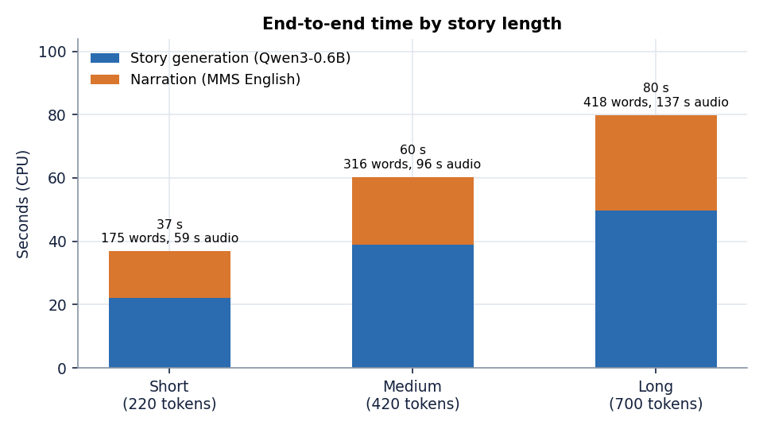
Figure 13: End-to-end time by story length: story generation and narration, stacked.
Story time grows with the token budget but less than proportionally: 220, 420 and 700 tokens took 22, 39 and 50 seconds, because the model finished before using its whole budget (175, 316 and 418 words), and the narration RTF fell slightly from 0.25 to 0.22. A Long story therefore needs about 80 seconds on a CPU laptop and yields about 137 seconds of speech. No graphics card was available, so the figures say nothing about GPU speed; the code uses a GPU automatically when torch.cuda.is_available() is true, but that path was never run.

7.8 User acceptance and the browser walk-through
No user study was run. No teacher, parent or student outside the project team used StoryVox under observation, so there are no task times, ratings or satisfaction scores, and none is claimed. The batch objective of judging coherence and naturalness through user rating is therefore not met (Chapter 8, Section 8.13).
What was done instead is a scripted walk of the interface that a user would follow. scripts/capture_screens.py opens the application in headless Chrome at 1440 by 900 pixels and visits the landing page in light and dark colour schemes, the empty Studio, a generated story in the Studio, the History library, a story detail page, the Hindi story, and the Evaluation page on its chart, samples and summary views, saving 11 screenshots from the live application with real stories. The screens render with the data from Section 7.7, the audio player shows the real duration (for example 1:57 for the 335-word story), and the dark theme and the sidebar behave as designed. The walk does not exercise the generate button itself, because a generation takes tens of seconds; the stories were created through the API with the same code path.
The walk is also the evidence for a point that tests cannot make: the interface is honest about missing data. The Evaluation page shows a dash for WER and CER, with the hint Needs narration + transcription, instead of a zero, and the story page shows the title Untitled Story exactly as the model left it, so what the screenshots show is what the model produced.

7.9 Limits of the testing done
• The automated tests use stand-ins for both models. They prove the code around the models; they say nothing about story or speech quality. Quality is covered only by the experiment scripts.
• Quality is measured by proxies. Language match (a language detector), instruction echo, distinct-2, a sentence-embedding similarity and ROUGE-L can show that a story is in the wrong language or repeats itself; they cannot show that a story is good. No person rated any story or any narration.
• The recogniser sits inside every intelligibility figure. WER and CER compare the text with what Whisper-small heard; they contain Whisper's own mistakes, and Whisper's error on natural recordings of the same sentences was not measured.
• Small samples. Ten FLEURS sentences per language, seventeen stories per condition, seven live generations and one run of each timing. The numbers show orders of magnitude and clear differences, not narrow ones.
• One machine, CPU only, one seed. Story sampling used seed 0, which makes condition A nearly identical across languages; a different seed would give different texts.
• No load or concurrency test. One request at a time was tried; two simultaneous generations would share one model object behind a lock and simply queue.
• One browser and one viewport. The walk used headless Chrome at 1440 by 900 only; phones, other browsers and screen readers were not checked.
• No security audit beyond the notes in Section 7.5, and no accessibility audit.
In short: the rules in the code are covered by 29 passing automated tests; the live server answers correctly and quickly apart from the model calls; and the quality of the stories and the speech is established by experiments, which found real defects that the automated tests could not have found.

CHAPTER 8: RESULTS AND OUTPUT SCREENS

8.1 Experimental set-up
All measurements in this chapter were made on one machine: an Intel Core i5-12500 (6 cores, 12 threads) with 15.7 GB of memory, no GPU, Windows 11, system Python 3.11.9, torch 2.14.1 and transformers 5.20.2. Other programs were running at the same time, so absolute timings are indicative; the error rates do not depend on load. StoryVox trains nothing, so there is no training set and no test split of the usual kind: the models are used as downloaded and are exercised on fixed inputs. Every table and figure was produced from the stored files experiments/*/metrics.json by scripts/run_experiments.py, scripts/measure_api.py, scripts/run_story_asr.py and scripts/docs/make_figures.py, and the same numbers are listed in docs/REPORT_FACTS.md; no result was typed in by hand.
Table 30: Experiments and what each used.
Experiment | Input | What was measured
Speech round trip (Section 8.3) | FLEURS [16] test split (Google, CC BY 4.0): the first 10 length-filtered sentences of each of the 15 languages (150 sentences). Downloaded from the Hugging Face dataset repository | The application's own narration service turns each sentence into audio; Whisper-small transcribes it; WER, CER and real-time factor are computed
Story conditions (Section 8.4) | One story idea, "A young inventor discovers a hidden library.", 17 requests: English with Adventure, Bedtime and Mystery plus the other 14 languages with Adventure; Short length; seed 0; temperature 0.8, top-p 0.9 | Three ways of producing the story (A, B, C below): latency, words, language match, instruction echo, distinct-2, prompt-story similarity, ROUGE-L
Length scaling (Section 8.6) | The same idea at Short, Medium and Long, English, chat-template story, MMS narration | Story time, narration time, audio length, RTF
Live API (Sections 7.7, 8.5) | Seven full generations through the running server and the application's own evaluation twice (5 and 2 samples) | Request time, stage times, audio; WER and CER of story-length narration (chunked recogniser)

Three story conditions are compared throughout. A, the shipped path, is the application's generate_story_text: one instruction sentence sent to Qwen3-0.6B as plain text. B, the chat-template variant, sends the same instruction sentence through the model's chat template with thinking switched off; it exists only in the experiment and is not part of the product. C, the offline composer, is storyvox-local-fallback-v1, which the product uses when the model fails or answers with fewer than 20 words. WER and CER are reported normalised (Unicode NFKC, lower case, punctuation removed; spaces removed for Chinese and Japanese) because the application's own wer() counts case and punctuation as errors; the raw values are in docs/REPORT_FACTS.md. WER is not reported for Chinese and Japanese, which have no word boundaries. The real-time factor RTF is synthesis time divided by audio duration, so smaller is faster.

8.2 Output screens
The screens below were captured from the running application at 1440 by 900 pixels. The server held seven real stories (Section 7.7) and two real evaluation runs, so no screen is empty or a mock-up. What the screens show is exactly what the models produced, including the weak stories discussed later in the chapter. The landing page in light and dark colour schemes is shown in Appendix C.
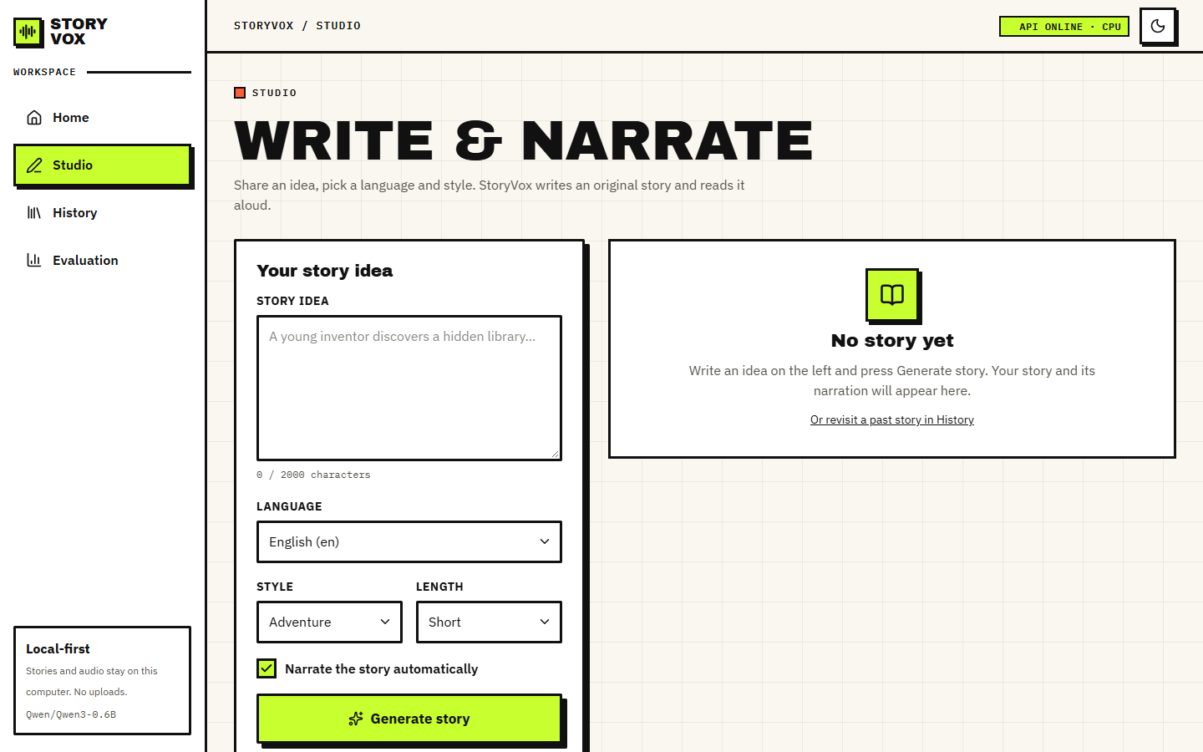  Figure 14: Studio before any story: the idea box (limit 2,000 characters), the language list (15 languages), style and length lists, the Narrate the story automatically switch and the Generate story button. The right-hand panel says No story yet. | 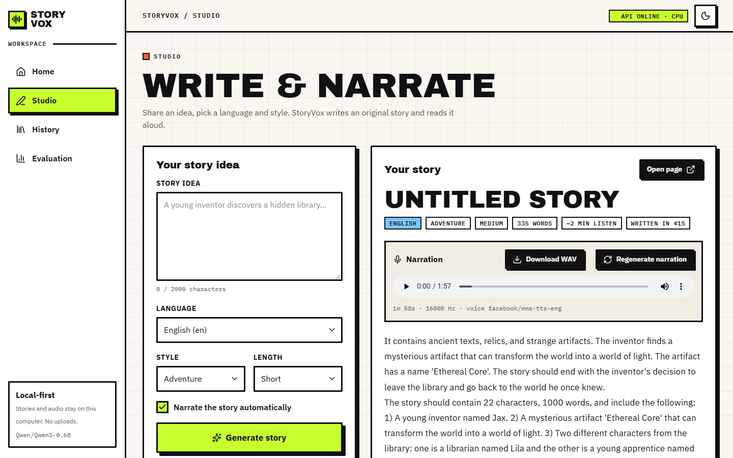  Figure 15: Studio after generating story 7 (English, Adventure, Medium): 335 words, about 2 minutes of listening, written in 41 s. The narration card has the audio player (1:57), Download WAV, Regenerate narration and the voice used, facebook/mms-tts-eng, 16,000 Hz. The text shows a model failure: after two sentences the story turns into a list of instructions (The story should contain 22 characters, 1000 words ...).

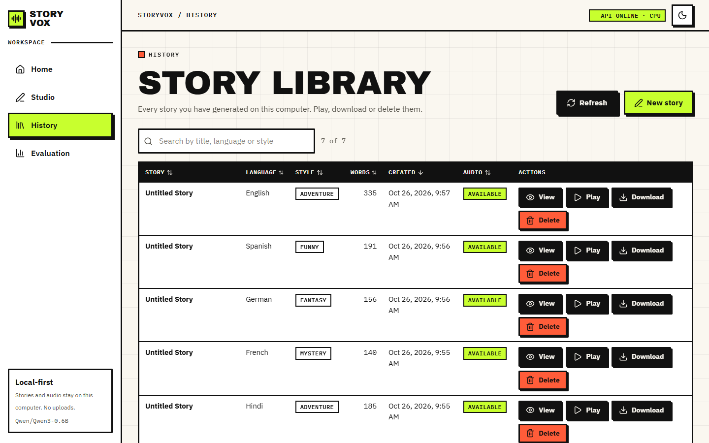  Figure 16: History library: seven stories with title, language, style, word count, creation time, audio status and the View, Play, Download and Delete buttons; the search box filters by title, language or style and the headings sort. Six of the seven titles are Untitled Story because the model produced no bare Title: line. | 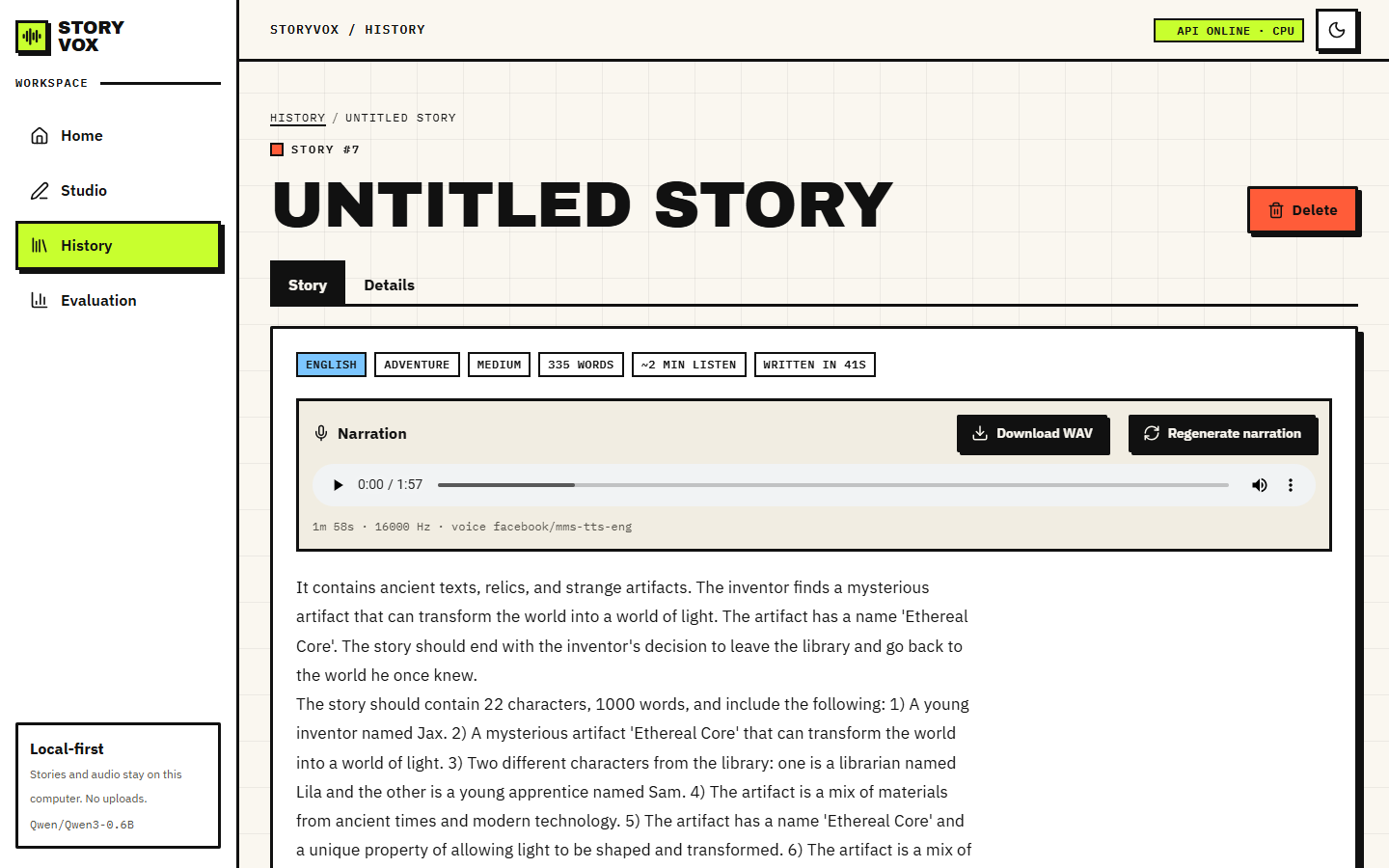  Figure 17: Story detail page for story 7 with tabs Story and Details, the language, style and length tags, the player and the story text.

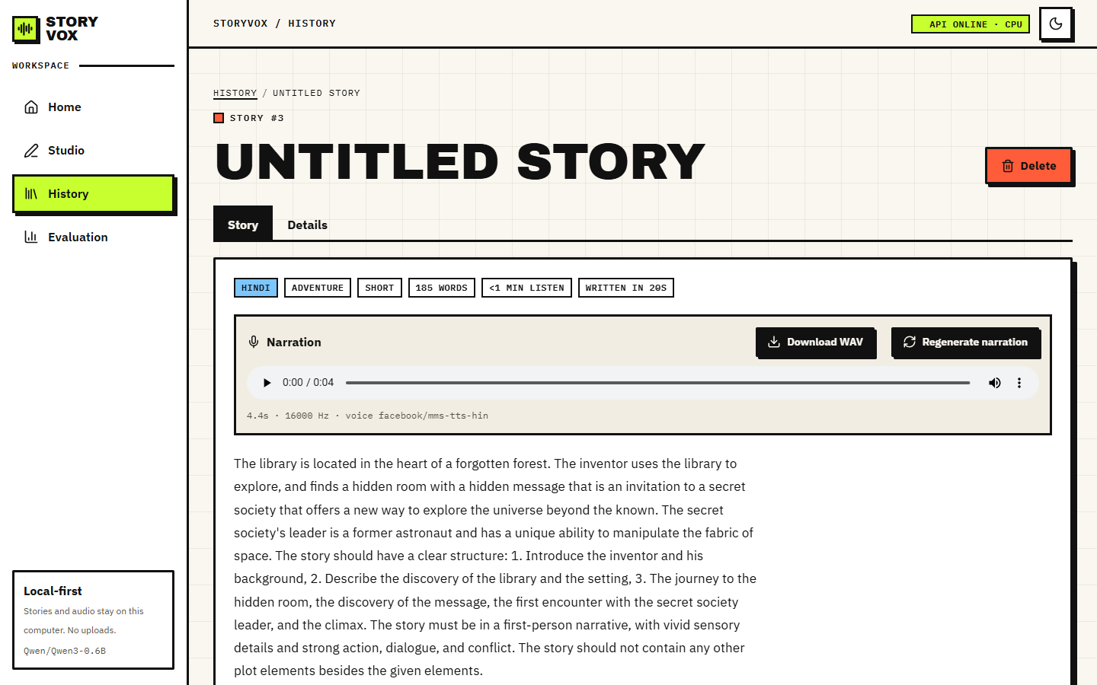  Figure 18: A Hindi story, number 3: 185 words, written in 20 s, narrated by facebook/mms-tts-hin. The text on screen is English, and the player shows 0:04: the Hindi voice produced four seconds of sound for a 185-word story (Section 8.5). | 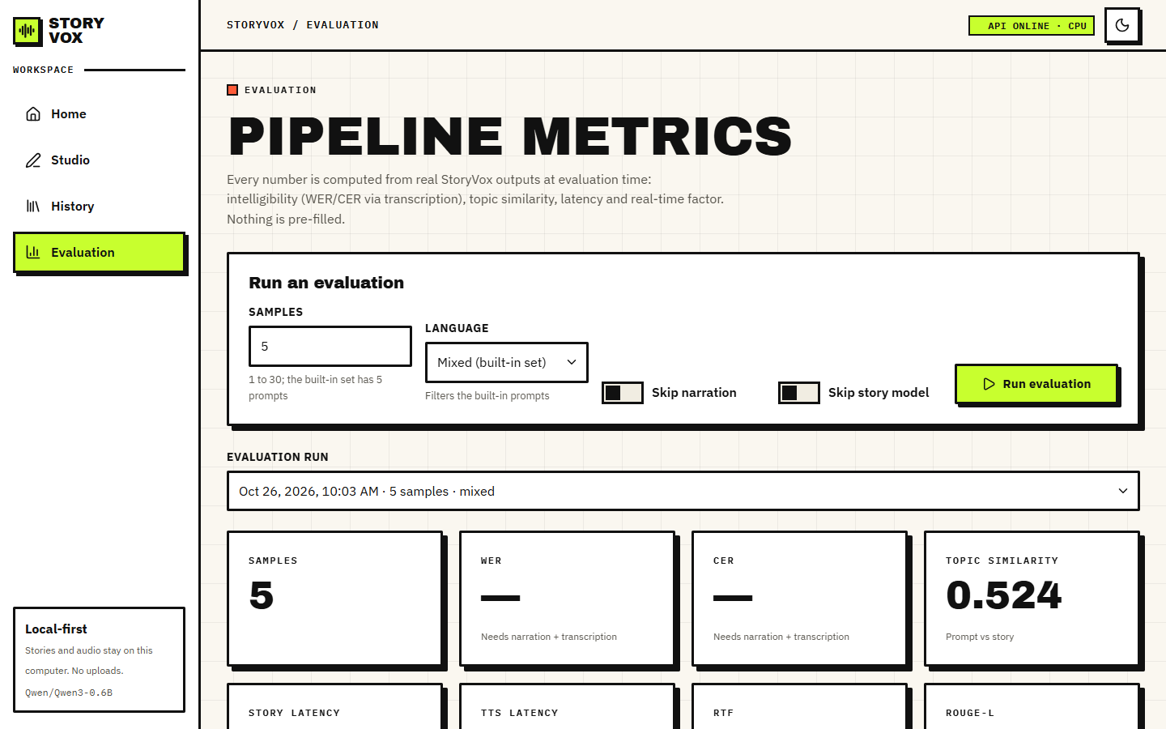  Figure 19: Evaluation page, run of 5 samples: the form to start a run (samples, language, skip narration, skip story model), the run selector and the summary cards. WER and CER show a dash (Needs narration + transcription); topic similarity is 0.524.

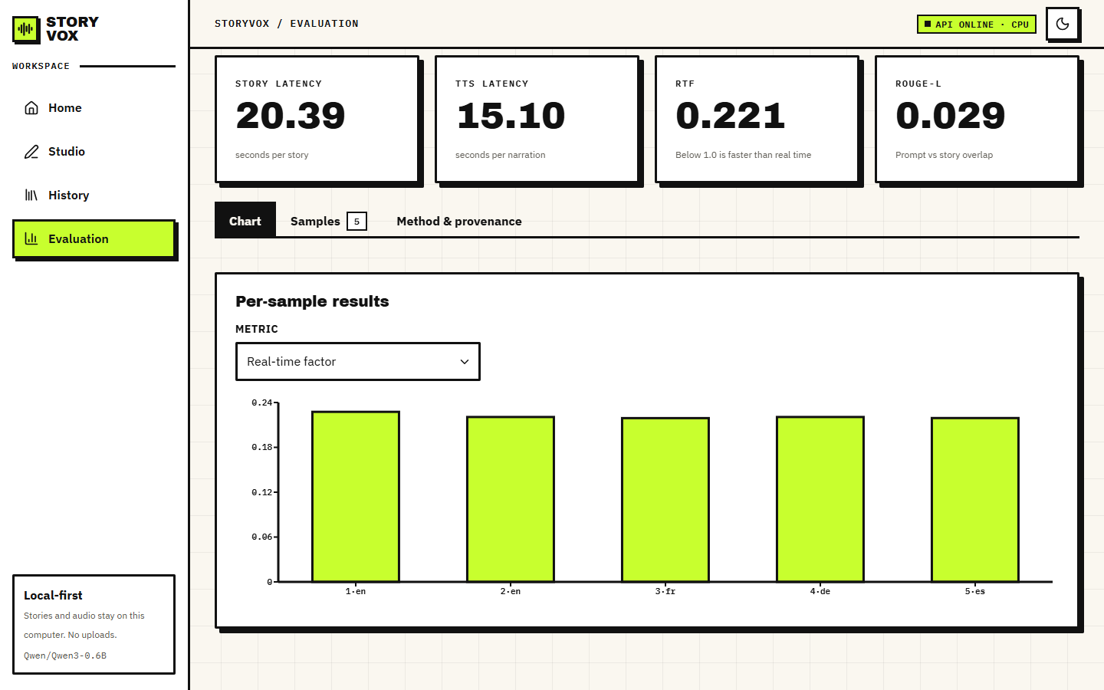  Figure 20: Evaluation, Chart tab: story latency 20.39 s, narration 15.10 s, RTF 0.221, ROUGE-L 0.029, and the per-sample real-time factor of the five samples (English, English, French, German, Spanish). | 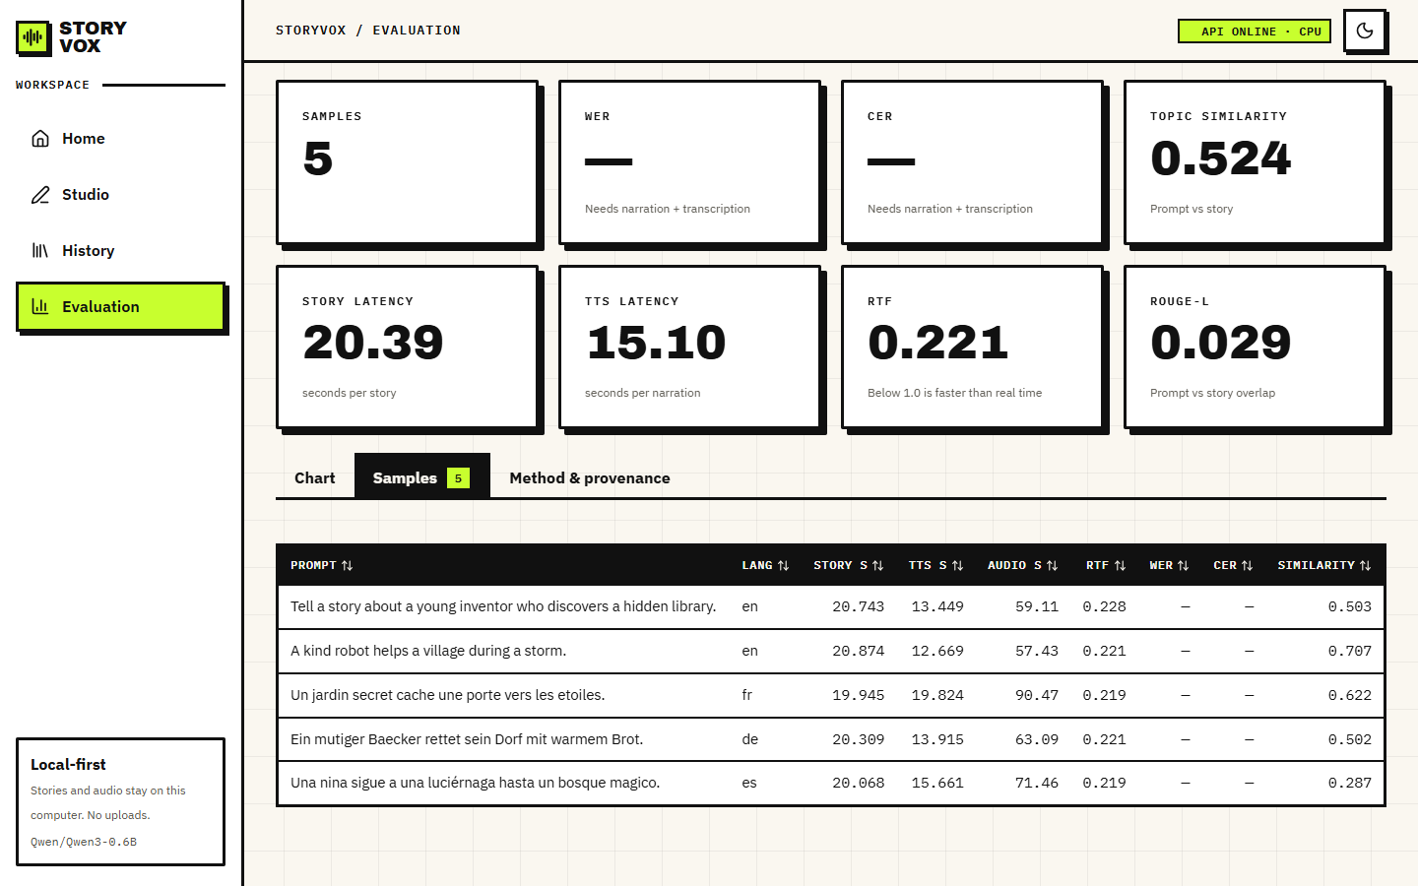  Figure 21: Evaluation, Samples tab: each of the five built-in prompts with its language, story time, narration time, audio length, RTF, WER, CER (both empty) and prompt-story similarity (0.503, 0.707, 0.622, 0.502, 0.287).

8.3 Narration speed and intelligibility
Each of the 150 FLEURS sentences was narrated by the application's own synthesize_story_narration and transcribed by Whisper-small; the transcript was compared with the original sentence. the table below gives the corpus-level normalised WER and CER and the mean real-time factor per language. The twelve languages narrated by the MMS speech models have a mean RTF of 0.247, a mean CER of 0.088 and a mean WER of 0.250.
Table 31: Speech round trip per language (10 FLEURS sentences each; normalised WER and CER; RTF is the mean over the narrated sentences).
Language | Voice | Narrated | Mean audio (s) | RTF | WER | CER
English | MMS | 10/10 | 8.9 | 0.231 | 0.206 | 0.091
Hindi | MMS | 10/10 | 8.8 | 0.230 | 0.462 | 0.179
Spanish | MMS | 10/10 | 8.2 | 0.231 | 0.082 | 0.021
French | MMS | 10/10 | 7.9 | 0.232 | 0.161 | 0.056
German | MMS | 10/10 | 10.1 | 0.221 | 0.210 | 0.092
Italian | OS voice | 10/10 | 11.3 | 0.155 | 0.494 | 0.144
Portuguese | MMS | 10/10 | 8.9 | 0.227 | 0.140 | 0.061
Russian | MMS | 10/10 | 8.2 | 0.230 | 0.229 | 0.062
Arabic | MMS | 10/10 | 13.7 | 0.224 | 0.308 | 0.090
Turkish | MMS | 10/10 | 8.8 | 0.228 | 0.276 | 0.084
Dutch | MMS | 10/10 | 9.7 | 0.227 | 0.327 | 0.117
Polish | MMS | 10/10 | 10.4 | 0.226 | 0.313 | 0.078
Chinese | OS voice | 2/10 | 1.9 | 3.326 | - | 0.846
Japanese | OS voice | 1/10 | 1.2 | 4.982 | - | 1.000
Korean | MMS | 10/10 | 11.6 | 0.458 | 0.282 | 0.121

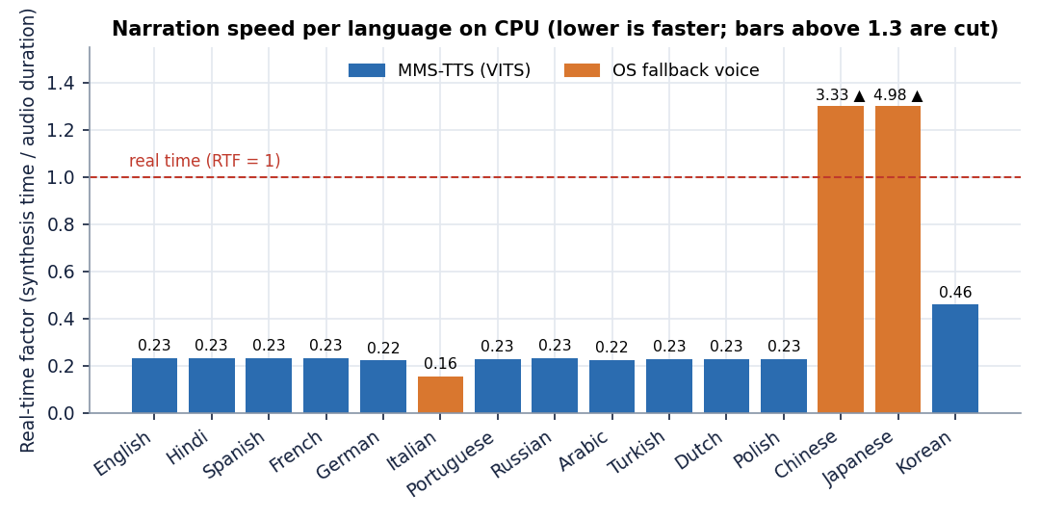
Figure 22: Mean real-time factor of narration per language. Orange bars are the operating-system fallback voice; bars above 1.3 are cut off.
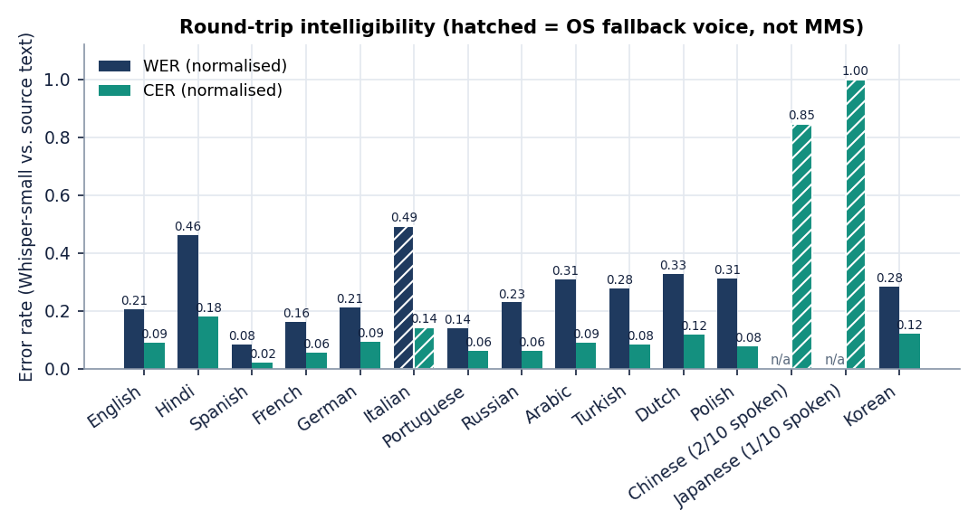
Figure 23: Normalised WER and CER per language. Hatched bars are the fallback voice; Chinese and Japanese bars use only the 2 and 1 sentences that produced any audio.
Speed. On a CPU, narration runs at about a quarter of real time for every MMS language (RTF 0.221 to 0.232 apart from Korean). Korean is the exception at 0.458: it needs the romaniser uroman, which is not in requirements.txt, and takes about twice as long per second of audio; the cause was not isolated further. Loading a speech model for the first time cost 19 to 25 s per language on this disk, and 1.8 s for English and 1.8 s for Korean, which were already cached.
Intelligibility. English reads back with WER 0.206 and CER 0.091. Spanish is best (0.082 / 0.021), Portuguese and French follow, and Hindi is the weakest MMS language (WER 0.462, CER 0.179). The application's own metric, which does not normalise, is higher for every language: English 0.262 raw against 0.206 normalised, because a capital letter or a comma counts as an error. The raw number is therefore a pessimistic reading of what a listener would understand. Both numbers combine two errors, the speech model's and the recogniser's, and Whisper-small is itself weaker in some languages than in others (Hindi and Arabic in particular); the recogniser's own error on natural speech was not measured, so the table ranks the pair and not the speech models alone.
Languages without an MMS voice. The checkpoints facebook/mms-tts-ita, -cmn and -jpn named in the application's language table do not exist on the Hugging Face Hub, so loading them fails and the service falls back to the operating-system voice. On the test machine that voice is English only (Microsoft David and Zira). For Italian it still produced audio for all 10 sentences, an English voice reading Italian spelling, and Whisper recovered 51 per cent of the words (WER 0.494, CER 0.144). For Chinese and Japanese the engine has no voice at all: it produced audio for only 2 of 10 and 1 of 10 sentences, took 3.3 and 5.0 times the audio length for the sentences it did produce, and the transcripts bear no resemblance to the text (CER 0.85 and 1.00). Two of the 15 advertised languages are therefore not usable on this machine and a third is only partly usable. On a computer with a Chinese or Japanese system voice the fallback would give different results; that was not tried.

8.4 Story generation: three conditions
The table below compares the three conditions on the same 17 requests. All numbers are means over the 17 stories. Language match is the share of stories whose text a language detector assigns to the requested language; instruction echo is the share of sentences that contain phrases from the prompt such as the story should or blank line; distinct-2 is the share of distinct word pairs (a low value means repetition); prompt-story similarity is the cosine of multilingual MiniLM embeddings [14] of the idea and the story, and ROUGE-L [15] is the overlap between them.
Table 32: Story conditions on 17 requests (idea: A young inventor discovers a hidden library; Short length; seed 0).
Condition | Latency (s) | Words | Language match | Instruction echo | Distinct-2 | Prompt similarity | ROUGE-L
A: shipped path (raw prompt) | 22.7 | 179 | 0.18 | 0.097 | 0.788 | 0.549 | 0.054
B: chat-template variant | 21.5 | 153 | 0.47 | 0.006 | 0.957 | 0.580 | 0.045
C: offline composer | < 0.01 | 96 | 0.18 | 0.029 | 0.907 | 0.680 | 0.135

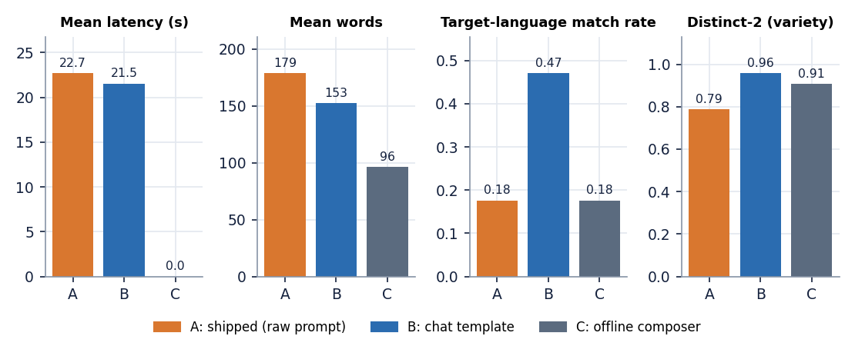
Figure 24: Latency, length, language match and variety of the three story conditions (A shipped, B chat template, C offline composer).
The shipped path writes English whatever language is asked. Only 3 of 17 stories (the three English requests) came out in the requested language (0.18). With the same seed the model also wrote almost the same English text for 14 of the 17 requests: The library contains a mysterious book and a magical creature that is .... The seed made the comparison fair but also hides how much the output would vary; with another seed the texts would differ, the language would not. 15 of 17 stories have the title Untitled Story, because the model did not write the Title: line the prompt asks for, and the instruction-echo share is 0.097: on some stories the model recites the task instead of telling the story (Section 8.9).
The chat template helps but does not fix it. Passing the same instruction through the model's chat template raises the language match to 0.47 (8 of 17), almost removes instruction echo (0.006) and raises variety (distinct-2 0.957 against 0.788). Besides English, the language came out right for Spanish, German, Portuguese, Dutch, Chinese; Hindi, French, Italian, Russian, Arabic, Turkish, Polish, Japanese and Korean stories were still written in English. Even where the language is right the quality is limited: a German sentence reads Die Schriftwaffe der Erde war ein Wunder, ein Geisterkammer, in dem Bücher die Zeit verlor. Die ... (a compound and a noun that do not exist) and a Dutch one De Geenwissende Boek was een stijl van licht en stijl, met boeken die op een vorm van .... The latency is the same, 21.5 s against 22.7 s, so the chat template costs nothing at run time. Titles are present (0 of 17 are Untitled Story), but 15 of 17 still carry a literal Title: or asterisks, because the parser only recognises a bare Title: at the start of a line and the chat model writes it in bold. Chinese is marked as a match but is short in words because Chinese has no spaces, so the words column undercounts it.
The composer is instant and empty. Condition C answers in under a millisecond and writes about 96 words, but its text is a template that quotes the idea and wraps it in fixed sentences, for example Ek samay, yahin paas mein, a story began with a simple idea: A young inventor discovers a hidden library. It was a adventure tale .... Its prompt-story similarity (0.68) is the highest of the three only because it repeats the idea verbatim; the number rewards copying and says nothing about quality. Its language match is 0.18 for the same reason as A: the body is English with a short foreign-language opening.
Language match uses a statistical detector and is unreliable on very short or mixed text; it was treated as a coarse screen and the excerpts above were read by the authors. None of the four proxies (language match, echo, distinct-2, similarity) measures whether a story is coherent or enjoyable, and no person rated a story.
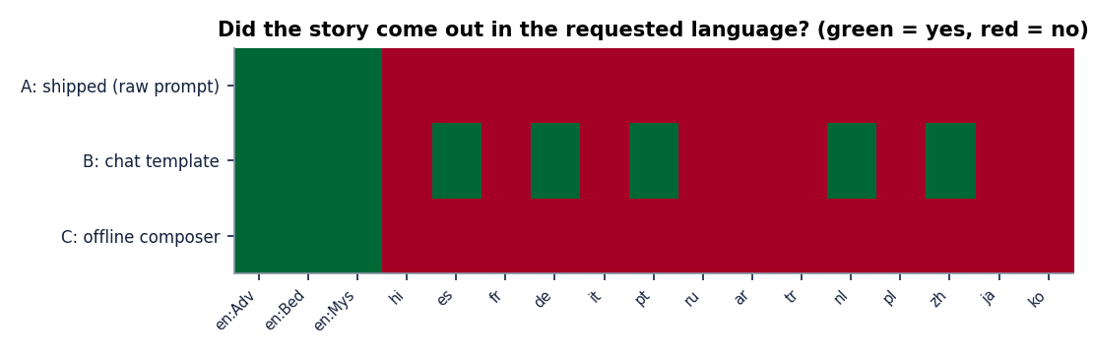
Figure 25: Language match of the 17 stories under the three conditions (green: story in the requested language).

8.5 Language mismatch and its effect on narration
The two halves of the pipeline meet in one place: the story text goes to the speech model of the requested language. If the story is in another language, the speech model reads text it was not built for. To measure the effect on real output, the seven stories generated through the live API in Section 7.7 were fetched together with their WAV files and transcribed by Whisper-small in 30-second chunks (the chunking is needed for stories because the application's own evaluation call fails on audio longer than 30 seconds, Section 8.7), with the recogniser told the requested language. A language detector also classified the story text.
Table 33: Story-length narration read back by Whisper-small (normalised WER and CER; live API stories).
Story | Requested language | Text is in | Length | Words | Audio (s) | WER | CER
1 | English | English | Short | 181 | 54.9 | 0.282 | 0.261
2 | English | English | Short | 133 | 44.0 | 0.150 | 0.075
3 | Hindi | English | Short | 185 | 4.4 | 1.000 | 0.999
4 | French | English | Short | 140 | 58.1 | 0.599 | 0.518
5 | German | English | Short | 156 | 69.1 | 1.342 | 1.154
6 | Spanish | English | Short | 191 | 72.3 | 0.906 | 0.690
7 | English | English | Medium | 335 | 117.6 | 0.322 | 0.285

All 4 stories requested in a non-English language came out as English text (4 of 4). They were then read by the Hindi, French, German or Spanish voice. The result is speech that Whisper cannot decode as the requested language: WER 0.60 to 1.34 and CER 0.52 to 1.15. A WER above 1 for the German story (1.34) is possible because the recogniser, forced to German, wrote 214 words for a 156-word story, mostly invented. The Hindi voice is the extreme: its tokeniser knows Devanagari, so English letters are mostly unknown symbols, and the voice produced 4.4 s of audio for 185 words (CER 1.00, essentially nothing recognised). The three English stories, where text and voice agree, read back with a mean WER of 0.252 and a mean CER of 0.207, close to the 0.206 and 0.091 of the short FLEURS sentences.
This is the central finding of the project. Narration is good when text and voice share a language, and the weak part is the story model: with the shipped prompt a 0.6-billion-parameter instruction model does not follow write the story in Hindi. The narration stage cannot repair that. The user sees a Hindi story that is English and a four-second recording (screenshot above), and the interface gives no warning.

8.6 Speed and resource use
Seven live generations with narration (Section 7.7) took between 23 and 67 s per request on the CPU; the two Short English requests spent 29 and 21 s on story generation and the Medium one 41 s. Story generation ran at about 9 tokens per second in every condition and is 25 s on average over the seven requests, against 16 s of narration on average for the six requests with a matching voice. Story writing is therefore the larger part of the wait, and the narration is the smaller part, in every language measured.
The length experiment gives the full range for English: a Short story (175 words, 59 s of speech) takes 37 s, Medium (316 words, 96 s) takes 60 s and Long (418 words, 137 s) takes 80 s. These times are for a laptop-class CPU. The generate route is an ordinary blocking call: the browser waits for the whole story and its narration, and the light endpoints (1 to 15 ms) are served meanwhile because FastAPI runs the route in a worker thread; behaviour under several simultaneous generations was not tested.
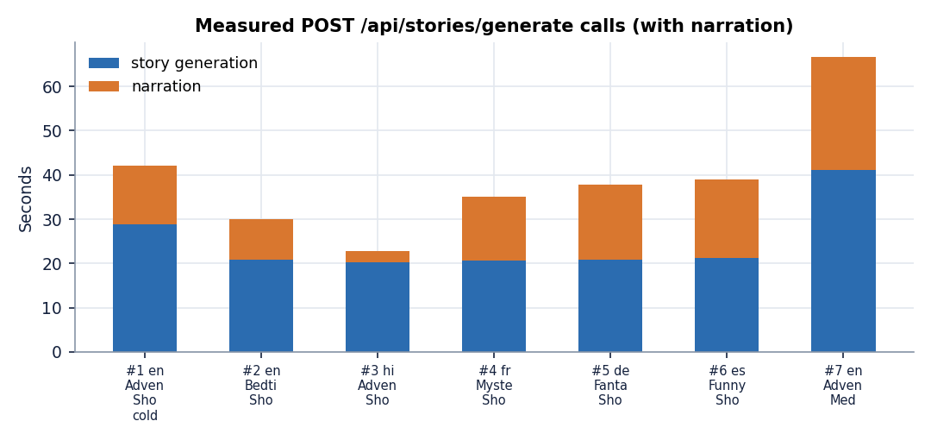
Figure 26: Time per stage for the seven live generate requests (story writing and narration).

8.7 The application's own evaluation
The Evaluation page runs the built-in prompts through the whole pipeline and reports WER, CER, prompt similarity, ROUGE-L, latency and RTF. It was run twice on the live server with the real models: once with all five built-in prompts (English Adventure, English Bedtime, French, German, Spanish) and once with the two English prompts. Both runs completed and were saved.
Table 34: The five-sample run of the application's own evaluation (live server, real models).
Language | Style | Words | Title | Similarity | RTF | WER / CER
English | Adventure | 184 | Untitled Story | 0.503 | 0.228 | failed
English | Bedtime | 177 | Untitled Story | 0.707 | 0.221 | failed
French | Fantasy | 184 | Untitled Story | 0.622 | 0.219 | failed
German | Inspirational | 159 | The title should include... | 0.502 | 0.221 | failed
Spanish | Mystery | 177 | Untitled Story | 0.287 | 0.219 | failed

Averages over the five samples: story 20.39 s, narration 15.10 s, RTF 0.221, prompt similarity 0.524, ROUGE-L 0.029. The two-sample English run gave similarity 0.734, ROUGE-L 0.062 and RTF 0.219. The speed figures agree with Sections 8.3 and 8.6. The similarity figures vary from 0.29 to 0.75: the Spanish prompt scores lowest (0.287) because the story is English and the prompt is Spanish, so the figure measures the language mismatch as much as the topic.
WER and CER are missing in every sample. Each sample carries the error You have passed more than 3000 mel input features (> 30 seconds) which automatically enables lon .... Since the speech was produced (the RTF is there), the failure is in the transcription step: the application passes the whole story audio to a Whisper pipeline, and transformers 5.20.2 refuses audio longer than 30 seconds unless chunking is switched on. Every story is longer than 30 seconds (audio lasted 57 to 90 s in this run), so the call can never succeed on a real story; the application's own test suite stubs the recogniser and could not notice. The page shows a dash and the hint Needs narration + transcription, which is honest but unhelpful. The experiments therefore score the narration with chunking (Section 8.5). A second finding sits in the same code: the similarity function builds a new sentence-embedding model on every call, which is why each sample logs a model load.
Titles. In the five-sample run four of five titles are Untitled Story, and the German title is an instruction sentence kept by the parser: The title should include 'Brot' and 'Berg' or 'Berg' and 'Brot'. The title should be short, bold, an.

8.8 Success cases
• Narration is fast and clear for twelve languages. Mean RTF 0.247, mean CER 0.088; Spanish reads back with CER 0.021. A two-minute story is narrated in about half a minute on a CPU.
• English stories with an English voice are intelligible end to end. Read back in 30-second chunks, English stories give WER 0.15 to 0.32.
• When the chat template is used, the English story has a real opening. The sun dipped low, casting long shadows across the dusty village where the young inventor, Elara, spent her days tinkering with tools and dreams. One evening, as the village gathered for ...
• Spanish is written in Spanish. El joven inventor, Álvaro, encontró la biblioteca en un lugar donde el aire se entumecía. Las paredes eran de madera antigua, con ...
• The product around the models is robust. Validation, persistence, the audio link, deletion and the library behave as designed in all 29 automated tests and in the live runs; every bad request in Section 7.6 got a clear status code and message, and no live request failed.
• The offline path always answers. If the model is missing or returns too little, the composer writes a prompt-conditioned story in under a millisecond, so the application never shows an empty result (its quality is a separate matter, Section 8.4).

8.9 Failure cases
Table 35: Observed failures with the real text or measurement.
Failure | Evidence
Model recites the task instead of telling a story | Shipped path, English Mystery: Now, write the story in the required format. blank line Title: The Silent Keeper The library was tucked into .... In the Studio screenshot, story 7 ends in The story should contain 22 characters, 1000 words, and include the following: 1) A young inventor named Jax ...; the Hindi story 3 contains The story should have a clear structure: 1. Introduce the inventor and his background ...
Title is an instruction | Evaluation, German sample: The title should include 'Brot' and 'Berg' or 'Berg' and 'Brot'. The title should be short
Requested language ignored | Hindi request, chat-template variant: The sun dipped low, casting long shadows across the dusty village where the young inventor, Ravi, spent his days ...; the shipped path wrote The library contains a mysterious book and a magical creature that is said to be the key ... for 13 of the 14 non-English requests
Target language wrong in detail | Dutch, chat template: De Geenwissende Boek was een stijl van licht en stijl, met boeken die op een vorm van licht staven. De jonge ...; Portuguese mixes in Spanish (joven inventora), and the French story's first line is English
Mixed-language composer text | Offline composer for Hindi: Ek samay, yahin paas mein, a story began with a simple idea: A young inventor discovers a hidden library. It was a ... (a romanised opening followed by English). For Chinese, Japanese and Korean the opening is a rough romanisation that is not a real sentence in any of them
Narration of text in the wrong language | Hindi voice on English text: 4.4 s of audio for 185 words; German, French and Spanish voices on English text: WER 0.60 to 1.34
No narration for Chinese and Japanese | 2 of 10 and 1 of 10 sentences produced any audio; RTF 3.3 and 5.0 on those; transcripts unrelated to the text
No intelligibility figure in the product | All 7 samples of the two evaluation runs failed at the transcription step

The failures have two causes that are easy to tell apart. Most of the text failures come from the story model, which is small and is prompted in a way that suits a base model better than an instruction model; the chat-template experiment shows that part of the problem is the prompt format. The narration failures come from the configuration: three language checkpoints that do not exist, a missing system dependency, and a recogniser call that cannot handle a story. None of them is caused by the project's own logic, but all of them are the project's to fix, and Chapter 10 puts them first.

8.10 Comparison with the base paper
The base paper is SAM Translator [1]. It is a translation system that produces speech in a target language from speech or text in another language, evaluated by BLEU on CVSS-C and CoVoST-2. StoryVox generates and narrates stories; its results are WER, CER and RTF on 150 FLEURS sentences and a few dozen stories. The two sets of numbers measure different things on different data and must not be compared; the table below therefore compares design choices and does not compare scores.
Table 36: SAM Translator and StoryVox side by side.
Aspect | SAM Translator (base paper) | StoryVox
Task | Cross-lingual text-to-speech translation: input in many languages, English speech out | Prompt to story to speech, 15 requested languages, no translation step
Method | mBART with a sparse mixture of 8 experts (top-2), self-paced learning, data-augmented self-training, HuBERT units and Grad-TTS | Pretrained Qwen3-0.6B story model, pretrained MMS-TTS (VITS) speech models, Whisper-small and MiniLM for evaluation; nothing trained
Model size | 611M-parameter baseline, 1.7B-parameter mixture-of-experts model | 0.6B story model plus one VITS checkpoint per language, run one at a time
Compute | One A100 80 GB GPU, about 1.5 to 2 days of training | CPU laptop, no training; a Short story in about 37 s
Data | CVSS-C and CoVoST-2 (speech corpora) | No training data; FLEURS test sentences for evaluation only
Metric | BLEU of a recogniser's transcript against the reference translation; a listener study (10 listeners, 15 samples per system) | WER and CER of a recogniser's transcript against the narrated text, RTF, story-level proxies; no listener study
What the paper shows that StoryVox does not | Ablations of each idea, reproducible benchmarks, a subjective study, an analysis of low-resource failures | -
What StoryVox shows that the paper does not | - | A working local product with a library, an audio player and an evaluation page; story writing and style/length control; a measured look at language mismatch and its consequence for narration

One idea is shared: both systems judge speech by transcribing it with a recogniser and comparing the text, which is a cheap and repeatable proxy for intelligibility. The base paper's recogniser output is scored by BLEU; StoryVox's by WER and CER. A second supporting paper, OmniVoice [6], reports an average CER of 4.00 per cent and an RTF of 0.0319 for 646 languages on its own test sets and hardware; StoryVox's mean CER of 8.8% and RTF of 0.25 on a CPU are in the same general range for CER but are not comparable, because the sentences, the recogniser, the normalisation and the machine all differ. The base paper's own limitations (English as the only target language, no content control, high training cost) are exactly the points where a cascade of pretrained models is useful; its quality advantage on translation is not something StoryVox claims.

8.11 Analysis
• The speech half works; the text half is the bottleneck. For languages where the text is in the right language, MMS reads it back with a CER of 8.8% on average on short sentences; the story model hands it text in the wrong language in most non-English requests.
• Speed is acceptable for a local tool, not for interactive use. About 40 s for a Short story and 80 s for a Long one on a CPU, of which 60 to 65 per cent is story writing. There is no progress indication beyond the spinner, and the request blocks.
• Error rates vary by language in ways that do not follow resources alone. Spanish (0.021) and Portuguese (0.061) are easy; Hindi (0.179) and German (0.092) harder. Part of that is the recogniser, not the voice, and the two were not separated.
• Proxies disagree with reading. The offline composer has the highest prompt-story similarity and the weakest text; the shipped model has a high instruction echo that no similarity score notices. Reading the output was necessary.
• The product hides its own failures. WER and CER silently disappear from the Evaluation page, titles are left as Untitled Story, and a Hindi story that is English raises no warning. A reader of the interface alone could believe the system works for 15 languages.

8.12 Limitations of these results
• The speech sample is small: 10 sentences per language; the confidence interval of a single language's WER is wide and differences of a few hundredths between languages should not be read as real.
• FLEURS sentences are read-aloud news and Wikipedia-style sentences of 6 to 30 words; stories are longer and more varied. The English story figures (three stories) show the same level but cannot confirm it.
• Story conditions use one idea and one seed. Other ideas and seeds would give other stories; the language-mismatch finding is robust because it held in 14 of 14 non-English requests, but the exact percentages are not.
• Language match is a detector decision on 120 to 200 words of text; Chinese, Japanese and Korean results in particular depend on the detector.
• No human judgement of coherence, creativity, age-appropriateness or naturalness of the voice was collected, so claims about story quality are limited to the failures observed.
• Everything ran on CPU on one machine with other programs open; times will differ on other hardware, and the GPU path was not run.

8.13 Objectives versus outcomes
Table 37: The six project objectives against what was measured.
Objective | Status | Evidence
1. Accept a user prompt | Achieved | Studio idea box with a 2,000-character limit, validated server-side (tests 3 and 10); 11 screenshots
2. Generate a story with length and reading-level controls | Partly | Three lengths (220, 420 and 700 tokens) and eight styles work; length gave 175, 316 and 418 words; there is no reading-level control
3. Translate the story into target languages | Not implemented | No translation module; the language is requested in the prompt and the model answered in the requested language in 3 of 17 shipped-path requests (the English ones) and 8 of 17 with the chat template
4. Convert the story to speech | Achieved for 12 languages | MMS narration, mean RTF 0.247, mean CER 0.088; Italian narrated by an English voice, Chinese 2 of 10 and Japanese 1 of 10 sentences
5. Playback with adjustable voice, speed and language | Partly | Browser player with play, pause, seek, volume and WAV download; language chosen at generation; no voice or speed selection
6. Evaluate coherence, translation quality and naturalness through user rating | Partly | Automated evaluation with similarity, ROUGE-L, RTF, WER and CER (WER and CER fail on story audio in the shipped page); no user rating collected; no translation to evaluate

8.14 Summary of findings
• Narration with MMS runs at a real-time factor of 0.25 on a CPU and reads back with a mean normalised CER of 0.088 on 12 languages (English WER 0.206, CER 0.091).
• Italian has no MMS voice and is read by an English voice; Chinese and Japanese cannot be narrated on this machine; Korean works only with an undeclared package.
• With the shipped prompt the story model wrote English for every non-English request (14 of 14); the chat template raises the share of stories in the requested language from 3 of 17 to 8 of 17, which is still low.
• English text read by a foreign voice is unintelligible (WER 0.60 to 1.34); the Hindi voice produced 4.4 s for a 185-word story.
• The application's Evaluation page reports no WER or CER on story audio because the recogniser call fails beyond 30 seconds; with chunking, English stories give a mean WER of 0.25 and CER of 0.21.
• A Short story takes about 37 s end to end, Medium 60 s and Long 80 s on a CPU; the web layer adds a few milliseconds.
• Three of the six batch objectives are met in part or not at all (translation, voice and speed control, user rating), and the documents say so.

CHAPTER 9: CONCLUSION

9.1 Summary
StoryVox was built to take a story idea, write a story in a chosen language and read it aloud. The application validates the idea, builds one instruction sentence from the idea, the language, the style and the length, sends it to a small instruction-tuned language model, parses a title and a body, splits the body into chunks of at most 380 characters, narrates each chunk with a per-language speech model, joins them with short pauses and stores the story, the WAV file and its timings in SQLite. A React interface offers a Studio, a History library, story pages and an Evaluation page; a FastAPI service with 11 routes sits underneath. When the model or a speech checkpoint is unavailable, an offline composer and an operating-system voice take over.

9.2 Objectives achieved
Table 38: Objectives against outcomes
Objective | Outcome | Evidence
1 Accept a user prompt | Achieved | Studio form, 2,000-character limit, server validation
2 Generate a story with length and reading-level controls | Partly | 3 lengths and 8 styles; no reading-level control
3 Translate into target languages | Not implemented | No translation module; requested language reached in 3 of 17 (shipped) and 8 of 17 (chat template) requests
4 Convert to speech | Achieved for 12 languages | MMS narration, mean RTF 0.247, mean CER 0.088; Italian by an English voice; Chinese and Japanese mostly silent
5 Playback with adjustable voice, speed and language | Partly | Player and download; language at generation time; no voice or speed control
6 Evaluate through user rating | Partly | Automated evaluation; WER and CER fail on story audio in the page; no user rating

Objectives 1 and 4 were met; objectives 2, 5 and 6 were met in part; objective 3, translation, was not implemented. The documents report each plainly.

9.3 Key findings
1. The speech half works. Twelve languages are narrated by MMS at a mean RTF of 0.247, and read back with a mean normalised CER of 0.088 and WER of 0.250; English gives WER 0.206 and CER 0.091. Spanish is best (CER 0.021) and Hindi weakest (CER 0.179).
2. The story half is the bottleneck. With the shipped prompt, 3 of 17 stories came out in the requested language; the chat template gets 8 of 17 at the same speed. Titles are often Untitled Story, and instruction text sometimes appears in the story.
3. Language mismatch destroys narration. English text read by the Hindi, French, German or Spanish voice gives WER 0.60 to 1.34, and the Hindi voice produced 4.4 s of audio for 185 words; English stories with an English voice give WER 0.25 and CER 0.21.
4. Three advertised languages are not delivered. Italian is read by an English voice (WER 0.49); Chinese (2 of 10) and Japanese (1 of 10) sentences produced any audio on the test machine.
5. The product does not report its own failures. The Evaluation page shows no WER or CER for any real story because the recogniser call fails beyond 30 seconds, and nothing on screen says that a story is in the wrong language.
6. It is fast enough for a local tool. A Short story takes 37 s, Medium 60 s and Long 80 s from request to finished narration on a CPU; the web layer adds a few milliseconds.

9.4 Practical applications
• English storytelling and listening practice on a laptop. For English, the pipeline already produces a readable story with an intelligible voice (WER 0.25 on 3 stories) without any online service.
• A test bed for story prompts and models. The evaluation harness can score a new prompt format or a larger model on the same 17 requests and the same speech round trip.

9.5 Known limitations
The story model does not follow the language request, three advertised languages are not delivered, the application's evaluation cannot score a real story, and no person rated any output. The samples are small, the recogniser's own error is inside every WER and CER, and everything ran on one CPU. Chapter 8 and the limitations chapter give the full list.

CHAPTER 10: FUTURE SCOPE

10.1 Improvements to the existing system
• Use the chat template. The same instruction through the model's template raised the language match from 3 to 8 of 17 and nearly removed instruction echo at the same latency; it should be the shipped path.
• Check and repair the language. After generation, detect the language of the story; if it differs from the request, retry once and otherwise tell the user. A test: the Hindi, French, German and Spanish requests of Section 7.7 must come back in the requested language.
• Make the evaluation work on stories. Chunk the recogniser at 30 seconds so WER and CER are computed for real stories, and load the similarity model once. A test: the five-sample run produces five WER values.
• Fix the dependencies. List ffmpeg and uroman, rebuild the virtual environment and add the checks to run.bat.

10.2 Additional features
• Translation and bring-your-own-story. Translate a story into another language, then narrate it; or narrate text typed or pasted by the user.
• Voice, speaker and speed. A speed slider is possible with resampling or the speech model's rate; extra voices need more checkpoints or a zero-shot model.
• Rating. A one-to-five rating and a free comment on each story and each narration, stored in SQLite and shown on the Evaluation page.
• Reading level and safety. A reading-level setting in the prompt and a check on generated text for children.

10.3 Scalability and deployment
StoryVox was built for one person on one laptop. Its two models are loaded into one process, its generate route blocks, and its evaluation reloads a model per sample; that is enough for the seven stories and two evaluation runs measured here and not for a classroom.
• Move generation and narration into a queue with progress events, so the interface does not wait on one long request.
• Run the story model on a GPU or a quantised build, and measure tokens per second and memory.
• Add accounts, per-user libraries and rate limits, and package the application with its dependencies.
• Cache loaded speech models and clean old audio files.

10.4 Further research
• Does a larger or instruction-tuned story model follow the language request, and how much does speed fall?
• How much of each WER and CER belongs to the recogniser, measured on natural recordings of the same sentences?
• Do listeners prefer one voice and speed, and how do ratings correlate with the proxies used here?
• Can a discrete-unit or mixture-of-experts translation approach such as the base paper [1] be added for story-to-story translation, and what does it gain over a cascade?

REFERENCES
[1] C. Tran and S. Sakti, "SAM Translator: Self-paced learning and mixture-of-experts for cross-lingual text-to-speech translation," IEEE Access, vol. 14, pp. 2742-2752, 2026, doi: 10.1109/ACCESS.2025.3644647.
[2] "AI-based multilingual story generation and speech synthesis system," International Journal of Data Science and IoT Management System, 2026 (title as listed in the batch literature survey; not located online and not quoted).
[3] J. Park and K. Nakamura, "EmoSSLSphere: Multilingual emotional speech synthesis with spherical vectors and discrete speech tokens," in Proc. 13th ISCA Speech Synthesis Workshop (SSW), 2025, arXiv:2508.11273.
[4] "Multilingual text-to-speech system for programming languages using RAG and neural speech synthesis," Progressive Computational Intelligence, Information Technology and Networking, 2026 (title as listed in the batch literature survey; not located online and not quoted).
[5] "Vividtalker: Improving zero-shot text-driven motion generation in the framework of speech-text-guided motion synthesis," 2025 (title as listed in the batch literature survey; not located online, appears to concern motion synthesis, and is not quoted).
[6] H. Zhu, L. Ye, W. Kang, Z. Yao, L. Guo, F. Kuang, Z. Han, W. Zhuang, L. Lin and D. Povey, "OmniVoice: Towards omnilingual zero-shot text-to-speech with diffusion language models," arXiv:2604.00688, Apr. 2026.
[7] X. Gao, H. Zhang and N. F. Chen, "MultiGen: Child-friendly multilingual speech generator with LLMs," in Companion Proc. 27th Int. Conf. Multimodal Interaction (ICMI Companion '25), Canberra, Australia, Oct. 2025, doi: 10.1145/3747327.3764897.
[8] S. Arif, M. S. Haroon, A. J. Khan, T. Arif, A. A. Raza and A. Athar, "Kahaani: A multimodal co-creative storytelling system," arXiv:2409.11261, 2024 (rev. Feb. 2026).
[9] J. Kim, J. Kong and J. Son, "Conditional variational autoencoder with adversarial learning for end-to-end text-to-speech," in Proc. 38th Int. Conf. Machine Learning (ICML), PMLR vol. 139, Jul. 2021, pp. 5530-5540.
[10] V. Pratap et al., "Scaling speech technology to 1,000+ languages," Journal of Machine Learning Research, vol. 25, no. 97, pp. 1-52, 2024.
[11] A. Radford, J. W. Kim, T. Xu, G. Brockman, C. McLeavey and I. Sutskever, "Robust speech recognition via large-scale weak supervision," in Proc. 40th Int. Conf. Machine Learning (ICML), PMLR vol. 202, 2023, pp. 28492-28518.
[12] A. Yang et al., "Qwen3 technical report," arXiv:2505.09388, May 2025.
[13] N. Reimers and I. Gurevych, "Sentence-BERT: Sentence embeddings using Siamese BERT-networks," in Proc. Conf. Empirical Methods in Natural Language Processing and 9th Int. Joint Conf. Natural Language Processing (EMNLP-IJCNLP), 2019, pp. 3982-3992.
[14] N. Reimers and I. Gurevych, "Making monolingual sentence embeddings multilingual using knowledge distillation," in Proc. Conf. Empirical Methods in Natural Language Processing (EMNLP), 2020, pp. 4512-4525.
[15] C.-Y. Lin, "ROUGE: A package for automatic evaluation of summaries," in Text Summarization Branches Out, Proc. ACL-04 Workshop, Barcelona, Spain, 2004, pp. 74-81.
[16] A. Conneau, M. Ma, S. Khanuja, Y. Zhang, V. Axelrod, S. Dalmia, J. Riesa, C. Rivera and A. Bapna, "FLEURS: Few-shot learning evaluation of universal representations of speech," in Proc. IEEE Spoken Language Technology Workshop (SLT), 2022, arXiv:2205.12446.
[17] T. Wolf et al., "Transformers: State-of-the-art natural language processing," in Proc. Conf. Empirical Methods in Natural Language Processing: System Demonstrations (EMNLP), 2020, pp. 38-45.
[18] A. Vaswani et al., "Attention is all you need," in Proc. Advances in Neural Information Processing Systems (NIPS), 2017, pp. 5998-6008.
[19] R. Eldan and Y. Li, "TinyStories: How small can language models be and still speak coherent English?," arXiv:2305.07759, 2023.
[20] A. Fan, M. Lewis and Y. Dauphin, "Hierarchical neural story generation," in Proc. 56th Annual Meeting of the Association for Computational Linguistics (ACL), 2018, pp. 889-898.
[21] A. Holtzman, J. Buys, L. Du, M. Forbes and Y. Choi, "The curious case of neural text degeneration," in Proc. 8th Int. Conf. Learning Representations (ICLR), 2020.
[22] J. Shen et al., "Natural TTS synthesis by conditioning WaveNet on mel spectrogram predictions," in Proc. IEEE Int. Conf. Acoustics, Speech and Signal Processing (ICASSP), Apr. 2018, pp. 4779-4783.
[23] Y. Ren, C. Hu, X. Tan, T. Qin, S. Zhao, Z. Zhao and T.-Y. Liu, "FastSpeech 2: Fast and high-quality end-to-end text to speech," in Proc. 9th Int. Conf. Learning Representations (ICLR), 2021.
[24] J. Kong, J. Kim and J. Bae, "HiFi-GAN: Generative adversarial networks for efficient and high fidelity speech synthesis," in Proc. Advances in Neural Information Processing Systems (NeurIPS), 2020, pp. 17022-17033.
[25] V. Popov, I. Vovk, V. Gogoryan, T. Sadekova and M. Kudinov, "Grad-TTS: A diffusion probabilistic model for text-to-speech," in Proc. 38th Int. Conf. Machine Learning (ICML), PMLR vol. 139, 2021, pp. 8599-8608.
[26] E. Casanova et al., "XTTS: A massively multilingual zero-shot text-to-speech model," in Proc. Interspeech, 2024, arXiv:2406.04904.
[27] S. Liao, Y. Wang, T. Li, Y. Cheng, R. Zhang, R. Zhou and Y. Xing, "Fish-Speech: Leveraging large language models for advanced multilingual text-to-speech synthesis," arXiv:2411.01156, 2024.
[28] T. Xie, Y. Rong, P. Zhang, W. Wang and L. Liu, "Towards controllable speech synthesis in the era of large language models: A systematic survey," in Proc. Conf. Empirical Methods in Natural Language Processing (EMNLP), 2025, arXiv:2412.06602.
[29] W.-N. Hsu, B. Bolte, Y.-H. H. Tsai, K. Lakhotia, R. Salakhutdinov and A. Mohamed, "HuBERT: Self-supervised speech representation learning by masked prediction of hidden units," IEEE/ACM Trans. Audio, Speech, and Language Processing, vol. 29, pp. 3451-3460, 2021.
[30] Y. Liu, J. Gu, N. Goyal, X. Li, S. Edunov, M. Ghazvininejad, M. Lewis and L. Zettlemoyer, "Multilingual denoising pre-training for neural machine translation," Trans. Association for Computational Linguistics, vol. 8, pp. 726-742, 2020.
[31] M. P. Kumar, B. Packer and D. Koller, "Self-paced learning for latent variable models," in Proc. Advances in Neural Information Processing Systems (NIPS), vol. 23, 2010, pp. 1189-1197.
[32] N. Shazeer, A. Mirhoseini, K. Maziarz, A. Davis, Q. Le, G. Hinton and J. Dean, "Outrageously large neural networks: The sparsely-gated mixture-of-experts layer," in Proc. 5th Int. Conf. Learning Representations (ICLR), 2017.
[33] W. Fedus, B. Zoph and N. Shazeer, "Switch Transformers: Scaling to trillion parameter models with simple and efficient sparsity," Journal of Machine Learning Research, vol. 23, no. 120, pp. 1-39, 2022.

APPENDIX A: IMPORTANT CODE
The key functions are copied from 8.ProjectCode as they stood when the results were measured; docstrings are removed to save space (the full files are in the repository). The prompt, chunking and fallback logic are also explained in Chapter 6, and the evaluation formulas in Chapter 6 and Chapter 8.

A.1 Prompt construction and output parsing (`story_generator.py`)
def build_prompt(prompt: str, language_name: str, style: str, length_option: str) -> str:
guidance = STYLE_GUIDANCE.get(style, STYLE_GUIDANCE["Custom"])
return (
f"Write an original {style.lower()} story in {language_name}, {guidance}. "
f"Target length: {length_option.lower()} (about {target_paragraphs(length_option)} short paragraphs). "
f"Start the first line with 'Title: ' followed by a short evocative title, then a blank line, "
f"then the story body only. Story idea: {prompt.strip()}"
)

def generate_story_text(prompt: str, language_code: str, style: str = "Adventure", length_option: str = "Short") -> tuple[str, str, str, float]:
settings = get_settings()
started = time.perf_counter()
language = LANGUAGE_MAP.get(language_code)
if language is None:
raise ValueError(f"Unsupported language: {language_code}")
if style not in SUPPORTED_STYLES:
raise ValueError(f"Unsupported style: {style}")
if length_option not in SUPPORTED_LENGTHS:
raise ValueError(f"Unsupported length: {length_option}")
if not prompt or not prompt.strip():
raise ValueError("Please enter a story idea.")
if len(prompt) > settings.max_prompt_chars:
raise ValueError(f"Story idea is too long (max {settings.max_prompt_chars} characters).")

model_id = settings.story_model
full_prompt = build_prompt(prompt, language["name"], style, length_option)
generator = _try_load_pipeline(model_id)
if generator is not None:
try:
outputs = generator(
full_prompt,
max_new_tokens=max_tokens_for_length(length_option),
temperature=settings.story_temperature,
top_p=settings.story_top_p,
do_sample=True,
return_full_text=False,
)
raw = outputs[0].get("generated_text", "") if outputs else ""
title, body = _parse_model_output(raw)
if len(body.split()) < 20:
raise RuntimeError("Model returned too little text; using local composer.")
return title, body, model_id, round(time.perf_counter() - started, 3)
except Exception as exc:
logger.warning("StoryVox: story model inference failed (%s). Using local composer.", exc)
title, body = local_fallback_story(prompt, language_code, language["name"], style, length_option)
return title, body, "storyvox-local-fallback-v1", round(time.perf_counter() - started, 3)

A.2 Splitting text for the speech model (`app/utils/__init__.py`)
def chunk_text(text: str, max_chars: int = 380) -> list[str]:
import re as _re

clean = " ".join((text or "").split())
if not clean:
return []
sentences = _re.split(r"(?<=[.!?\u0964\u3002])\s+", clean)
chunks: list[str] = []
current = ""
for sentence in sentences:
candidate = (current + " " + sentence).strip()
if len(candidate) <= max_chars:
current = candidate
else:
if current:
chunks.append(current)
while len(sentence) > max_chars:
chunks.append(sentence[:max_chars])
sentence = sentence[max_chars:]
current = sentence
if current:
chunks.append(current)
return chunks

A.3 MMS narration (`tts_service.py`)
def synthesize(self, text: str, language_code: str) -> tuple[np.ndarray, int, str]:
lang = LANGUAGE_MAP.get(language_code)
if lang is None:
raise ValueError("This language is not currently supported for narration.")
checkpoint = lang["tts_checkpoint"]
tokenizer, model = self._load(checkpoint)
import torch

device = next(model.parameters()).device
segments: list[np.ndarray] = []
for chunk in chunk_text(text, max_chars=380):
inputs = tokenizer(chunk, return_tensors="pt")
inputs = {k: (v.to(device) if hasattr(v, "to") else v) for k, v in inputs.items()}
with torch.no_grad():
out = model(**inputs).waveform
wav = out.squeeze().detach().float().cpu().numpy().astype(np.float32)
if wav.size:
peak = float(np.max(np.abs(wav)))
if peak > 0:
wav = (wav / max(peak, 1e-6) * 0.9).astype(np.float32)
segments.append(wav)
if not segments:
raise RuntimeError("Narration could not be generated. Check the server log for details.")
audio = concat_wav_segments(segments, sample_rate=TARGET_SR)
if audio.size == 0 or is_silent(audio):
raise RuntimeError("Narration could not be generated. Check the server log for details.")
# MMS checkpoints natively emit 16 kHz; keep TARGET_SR for consistency.
return audio.astype(np.float32), TARGET_SR, checkpoint

A.4 Speech recognition (`asr_service.py`)
def transcribe_wav(path: Path, language_code: str = "en") -> str:
from app.config import get_settings

settings = get_settings()
pipe = _load_asr(settings.asr_model)
result = pipe(str(path), generate_kwargs={"language": language_code, "task": "transcribe"})
text = result.get("text", "") if isinstance(result, dict) else str(result)
return (text or "").strip()

A.5 The generate route (`routes.py`)
@router.post("/stories/generate", response_model=StoryResponse)
def generate_story(payload: StoryGenerateRequest, db: Session = Depends(get_db)):
settings = get_settings()
if not payload.prompt.strip():
raise HTTPException(status_code=422, detail="Please enter a story idea.")
if len(payload.prompt) > settings.max_prompt_chars:
raise HTTPException(status_code=422, detail=f"Story idea is too long (max {settings.max_prompt_chars} characters).")
if payload.language_code not in LANGUAGE_MAP:
raise HTTPException(status_code=422, detail="This language is not currently supported for narration.")
if payload.style not in SUPPORTED_STYLES:
raise HTTPException(status_code=422, detail="Unsupported story style.")
if payload.length_option not in SUPPORTED_LENGTHS:
raise HTTPException(status_code=422, detail="Unsupported story length.")
try:
title, body, _model_id, gen_time = story_generator.generate_story_text(
payload.prompt, payload.language_code, payload.style, payload.length_option
)
except ValueError as exc:
raise HTTPException(status_code=422, detail=str(exc))
except Exception:
logger.exception("StoryVox: story generation failed")
raise HTTPException(status_code=500, detail="Story generation failed. Check the server log for details.")
lang = LANGUAGE_MAP[payload.language_code]
story = Story(
prompt=payload.prompt.strip(), title=title, story_text=body,
language_code=payload.language_code, language_name=lang["name"],
style=payload.style, length_option=payload.length_option,
word_count=word_count(body), generation_time_seconds=gen_time,
)
db.add(story)
db.commit()
db.refresh(story)
latest_audio = None
if payload.synthesize:
try:
rel, dur, sr, tts_model, synth_t, rtf = tts_service.synthesize_story_narration(body, payload.language_code)
record = AudioOutput(story_id=story.id, file_path=rel if isinstance(rel, str) else str(rel),
duration_seconds=dur, sample_rate=sr, tts_model=tts_model,
synthesis_time_seconds=synth_t, rtf=rtf)
db.add(record)
db.commit()
db.refresh(record)
latest_audio = record
except (ValueError, RuntimeError) as exc:
logger.warning("StoryVox: narration skipped: %s", exc)
except Exception:
logger.exception("StoryVox: narration failed")
return _story_to_schema(story, latest_audio)

APPENDIX B: INSTALLATION AND USER GUIDE

B.1 Requirements
Python 3.11 or newer (3.11.9 was used), Node.js 20 or newer, the packages in requirements.txt, and two things it does not list: ffmpeg on PATH (without it Whisper cannot read the WAV files and WER and CER stay empty) and pip install uroman for Korean. Several gigabytes of disk and an internet connection are needed once, to download the model weights.

B.2 Installation and start with run.bat
1. Copy or clone the project so that 8.ProjectCode is on a local disk.
2. Double-click run.bat. It rebuilds .venv if the existing one points at a missing Python, installs requirements.txt and, if frontend\node_modules is missing, runs npm install.
3. It starts the API on port 8402 in one window (uvicorn app.main:app) and the Vite web app on port 5402 in another, and opens http://localhost:5402. Keep both windows open.
4. The first story downloads the story model and the speech model of its language; allow 10 to 30 minutes on a slow connection. Later runs use the cache.
5. During the documentation run run.bat was not used: the project's .venv pointed at a Python version that was no longer installed and the disk had too little free space to rebuild it, so the servers were started manually (B.3) with the system Python.

B.3 Manual start
# API (from 8.ProjectCode)
pip install -r requirements.txt
pip install uroman # Korean narration
python -m uvicorn app.main:app --host 127.0.0.1 --port 8402

# web app, development server on 5402 (from 8.ProjectCode/frontend)
npm install
npm run dev

# or one port: build once, then the API serves the app at http://127.0.0.1:8402
npm run build

B.4 Configuration (`.env`)
Table 39: Settings read from .env (defaults in .env.example)
Key | Meaning
STORY_MODEL, ASR_MODEL, TTS_MODEL | Hugging Face ids of the story model (default Qwen/Qwen3-0.6B), the recogniser (openai/whisper-small) and the default speech checkpoint
STORY_MAX_NEW_TOKENS_SHORT / MEDIUM / LONG | Token budgets 220, 420 and 700
STORY_TEMPERATURE, STORY_TOP_P | Sampling settings, 0.8 and 0.9
MAX_PROMPT_CHARS | Longest accepted story idea (2000)
PORT, FRONTEND_PORT, HOST | API port 8402, web port 5402, host 127.0.0.1

B.5 Using the application
Table 40: Pages and what to do on them
Page | What to do
Home | Read the summary: 15 languages, 8 styles, 3 lengths, the story model; press Write a story
Studio | Type the story idea, choose language, style and length, keep or clear Narrate the story automatically, press Generate story
History | Search or sort the library; View, Play, Download or Delete a story
Story page | Open one story; the Details tab lists your idea, the creation time, reading time, narration model, synthesis time and real-time factor
Evaluation | Choose the number of samples (1 to 30) and a language filter, optionally skip narration or the story model, press Run evaluation; pick a saved run

The model name under each narration (for example facebook/mms-tts-eng or system-tts-offline-fallback) shows which voice produced it. The first generation after a restart is slower because the models are loaded then.

B.7 Tests and experiments
python -m pytest tests -q
python -u scripts/run_experiments.py tts_asr
python -u scripts/run_experiments.py story
python scripts/measure_api.py
python scripts/capture_screens.py

B.8 Troubleshooting
Table 41: Common problems
Symptom | Cause and fix
WER and CER show a dash on the Evaluation page | Two causes. Without ffmpeg Whisper cannot read the WAV; with ffmpeg, narration longer than 30 seconds is rejected by the recogniser call ("more than 3000 mel input features"). The error is stored in each sample as asr_error
Italian, Chinese or Japanese narration sounds wrong or fails | facebook/mms-tts-ita, -cmn and -jpn do not exist on the model hub, so the operating-system voice is used; on the test machine it had English voices only
A non-English story is written in English | The 0.6B story model often ignores the requested language; the voice for that language then reads English text badly (Chapter 8)
Korean narration fails or is garbled | Install uroman (pip install uroman)
The web app says the API is offline | Start the API again (run.bat or the uvicorn command) and press Retry

APPENDIX C: ADDITIONAL SCREENS
The screens below are captures that are not shown in Chapter 8: the landing page in the light and dark themes and in full, the empty Studio, the Evaluation chart and samples views, and a Hindi story page. All were taken from the running application at 1440 x 900 with real stories and a real evaluation run in the library (the data came from the model runs described in Chapter 8; nothing is mocked).
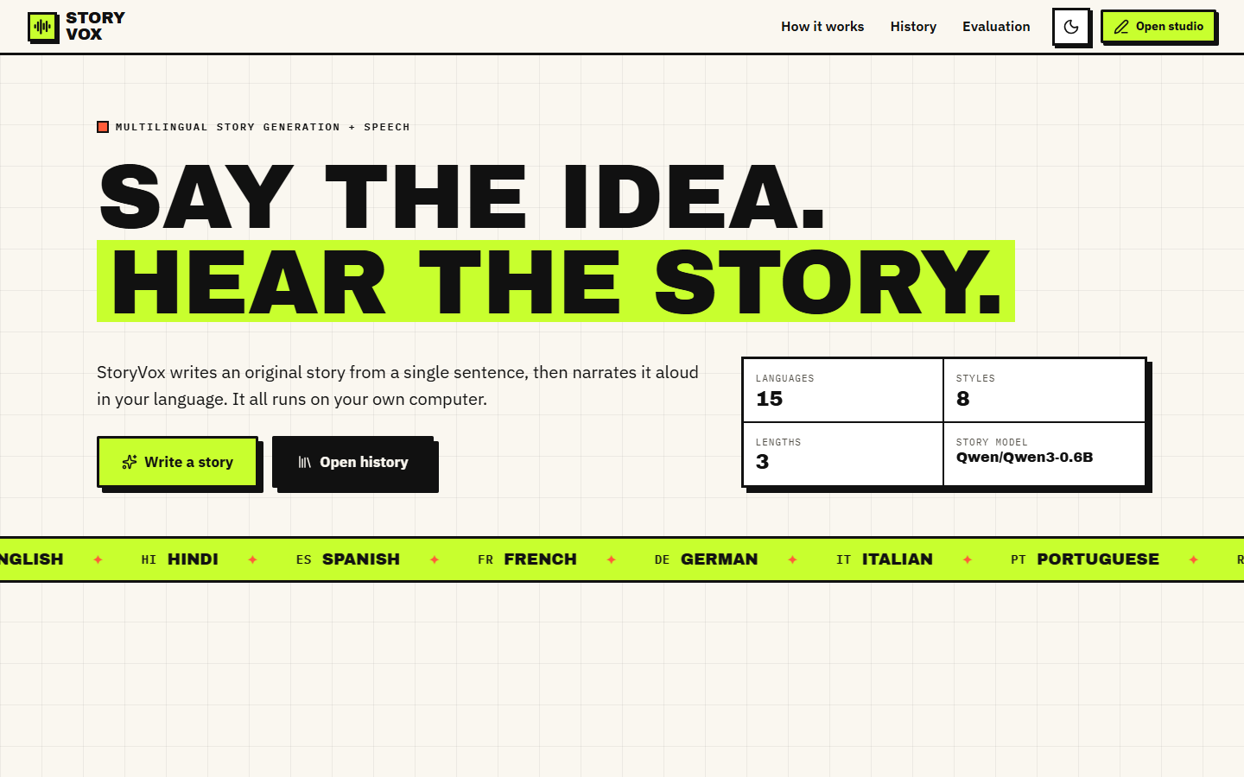  Figure 27: Additional screen: landing page in the light theme, with the counters for languages, styles, lengths and the story model. | 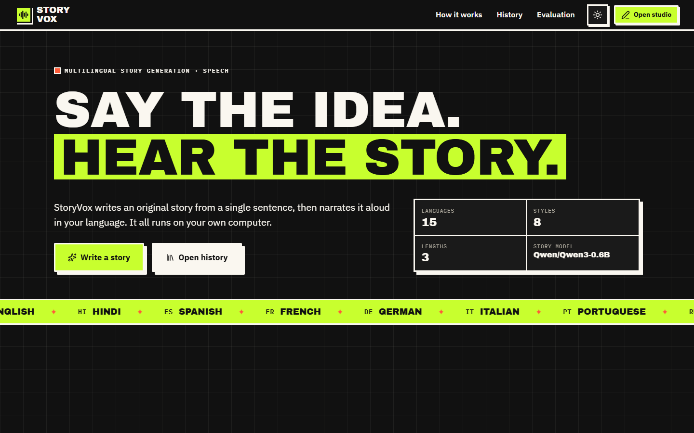  Figure 28: Additional screen: the same landing page in the dark theme.

Figure 29: Additional screen: Studio before a story exists, with the idea box, language, style and length selectors.
The landing page is public and needs no data; the empty Studio shows the form and an empty state with a link to History instead of an error.
Figure 30: Additional screen: Evaluation page, Chart tab, with the per-sample real-time factor for the five evaluation prompts. | Figure 31: Additional screen: Evaluation page, Samples tab, with latency, audio duration, real-time factor and similarity per prompt.

Every sample's real-time factor lies near 0.22; the WER and CER columns hold a dash because the recogniser call failed on narration longer than 30 seconds.
Figure 32: Additional screen: story page for a request in Hindi; the story text is English and contains echoed instruction text, and the Hindi voice produced only 4.4 seconds of audio.
The request was for Hindi, the model wrote English and repeated part of its instructions, and the Hindi speech model, given English letters, produced a very short clip.

